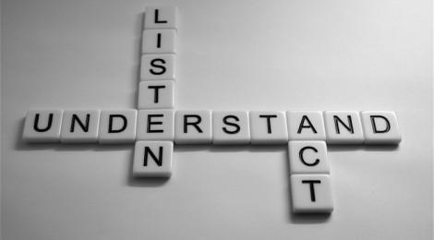
Listening Skills
Best Practices

As a caring adult who supports youth, 4-H volunteers play a very important role. The following are some best practices to follow when talking and interacting with youth.

“WE HAVE TWO EARS AND ONE MOUTH SO WE CAN LISTEN TWICE AS MUCH AS WE SPEAK.” (Epictetus AD55-c135)

- State your intention to listen:
- “I LOOK FORWARD TO HEARING YOUR VIEWS”
- Manage your physical environment:
- REDUCE DISTRACTIONS (NOISE AND DISRUPTIONS)
- IGNORE FLAWS IN THE SPEAKER’S DELIVERY (LIKE NERVOUS GESTURES)
- Make an internal commitment to listen:
- BE OPEN TO HEARING DIFFERENT PERSPECTIVES
- DON’T JUDGE
- MAKE MENTAL SUMMARIES ABOUT WHAT IS SAID
- Assume a listening posture:
- MAKE EYE CONTACT
- USE APPROPRIATE BODY LANGUAGE
- USE MINIMAL ENCOURAGERS (EX.- “UH HUH”)
- ALLOW FOR SILENCE
- Participate actively in the listening process:
- INVITE THE SPEAKER TO SAY MORE
- PARAPHRASE TO CHECK FOR UNDERSTANDING
- ASK CLARIFYING QUESTIONS
- TAKE NOTES
- WORK TO UNDERSTAND THE PERSPECTIVE OF THE SPEAKER WITH A STATEMENT OF RESPECT FOR THE SPEAKER’S VIEWS

