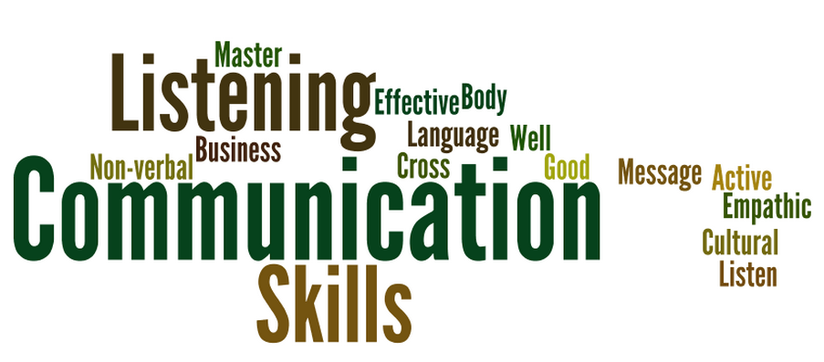
Listening Skills Activity

A good listener receives a message from someone else with care and respect; and works to confirm their understanding of the speaker’s message. A good listener focuses on what the speaker is saying and temporarily blocks other thoughts and distractions from their mind.
In most situations, the active listener is the most effective, as they receive the speaker’s message with care and respect and strive to confirm their understanding of the speaker’s message. The active listener leaves the conversation with little doubt about the speaker’s message or feelings. When an individual engages as an active listener, he or she receives two types of messages – the facts and the feelings.
ACTIVITY OVERVIEW: During this activity, you will explore different scenarios that demonstrate good and bad listening skills. Two-person teams will receive scripts to use while role-playing the situation. The remaining participants will identify the good and/or bad listening skills demonstrated.

RESOURCES NEEDED:
- Two copies of each scripts
- Copies of Listening Skills Handout – 1 for each participant

DIRECTIONS: Divide the larger group into pairs and pass each pair two copies of one section to read and act out. THEY SHOULD NOT INCLUDE THE TITLE OF THEIR SCRIPT DURING ROLE-PLAYING!

Participants NOT involved in the role-play should use their copy of the Listening Skills Handout to identify the good or bad listening skills demonstrated.

Script #1:
ACTIVE LISTENING

Person A says: So tell me about what you did from the moment you got up until you got to school.
Person A: (WHAT TO DO WHILE PERSON B SPEAKS)
- Take notes while person B speaks.
Person B says: I got out of bed and went to the bathroom. I brushed my teeth and washed up. I went back to my room and made my bed then I went to the kitchen and had breakfast. After breakfast, I put on my coat, got my backpack and caught the bus for school.

SCRIPT #2
FAILURE TO REDUCE DISTRACTIONS
Person A says: So tell me about what you did from the moment you got up until you got to school.
Person A: (WHAT TO DO WHILE PERSON B SPEAKS)
- Pretend your phone rings right after person B starts to talk. Interrupt them with “Excuse me” and “answer” your phone.
Person B says: I got out of bed and went to the bathroom. I brushed my teeth and washed up. I went back to my room and made my bed then I went to the kitchen and had breakfast. After breakfast, I put on my coat, got my backpack and caught the bus for school.

SCRIPT #3
POOR BODY LANGUAGE
Person A says: So tell me about what you did from the moment you got up until you got to school.
Person A: (WHAT TO DO WHILE PERSON B SPEAKS)
- Cross your arms and look out the door or window.
Person B says: I got out of bed and went to the bathroom. I brushed my teeth and washed up. I went back to my room and made my bed then I went to the kitchen and had breakfast. After breakfast, I put on my coat, got my backpack and caught the bus for school.

SCRIPT #4
INVITING SPEAKER TO SAY MORE
Person A says: So tell me about what you did from the moment you got up until you got to school.
Person B says: I got out of bed and went to the bathroom. I brushed my teeth and washed up. I went back to my room and made my bed then I went to the kitchen and had breakfast. After breakfast, I put on my coat, got my backpack and caught the bus for school.
Person A: What did you eat for breakfast?

SCRIPT #5
ASKING CLARIFYING QUESTIONS
Person A says: So tell me about what you did from the moment you got up until you got to school.
Person B says: I got out of bed and went to the bathroom. I brushed my teeth and washed up. I went back to my room and made my bed then I went to the kitchen and had breakfast. After breakfast, I put on my coat, got my backpack and caught the bus for school.
Person A says: What did you eat for breakfast? Person B says: Eggs
Person A says: Were they fried or scrambled?

SCRIPT #6
PARAPHRASING/SUMMARIZING
Person A says: What do you think about keeping 4-H Record Books?
Person B says: I think they are a pain to do but I like to look back and remember what I have done in past years.
Person A says: So you think they are hard to do but worth it.

