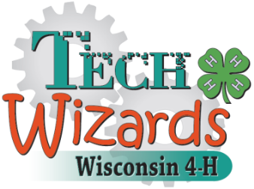

What is 4-H Tech Wizards?

The 4-H Tech Wizards Program engages youth in Science, Technology, Engineering and Math (STEM) related activities while providing a strong small group mentoring environment. The mentoring groups meet weekly the entire calendar year.

What is a Mentor?
A mentor is an adult/college student that enjoys working with youth and engaging in hands-on educational activities. The mentor does not need any experience or background in science. A mentor is supported by University of Wisconsin – Extension faculty and staff while in the program. All materials and supplies are provided. A mentor makes a commitment to mentor a group of four youth for an entire calendar year (including summer).

What is the Role of a Mentor?
A mentor will:
  - have an interest in working with youth
  - be responsible for his or her own team comprised of four youth
  - meet with their “team” once a week in an after-school or summer school setting
  - provide guidance for the students and build a relationship
  - take attendance every time that they meet as a group
  - work with a UW-Extension Mentor Coordinator to make the program a success

UW-Extension Expectations of a Mentor:
A mentor is someone who is committed to their group of students and who is interested in working with youth. The 4-H Tech Wizards Program is based on developing a long-term relationship between youth and adults. Thus, we ask that adults be willing to work with youth for a year or more. A background check will be required for all mentors.

If you are interested in being a 4-H Tech Wizards Mentor please contact:

Joanna Skluzacek at joanna.skluzacek@ces.uwex.edu

Requests for reasonable accommodations for disabilities or limitations should be made prior to the date of the program or activity for which it is needed. Please do so as early as possible prior to the program or activity so that proper arrangements can be made. Requests are kept confidential.

