Waukesha County Rental Garden
RULES – 2020

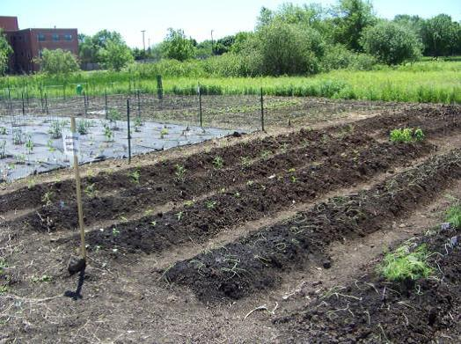
- All gardeners must be Waukesha County residents and sign the Garden Waiver (on the Reservation Form, contact 262-548-7775 for additional copies). Gardeners acknowledge neither Waukesha County nor the University of Wisconsin-Madison Extension is liable in case of accident, theft, or vandalism.
- Garden plot rental fees are non-refundable.
- NO gardening before the Garden officially opens and you see a stake identifying your plot number in front of your plot and stakes at the four corners of your plot. (Permanent plot renters are exempt from this rule.)
  - The Garden will OPEN approximately Saturday, May 16, 2020 (weather permitting).
- NO moving stakes and/or changing plot borders. Plot sizes are approximately 20’x20’ and 30’x30’ but plots may be wider and shorter, i.e. 22’X18’ or thinner and longer, i.e. 19’X21’. Plots shapes are established by the Garden Coordinator.
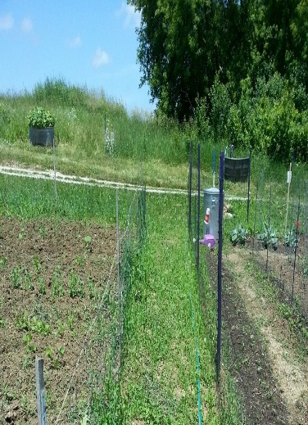
- Garden Plot Restrictions:
  - Non-Organic Garden Plots = Rows A, B, C, E, F, X
    - Chemical weed killers (herbicides) are NOT allowed.
    - Insecticides and chemical fertilizers are allowed, but we encourage the use of cultural biological insect control.
  - Organic Garden Plots = Row D
    - Only materials certified for organic gardening such as pheromone traps, horticultural oils, BT, insecticidal soaps, hot pepper sprays, compost, and manures may be used.
    - Commercial chemical pesticides and fertilizers not certified for organic gardening are NOT allowed. This includes insecticides, fungicides, herbicides, and fertilizers.
  - Tall crops (corn, sunflower, trellised plants) may be grown, but they must not shade another gardener’s plot.
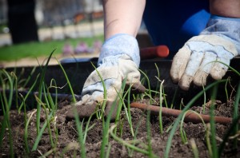
- Mulch:
  - Carpet may NOT be used as mulch.
  - Cardboard must be removed at the end of the season if used as mulch.
  - Plastic and fabric mulch must be removed at the end of the season. These are NOT Recommended as both are difficult to remove and dispose of at the end of the season. Such materials can get caught in our plowing equipment and require mechanical removal which can incur costly repairs.
  - Newspaper, straw, or hay are the recommended choice for weed suppression since these decompose and do not need to be removed.
- All tools (i.e. hose), garden supplies, and vegetable plantings must be kept within the gardener’s rental plot.
- Fences are allowed, but
  - Fences must be placed INSIDE your plot borders, unless you and your neighbor have agreed to share the fence, then it may be on the border.
  - Fences must be taken down by the Garden’s closing date.
Extension Waukesha County
515 W Moreland Blvd., AC G22
Waukesha, WI 53188
Phone: 262-548-7775
Fax: 262-548-7787
(711) Wisconsin Relay
- Gardeners are responsible for controlling the weeds on their plot and preventing them from spreading to other gardens from the Garden opening date to the Garden closing date.
Continued on back
- Plant waste must be properly disposed of in any of the five designated plant waste piles – diseased plant waste should be bagged and thrown in the garbage.
- Garden Paths:
  - Only established paths are to be used for walking to and from plots.
  - Paths must be clear and accessible:
    - All paths to the water and other plots should be passable and not fenced off.
    - Pathways should have no planted material growing on them. Garden pathways are to be maintained (weeded, mowed, and/or mulched) by the garden renters surrounding the paths.
- Water is available at the six water tanks:
  - You may run your hose from the water tank or couplers to your plot for watering while you are at the garden, but please be considerate of other gardeners.
  - Hoses must be unhooked from water tanks and stored inside your garden plot when you are not at the Garden.
  - Sprinklers are NOT allowed.
- Gardeners are responsible for their children and their guests. Children should be supervised.
- Pets are NOT allowed at the Garden.
- NO feeding animals at the Garden, i.e., squirrels, chipmunks, deer, etc.
- If you fail to garden (i.e. barely planted, mostly all weeds) for TWO consecutive years, you will not be allowed to garden the following year per the discretion of the Rental Garden Coordinator.
- The Waukesha County Rental Garden will close Monday, October 19, 2020 at 9:00 am and a $25 fee will be assessed to gardeners if they have not:
  - Removed everything they brought into the plot including fencing, stakes, string, tomato cages, tools, tarps, plastic, etc.
  - Dug up and removed all thick-stem vegetables (i.e., corn), thick-stem flowers (i.e., sunflower), and thick-stem weeds.
Not rules, but you should know….
- Communication:
  - Bulletin Board – Check the bulletin board at the Garden entrance for timely announcements.
  - Website – Please visit our website for Garden information and updates at https://fyi.extension.wisc.edu/community-gardens/.
  - Newsletter – Gardeners receive 4 to 5 issues of our newsletter, The Garden Connection, during the growing season via email. Newsletters are mailed to those without email. (Past newsletters are on the website.)
- Gardeners provide their own tools, seeds, and plants.
- Garden Rows: Consider the benefit of planting in raised garden rows (see photo on left) and/or positioning the rows in your garden in such a way as to avoid run-off during heavy rains.
- Permanent Garden Plots: There are a limited number of "permanent" garden plots (plots that are not tilled in spring). There is a waiting list, please contact office.
Extension Waukesha County
515 W Moreland Blvd., AC G22
Waukesha, WI 53188
Phone: 262-548-7775
Fax: 262-548-7787
(711) Wisconsin Relay
Questions? Contact the Extension Waukesha County office by calling 262-548-7775

