Tuesday February 12th Waunakee High School Door #9 301 Community Drive (The address will not navigate you to the correct entrance. Please reference map for route to Door #9)
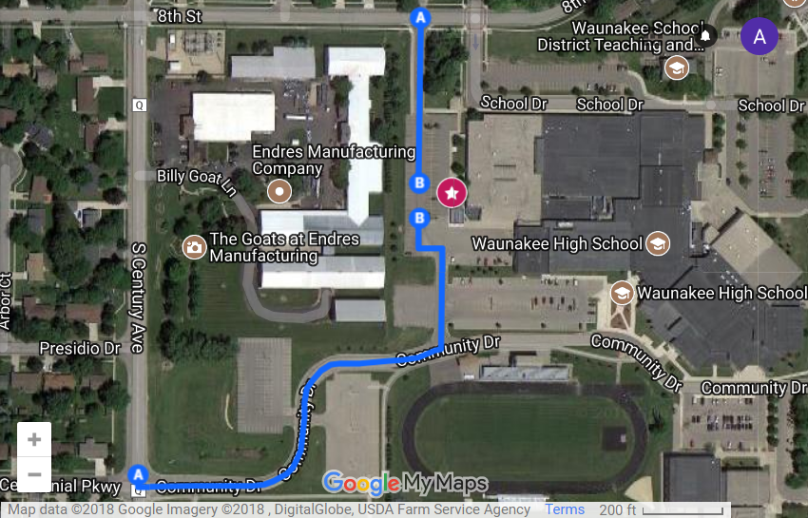

Saturday, February 16th Dane County UW Extension Office 5201 Fen Oak Court, Madison
