4-H Promotion Challenge

Purpose: To promote 4-H, to make 4-H visible in the community, and provide an opportunity for club members to build club spirit.

Details:
- A 4-H Promotion Contest that will include all 4-H promotions between August 2021 and October 2021. Open to all 4-H clubs in Dane County. National 4-H Week is October 3-9, 2021
- Use the attached form to describe the 4-H promotion activities your club did this year.
- Submit the attached report of your club’s activities no later than November 1, 2021.
- 4-H Promotion activities can include (but are not limited to) window displays, promotional talks, open houses, newspaper articles, videos (up to 60 seconds), social media posts, electronic flyers, online news articles, etc. Be creative!
- Submit pictures of the activity (or activities) whenever possible. If the submission is a video, add a link on the form for judges to view.
- Judging of reports will be done after the close of the contest. Winners will be announced at the November Leaders Association Meeting. The attached entry form will be used during the judging.
- Entries will be judged on Results of Promotional Efforts, Teamwork Experiences, Documentation, and Creativity.
- Decision of judges will be final.
- Awards: 1st place = $75, 2nd place = $50, 3rd place = $25

Return attached report form and any other documentation to the Extension/4-H Office, 5201 Fen Oak Drive, Suite 138, Madison, WI 53718 by November 1, 2021!

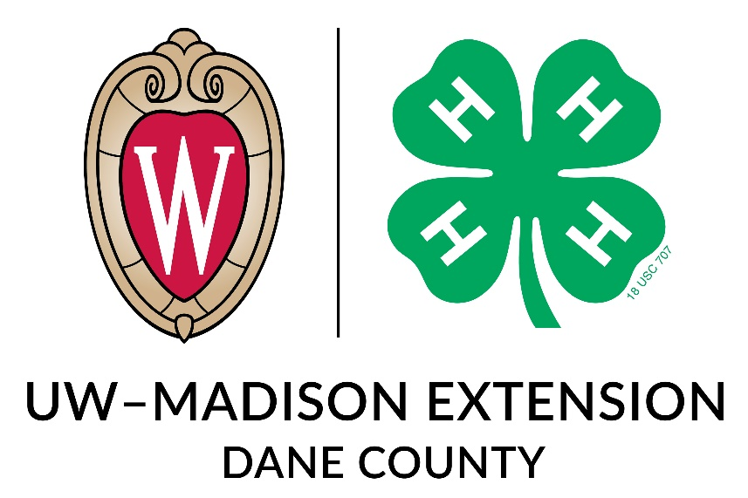

4-H Promotion Contest - Entry Sheet

Name of Club:
4-H Promotion Activity: (If submitting more than one activity, please use additional sheets – one activity per sheet)

Date, Time and Place of Promotion:
Purpose of Promotion (What did you hope to accomplish? What made your choose this activity?):

How many members, leaders, and youth leaders helped with this promotion?

# of Members: _____

Role:

# of Leaders: _____

Role:

# of Youth Leaders: _____
Role:

Results of Promotion (What did you accomplish?):

Estimate number of people reached:
Do you feel this promotion was successful?

If you were doing this promotion again, what changes would you make?

Anything else you would like to tell us about this promotional activity:

Name of Person Submitting Report: ____________________________________________________
Club Name: ____________________________________________________________________________
Number of members (including Cloverbuds in club: ______________
Number of Youth Leaders in club: _________________________
Please attach pictures and other supporting documents (example: news articles), if possible.

