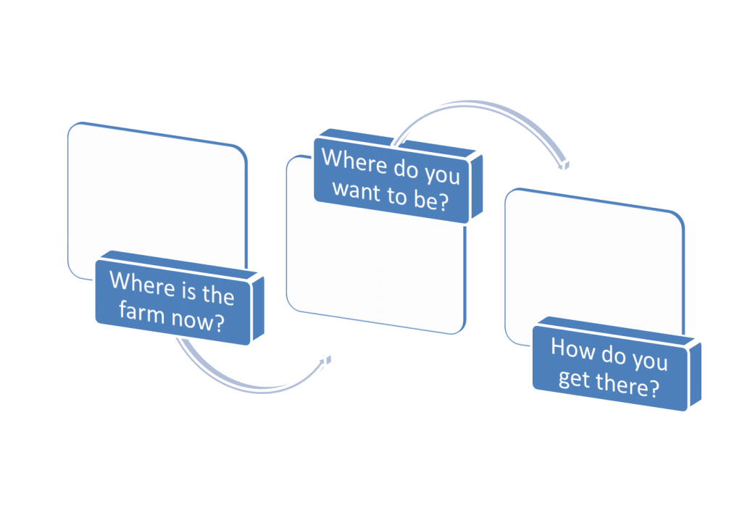

# Where Do You Want to Be?

* Values
* Vision
* Mission
* Goals
* Stakeholders (who needs to be involved):
  + -Business
  + -Family
* Explore the options:

-SWAT analysis

**Where is the Farm Now?**

* History of the farm:
* History of the family (information about children)
* Who is doing what?
* How are decisions made?
* Who is making decisions?
  + -Operational
  + –Strategic
* How are the assets owned?
* How is income distributed?
* How are expenses distributed?
* Financial Information:
  + -Balance sheets
  + -Income statements
  + -Schedule F
  + -Benchmarking
  + -Family living needs
  + -Retirement savings
* Production data