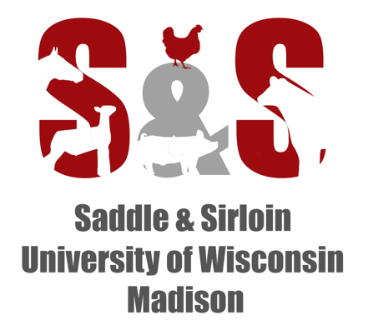

University of Wisconsin – Madison Saddle and Sirloin Club
2019 Swine Project Award Application
Deadline: MUST BE POSTMARKED ON OR BEFORE APRIL 19th, 2019
APPLICATIONS WILL NOT BE ACCEPTED VIA E-MAIL
Applications need to be filled out by the exhibitors themselves, handwritten is preferred, please attach a picture of the pig and exhibitor, this can be digital or hand drawn. Please remember you will be required to submit a picture of the pig and exhibitor at the end of your show season.
Please type or print neatly:
Name: _____________________________ Age: ___________ County: ___________________
Phone: ____________________
Address: ______________________________________________________________________
City, State, Zip: ________________________________________________________________
4-H Club/FFA Chapter: __________________________________________________________
Parents’ or Guardians’ Name: _____________________________________________________
Year in Swine Project (Must be 1st or 2nd year): _____________
Swine Project Leader/FFA Advisor: ________________________________________________
Address of Leader: _______________________________________ Phone: ________________
How did you hear about this award? ________________________________________________
________________________________________________ (Not considered in award decision)

Describe your swine project for this year. (Incorporate details. Include how many pigs, what fair(s) you will show at, feeding, your facilities, etc.):

How did you become interested in raising pigs and who helps you with your project?

Describe your other livestock related involvement. (Other animals shown, farm background, clubs you might participate in, etc.):

What swine-related learning experiences/activities do you plan to participate in this year? (Club meetings, clinics, quiz bowl teams, showmanship, judging contests, etc.):

Please send completed application POSTMARKED ON or BEFORE APRIL 19th, 2019 to:
Saddle and Sirloin Club
c/o Cassidy Dabbs
1675 Observatory Drive
Madison, WI 53706
Questions? Please contact Cassidy Dabbs at:
(262) 220-4381 or email at cdabbs@wisc.edu

