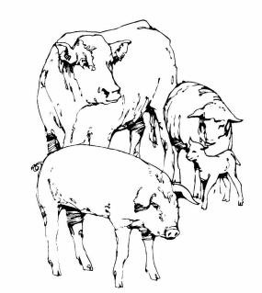

Fond du Lac County
Market Livestock Sale
Fond du Lac County Fair, PO Box 1466 Fond du Lac, WI 54936

FOND DU LAC COUNTY MARKET LIVESTOCK PROJECT
EDUCATIONAL CREDIT FORM FOR OUT-OF-COUNTY ACTIVITIES

This form is to be used for out of county educational activities and is to be signed by the event coordinator. Please return to the Fond du Lac County UW Extension office after returning from the event. (Please note: Planned events intended for credit must be approved one month prior to the event date. Contact Tina Kohlman, Fond du Lac County Dairy and Livestock Agent, for final approval.)

Event Name:

Event Date: _
Start Time:
End Time:

Location:

As the event coordinator, I hereby certify that the Fond du Lac County youth livestock project member(s) listed below were active participants in our event.

Coordinator Name:
Signature:

Date:
Phone:

Participant Name: _

Fond du Lac County Market Livestock Participant,
At the completion of the educational activity, the Market Livestock Committee would like you to take some time to reflect and briefly share what you learned and how you plan on using the knowledge gained in your project work this year. Please use the space below and the back of this form.

Return to: | UW-Extension Fond du Lac County Attn.: Market Livestock Sale | or FAX to: or email to: | 920.929.3181  tina.engelhardt@wisc.edu
 | Rm. 227 Admin/Extension Bldg.
400 University Drive
Fond du Lac, WI 54935

