**Financial Well-being Idea Sheet**

What’s one thing you can do in the next few weeks for your own financial well-being?

Pick an area and write in your action step.

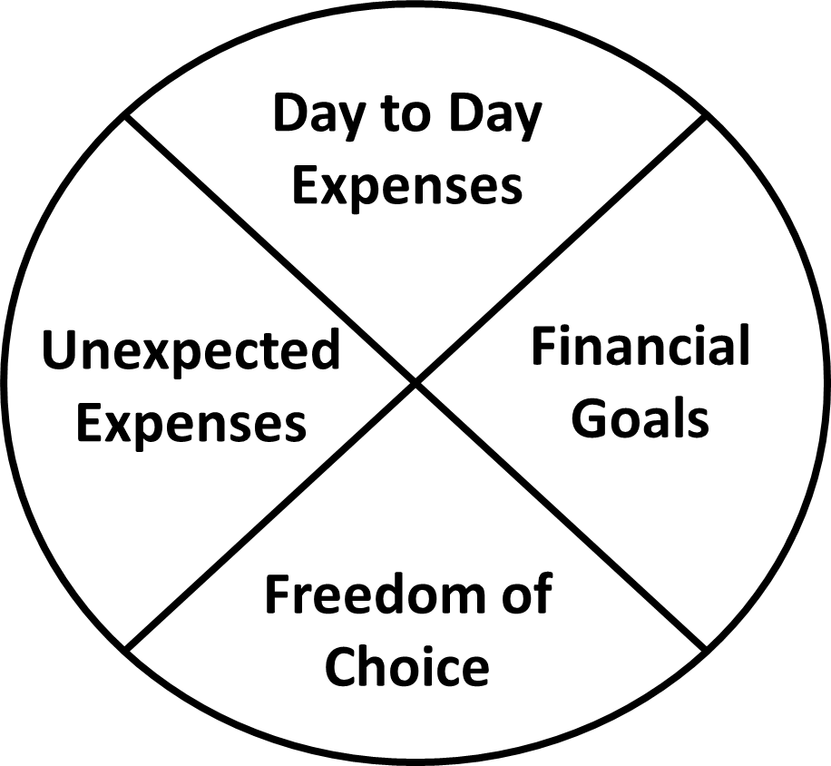

*I will do this step: _________________________________________________ by this date: __________________________*

**Accountability Buddy:**

Sometimes life gets in the way and we don’t always act on our best intentions. Think about sharing your action step with a friend or family member who can follow-up and ask you how it’s going.

**ACTION:**

**ACTION:**

**ACTION:**

**ACTION:**