**Financial Well-Being**

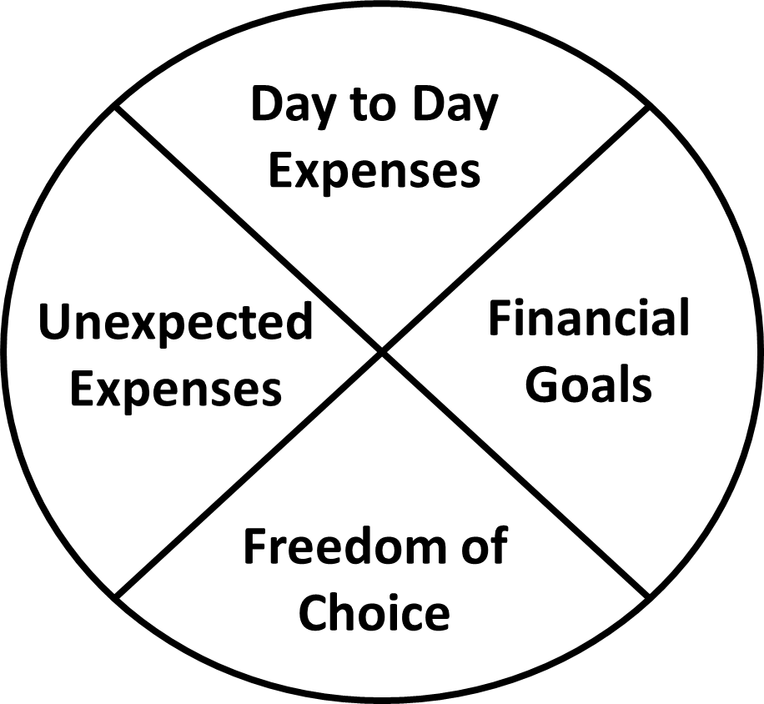

These are four factors that help determine how people feel about their current financial situation. CFPB researchers have developed both a pen-and-paper survey and an interactive online questionnaire as a tool to help measure your current financial well-being—that is, how well your current money situation is providing you with financial security and freedom of choice, today and for the future.

You can find more information and tools on the Consumer Financial Protection Bureau website: [www.consumerfinance.gov/consumer-tools/financial-well-being/](http://www.consumerfinance.gov/consumer-tools/financial-well-being/)

Having the ability and wiggle room in your budget to spend your money on things that are most important to you.

Having a handle on money entering and leaving your household.

Knowing what your goals are and taking steps to make progress towards those goals.

Having a plan to cover life’s emergencies and surprises.