Biosecurity – Keeping Your Horse Healthy at Equine Events

We appreciate your participation in this event and want you and your horses to return in future years. To ensure the success of this year’s event, the health of your horse and that of other horses is of primary importance. As a result, we ask that you observe these important biosecurity precautions during this show.

Exhibiting at Horse Events
Horse shows, competitions and sales are an important component of Wisconsin’s horse industry. Many hours of training and hard work are invested to prepare healthy, high quality horses for competition and exhibition. Participation in equine events may pose a potential risk to horse health. The stresses of travel, close confinement and a new environment may compromise a horse’s resistance to disease. The commingling of horses of different breeds, ages and from multiple premises and disease management backgrounds, creates an environment for potential disease exposure. People attending horse events may also contribute to potential disease spread. Horses returning to their home stables may pose a risk of disease introduction and spread to their stable mates.

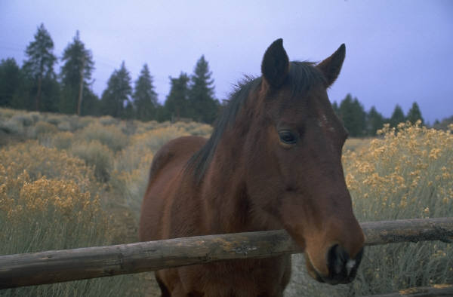

Event Biosecurity
Biosecurity refers to measures taken to prevent the introduction and spread of new disease agents into a herd. Commingling of horses, multiple human contacts and contaminated equipment represent the greatest threats for disease exposure and spread at horse events. Consistent biosecurity practices play an important role in reducing the risk of exposure to infectious disease when attending an equine event. Even the best biosecurity does not eliminate the risk of disease exposure. However, each measure taken will reduce the potential of disease exposure and help keep your horse healthy.

Transport Healthy Horses
Horses that travel frequently and commingle with various horses at events have the highest risk for disease exposure. Only healthy horses should participate in equine events. Before horses leave their home stable, a veterinarian should examine each horse to ensure the health of the animal. Consult your veterinarian for vaccination recommendations before travel to the event. Record each horse’s normal resting vital signs, which include temperature, heart rate and respiratory rate. Check with event management for health entry requirements, some events may require health certification statements signed by a veterinarian and some may require owner health declarations.

A clean and disinfected trailer should be used each time a horse is shipped to a new premise. At the time of loading the horse onto the trailer, observe each horse for any obvious signs of disease, such as abnormal nasal discharge, persistent frequent coughing, and neurologic signs of ataxia or hind limb weakness. Horses displaying signs of disease should not be shipped to an event.

Monitor Horse Health at Event
A horse appearing healthy entering an event grounds may be infected with an infectious disease agent or incubating the disease. The stress of travel and the stress of competition may result in that horse becoming sick. Continual monitoring of horse health throughout the event is essential. Any horse displaying clinical signs of disease poses a risk of disease spread to the population of horses on the event grounds. Any horse displaying clinical signs and/or a temperature above 102°F should be reported to a designated event official or a veterinarian. Immediate isolation of the sick horse is essential to prevent disease spread.

Limit Exposure to Disease
Infectious disease pathogens may be brought to and spread at an event premises by horses, people, domestic animals other than horses, vehicles, equipment, insects, ticks, birds, wildlife including rodents, feed, waste and water. The following simple biosecurity steps significantly reduce exposure risk to disease pathogens:

- Limit horse-to-horse contact, especially nose-to-nose contact.
- Avoid sharing of equipment unless thoroughly cleaned and disinfected between uses.
- Limit horse-to-human-to-horse contact.
- Wash hands between handling horses, particularly other people’s horses.
- Avoid use of communal water sources

Protect the Home Stable
The possibility of a horse’s exposure to disease agents can occur with even the best biosecurity practices at the horse event. To avoid introduction of disease to the homes stables from the event facility, implement the following protocols:

- Clean and Disinfect Equipment: Before leaving the event grounds, clean and disinfect all equipment including feed buckets, feeders, hay racks, shovels, pitch forks, muck buckets, wheelbarrows, grooming equipment, vehicle and trailer (inside and outside).

- Isolate Returning Horses: If possible, isolate returning horses for a minimum of 2 weeks. Isolated horses should have no direct contact with other horses and should be handled, fed, and stalls cleaned last.

- Shower and Change Clothes: Participants should shower, blow their nose and change clothes and footwear before entering the home stables. Clothing and footwear worn at an equine event should be thoroughly cleaned and disinfected prior to use on the home premises.

Cleaning and Disinfection
Most disease agents are susceptible to the various disinfectants. However, some disinfectants, specifically alcohol and bleach, are inactivated by organic matter, such as soil and manure. Consult a veterinarian for disinfectant recommendations.

Follow the four step process of cleaning and disinfection:

Step 1: Remove organic matter
Step 2: Wash with soap and rinse with water
Step 3: Allow time to dry
Step 4: Apply a disinfectant

Use disinfectants according to label directions following safety precautions. Comply with all product label application instructions and ensure adequate disinfectant contact time with surfaces for maximum efficacy.

In general, 1:10 dilution of bleach to water is effective. However, in most stall situations, organic material cannot be completely eliminated; therefore it is necessary to use a disinfectant that has activity in the presence of organic materials, such as phenolics or an accelerated hydrogen peroxide product. All products should be used in accordance with manufacturer’s recommendations and label instructions.

Your assistance is greatly appreciated by show management, fellow exhibitors and the visiting public.

Content kindly provided by the California Department of Food and Agriculture.

Wisconsin Department of Agriculture, Trade and Consumer Protection
www.datcp.wi.gov
Division of Animal Health General Information: 800-572-8981
datcpanimals@wi.gov

