
Country of Origin Labeling

Information for Parents and Exhibitors

What is COOL?
The COOL (Country of Origin Labeling) final rule for commodities took effect on March 16, 2009. This USDA rule provides consumers with knowledge and as to where their food originated.

In December 2015, COOL was rescinded by the federal government for Beef and Pork products. Thus NO COOL forms are needed for beef and swine producers.
This new requirement is not meant to be burdensome for producers to follow, but buyers of livestock projects will be asking for more information than in the past.

What Commodities Are Required?
This rule affects beef (including veal), lamb, pork, chicken and goats; perishable commodities (fresh and frozen fruits and vegetables); macadamia nuts; pecans; ginseng; and peanuts. For exhibitors, this would include the following species: beef, goats, poultry, sheep and swine, and also animals that may not be harvested until a much later time (for example, cull dairy cows, beef cows and dairy goats).
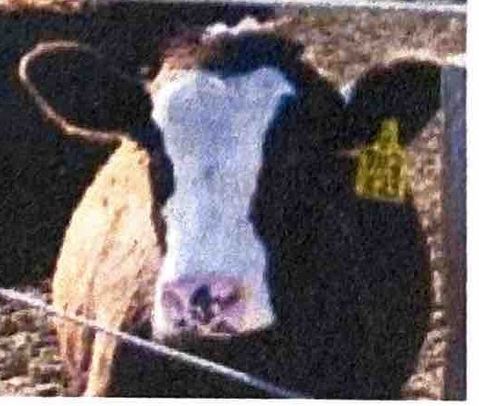
All animals that will eventually be harvested need to have documentation.

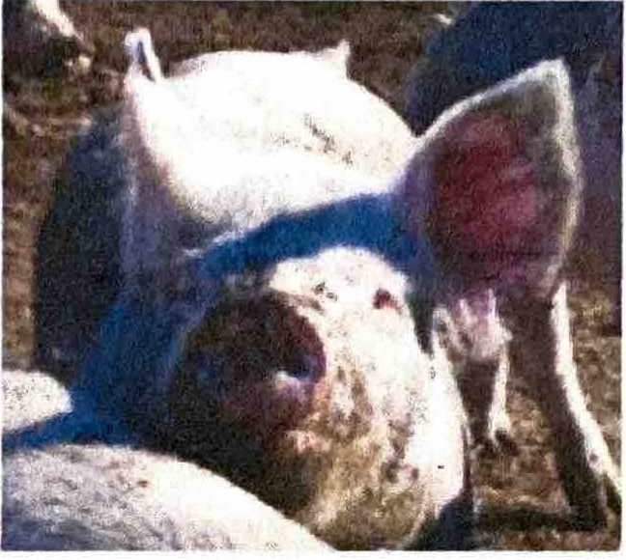

How Does This Rule Affect Youth Exhibitors?
Ask for Documentation-Exhibitors need to make sure they collect documentation from the seller when purchasing livestock. Documentation could include the following:
- Signed affidavit from seller of livestock (example on the 3rd page of this document)
- See other examples of
. documentation in table below.
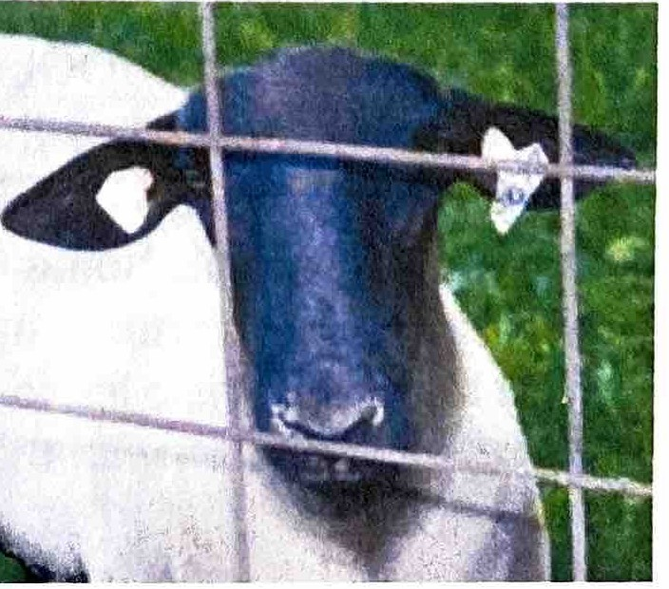
Keep Documentation for 2 Years Minimum-Exhibitors must keep the appropriate documentation for a minimum of two years in the case of a USDA audit.


Country of Origin Lab�l_ing

Information for Parents and Exhibitors

Buyers of Livestock
  - Signed affidavit from seller of livestock
  - Bill of sale
  - Health papers
  - Brand inspection
  - Supporting documents identified by USDA¹

Original Producers of Livestock
  - Birth records (calving, lambing, farrowing, etc.)
  - Inventory records that reconcile
  - Purchase and sales receipts
  - Supporting documents identified by USDA¹

¹Balance sheet, income statement, other financial records, scale tickets and purchase and sales receipts, closeout records and/or feed records or bills, health papers, vaccination or other health treatment records or receipts, shipping records, farrowing, calving, or lambing records, breed association registered pedigrees.

Sign County Fair Auction Documentation - Exhibitors will be required to sign documentation of animals that go to buying stations and/or large processors, such as Tyson, Cargill, Smithfield/Packerland, etc., from the county fair auction. The fair office/livestock/auction committees will keep these forms for a minimum of 2 years and pass on the original to the processing plant.
- Youth who are under 18 years of age need to have a parent/guardian sign COOL documentation as well as the exhibitor signature.
- If youth take animals home from the fair and market them later, it will be their responsibility to complete paperwork with the entities they sell to.

For Additional Information:

USDA Website:
http://www.ams.usda.gov/cool
Youth Livestock Website: http://livestock.extension.wise.edu/progr ams/wisconsin-youth-livestock
Written by: Bernie O'Rourke, Extension Youth Livestock Specialist, borourke2@wisc.edu, 608-263-4304
Issued in furtherance of Cooperative Extension work, Acts of Congress of May 8 and June 30, 1914, in cooperation with the
U.S. Department of Agriculture, University of Wisconsin-Extension, Cooperative Extension, University of Wisconsin-Extension provides equal opportunities in employment and programming, including Title IX and ADA requirements.

�Extension
� UNIVERSITY OF WISCONSIN·MADISON

COUNTRY OF ORIGIN AFFIDAVIT/ DECLARATION

As an affidavit is deemed by USDA as an official record of Country of Origin, I attest through first-hand knowledge, normal business records, or producer affidavit(s) that all livestock referenced by this document or other communications specific to the transaction and transferred are of U.S. origin (born and raised in the U.S.)

Date:

Seller Contact Information

Name: Address: City and State: Phone Number: Premise ID #: Number of Animals:
Animal ID: General Description:

Seller Signature Date

Exhibitor Signature Date

Premise ID # where animal will be housed

Parent/Guardian Signature Date

