Determining the Value of Standing Alfalfa in 2021
Kevin Jarek - UW-Madison, Division of Extension, Crops and Soils Agent - Outagamie County
The “fair” value of any given alfalfa stand can vary tremendously. The absence of daily quotes as compared to other agricultural commodities (grains) requires us to rely on the most recent hay market prices available at https://fyi.extension.wisc.edu/forage/h-m-r/. The three most significant factors to consider when determining the potential value for any individual cutting of alfalfa or the stand for the entire growing season include:
A) Expected Dry Matter (DM) Yield in Tons per Acre B) Estimated Value of a Ton of DM C) Harvesting Costs
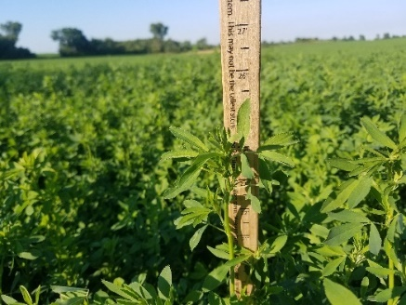
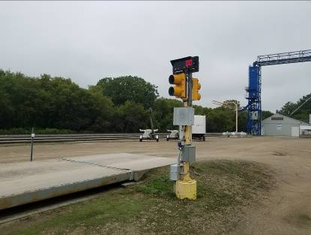
Ideally, one would be able to weigh the forage being harvested from any individual cutting from a particular field. This is the best way to ensure that both parties are treated equally in any formal arrangement in which standing alfalfa is bought or sold. If a scale is available, multiple forage samples should be collected during the process of harvesting to determine an accurate value for the average dry matter (DM) content of the feed being sold. Once you have agreed upon a fair price or value for a ton of DM (may be with or without harvesting costs), you simply multiply the harvested tonnage by the agreed upon value per DM ton then adjust for harvesting costs if they were not already taken into consideration. Unfortunately, not all farms have access to drive-over scales or state-certified scales at harvest.
Expected Dry Matter (DM) yield can be estimated by measuring alfalfa stand density as illustrated below or by utilizing multi-year data from the Wisconsin Alfalfa Yield and Persistence (WAYP) program managed by the University of Wisconsin-Madison and Division of Extension. The 2020 WAYP project summary can be downloaded for review at: https://fyi.extension.wisc.edu/forage/files/2021/03/2020-WAYP-Summary.pdf.
- Stand Density: Alfalfa stands with an average of 55 stems per square foot are defined as not being limited and having full season yield potential. Due to the high variability in alfalfa stem counts throughout many fields these past few growing seasons, it would be wise for buyers and sellers to evaluate stands to determine a realistic potential yield before a sale is agreed upon. WAYP project data can help you estimate DM yield derived from on-farm data collected over the past 14 years. Local growing conditions, alfalfa stand condition after overwintering, age of the stand, composition of the stand, soil texture/series, soil fertility, and soil drainage can all significantly impact alfalfa DM yields during any given growing season. It is not advisable to purchase standing alfalfa without taking each of these considerations into account before any final arrangement is agreed upon by all parties involved.
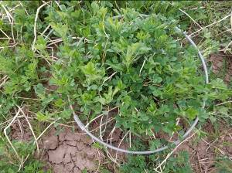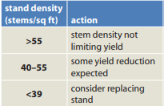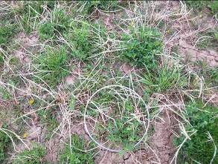
Source: Alfalfa Stand Assessment – Is This Stand Good Enough to Keep? – Dan Undersander, Forage Agronomist, UW-Madison
- Percentage of Overall Season Yield Per Cutting as Determined by the WAYP Program On-Farm Data:
3 cut system – 46% (1st crop) – 28% (2nd crop) – 26% (3rd crop)
4 cut system – 36% (1st crop) – 25% (2nd crop) – 21% (3rd crop) – 18% (4th crop)
5 cut system – 31% (1st crop) – 23% (2nd crop) – 18% (3rd crop) – 16% (4th crop) – 12% (5th crop)
WAYP data collection began with the first full production year following new seeding. Fifth crop data was collected and included in years when a fifth cutting was available. It should be noted that four-cut systems represent the largest percentage of the data. The low, mean (average), and high values for DM yield over the life of the project are illustrated below. In addition, 2020 data is included so you can compare the most recent year’s data to the other benchmark measurements established over the past 14 years. As illustrated below, 2020 was not a particularly good year for yield with each of the four cuttings coming in below the project mean. Also of note, we set a new record low yield for first cutting in 2020 which has contributed to the lower than expected forage inventories in some parts of the state as we head into the 2021 growing season.
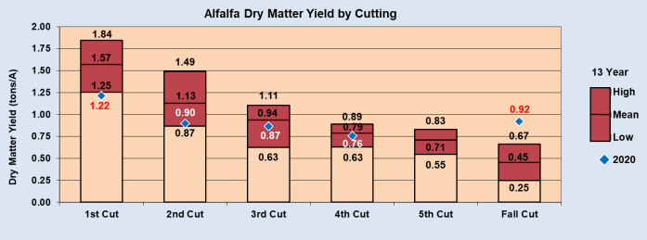
Source: Wisconsin Alfalfa Yield and Persistence (WAYP) Program Summary, 2020
- Total Season Yield: The WAYP program has an observed yield range of less than 3.0 tons to more than 6.0 tons DM per acre. The most frequently observed yield has been 4.0-4.49 Tons per DM per Year. The following chart illustrates the annually observed mean of alfalfa DM yield in tons per acre from 2007-2020. The average yield of first through fourth crops over the project is 4.40 tons DM per acre.
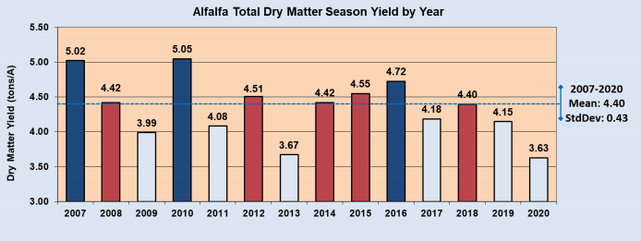
Source: Wisconsin Alfalfa Yield and Persistence (WAYP) Program Summary, 2020

Dry Matter Yield Level Distribution from 2007-2020 Dry Matter Yield Distribution 2020 Growing Season
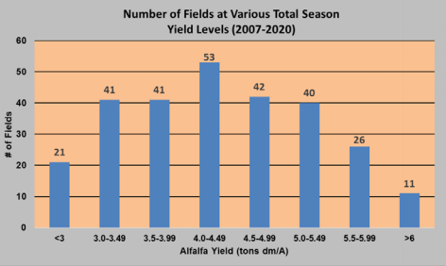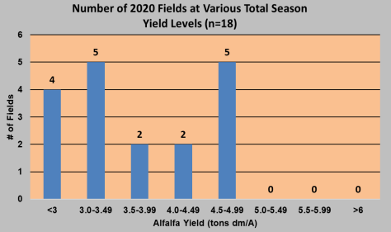
Source: Wisconsin Alfalfa Yield and Persistence (WAYP) Program Summary, 2020
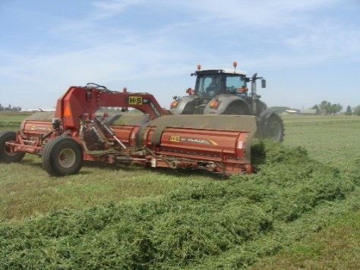
- Weather Risk and Field Losses: Management practices applied to the site by the buyer during the cutting and harvesting of alfalfa will influence the final quality measurements. Purchased baled hay may have a known, measured quality indicator like Relative Forage Quality (RFQ) or Relative Feed Value (RFV). Alfalfa purchased from the field has an unstable quality complex as weather risk, insect or disease pressure, advancing maturity, leaf shatter, and harvesting losses need to be considered and accounted for when determining the final price. An adjustment of 25 percent to the value of the alfalfa standing in the field may be considered a reasonable method to further account for the buyer’s risk.
- Determining the Value of a Ton of DM Alfalfa
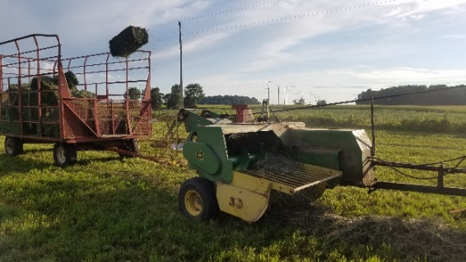
Hay Market Demand and Price Reports for the Upper Midwest are located on the UW-Madison, Division of Extension, Team Forage (http://fyi.uwex.edu/forage/) website with updates located at https://fyi.extension.wisc.edu/forage/h-m-r/. The most recent report (April 12, 2021) indicates large square bales of Prime Quality (>151 RFV/RFQ) alfalfa averaged $205 per ton. The value of a ton of DM is determined via the following calculations:
Price for a Ton of DM
As baled hay, assume moisture of 15 percent which means it is 85 percent DM or 0.85 DM
$205
.00
X
as fed ton
=
$241
.
18
as fed ton
0.85 ton DM
Ton DM

When is the last time you successfully harvested all your alfalfa without any weather damage? One may harvest four high quality cuttings, or one may harvest four lower quality cuttings. Earlier we identified the difference between purchasing alfalfa that has already been harvested. It is a know quality. Standing alfalfa must be adjusted for both field losses and potential weather risk, both of which can significantly impact the quality of the harvested forage. The buyer and seller can decide if they wish to use a factor other than 25%.
If we use $241.18 per ton DM and apply a 25% risk adjustment, we end up with a risk adjusted value for ton of DM standing alfalfa as follows: ($241.18 X 0.25 = $60.30), $241.18 - $60.30 = $180.88 per ton of DM.

- Harvesting Cost: Based on the most recent costs posted in the Wisconsin Custom Rate Guide 2017 https://www.nass.usda.gov/Statistics_by_State/Wisconsin/Publications/WI-CRate17.pdf or 2021 Iowa Farm Custom Rate Survey https://www.extension.iastate.edu/agdm/crops/pdf/a3-10.pdf one would expect to pay the following for the field operations identified below:
Mowing and Conditioning per acre: | Windrow Merging per acre: | Chopping, Hauling, and Filling Upright Silos and *Bunker Silos per acre
$5-$50 per acre, $14.20 statewide average (WI - 2017) | $3-$40 per acre, $11.60 statewide average (WI - 2017) | Pull-Type Forage Harvester $15.00-$60.00 per acre, $41.30 statewide average (WI - 2017)
$12-$20 per acre, $15.15 statewide average (IA - 2021) | $9-$18 per acre, $14.50 statewide average (IA - 2021) | Self-Propelled Forage Harvester $40.50 -$70.00 per acre, $52.20 statewide average (WI - 2017)
 |  | *Self-Propelled Forage Harvester $23.30 -$65.00 per acre, $49.20 statewide average (WI - 2017)

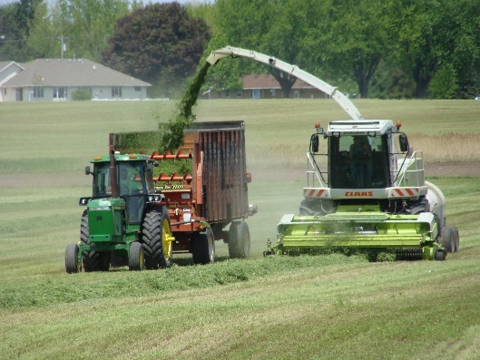
Using values cited earlier, one may spend $15 per acre cutting and conditioning the alfalfa, $14 per acre merging the alfalfa, and $47.57 per acre (average between pull type and self-propelled units - adjust your costs as needed) chopping, hauling, and filling an upright silo or a bunker silo resulting in $76.57 per acre invested for each cutting. One’s harvesting costs may be higher or lower than those cited here; however, this is what is used for this example. If one harvests four (4) cuttings, total harvest costs are $306.28/acre for the season ($76.57 X 4 cuttings = $306.28). If the buyer’s harvesting costs are less, one can adjust downward. If the buyer’s harvesting costs are higher, one can adjust upward. While the landowner who established the alfalfa has the expense of the land, taxes, seed, chemical, and fertilizer, the buyer not only has the harvesting costs, but assumes the risk of field losses and weather damage exceeding the 25 percent quality adjustment discussed earlier.
Once one has calculated or agreed upon the value of a ton of DM and has made a reasonable yield estimate, one may proceed. In this first example we used a 4.0-ton DM yield for the season at a value of $180.88 per ton DM. Four (4) tons of DM X $180.88 per ton DM = a final harvested value of $723.52. After we deduct the cost of harvesting $306.28, (4 cuts X $76.57), we are left with the following:
Harvesting 4.0 tons of DM total value would be $723.52 less harvesting costs of $306.28 = $417.24 residual
1
st
Cutting = $ 417.24 X 36% of total yield (1.44 tons DM) for the season = $150.21
2
nd
Cutting =$ 417.24 X 25% of total yield (1.00 tons DM) for the season = $104.31
3
rd
Cutting = $ 417.24 X 21% of total yield (0.84 tons DM) for the season = $ 87.62
4
th
Cutting = $ 417.24 X 18% of total yield (0.72 tons DM) for the season = $ 75.10

Harvesting 4.5 tons of DM total value would be $813.96 less harvesting costs of $306.28 = $507.68 residual
1
st
Cutting = $ 507.68 X 36% of total yield (1.62 tons DM) for the season = $182.76
2
nd
Cutting = $ 507.68 X 25% of total yield (1.13 tons DM) for the season = $126.92
3
rd
Cutting = $ 507.68 X 21% of total yield (0.95 tons DM) for the season = $106.61
4
th
Cutting = $ 507.68 X 18% of total yield (0.81 tons DM) for the season = $ 91.38

Harvesting 5.0 tons of DM total value would be $904.40 less harvesting costs of $306.28 = $598.12 residual
1
st
Cutting = $ 598.12 X 36% of total yield (1.80 tons DM) for the season = $215.32
2
nd
Cutting = $ 598.12 X 25% of total yield (1.25 tons DM) for the season = $149.53
3
rd
Cutting = $ 598.12 X 21% of total yield (1.05 tons DM) for the season = $125.60
4
th
Cutting = $ 598.12 X 18% of total yield (0.90 tons DM) for the season = $107.66

Summary
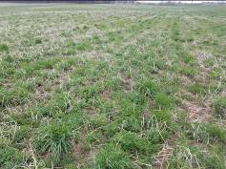
When a drive-over or state-certified scale is not available to measure yield, purchasing alfalfa by the cutting or by the acre may be difficult given the widespread variability in fields in 2021. Focusing time and effort on the three most significant considerations when determining the value of standing alfalfa can help. The buyer needs to estimate as accurately as possible what the potential DM yield may be, and the seller needs to account for reasonable harvesting costs associated with getting the crop out of the field. As discussed earlier, the best option is always to weigh the crop as it is harvested and adjust for DM. However, if that is not an option, walking the fields, estimating stems counts per sq. ft., and assessing overall plant health may help all parties involved arrive at a fair value and avoid later conflict.
Additional Methods for Determining the Value of Alfalfa – Is There an App for That?
Additional methods to calculate the value of standing alfalfa include an app that can be downloaded for free at https://play.google.com/store/apps/details?id=com.smartmappsconsulting.haypricing. Those with iPhones and iPads can download the app from the Apple Store by searching “Hay Pricing”.
April 2021

