“It was so practical, easy to understand, and very worthwhile. It will help you feel more confident when working with volunteers.”

“I highly recommend this to ANY extension staff….” Feedback from Participants
National Professional Development Opportunity:
January 24 – March 14, 2022
Volunteers are fundamental to many successful Extension programs. Research indicates that nearly one third of volunteers will choose not to continue volunteering based on poor management practices. Nearly 600 professional staff have completed the course in the past six years.

Achieving the Extension Mission through Volunteers is an online cohort course for the novice and experienced professional working with volunteers to enhance and deliver Extension programs. It is designed to:
- Build staff and organizational capacity around volunteer management and development
- Increase volunteer management competencies
- Build knowledge and skills to identify, recruit, select, and support volunteers
- Learn current volunteer trends and how they may impact programming
- Understand the organization’s philosophy related to volunteerism and develop your own philosophy

Registration will open September 15 nationwide for Extension staff. A cohort will be 25-35 individuals from across program areas. Space is limited. This course is brought to you by the North Central Region 4-H Youth Development Volunteer Specialists. Course is recommended for staff with at least one year of experience. Experienced staff members have found this very valuable as well. Read the Impact this course is having on colleagues across the country

During this 7-week course members participate in pre-recorded sessions, readings, activities and 3 live webinars, interact with a wide variety of resources and hear from experts. The course is led by a facilitator team. Each module will require approximately 4 - 6 hours each week. Guest contributors include:
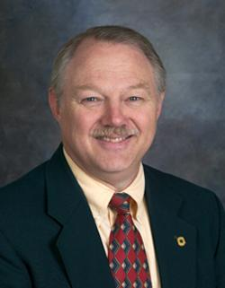
Jim Rutledge, Ph.D., Adjunct Professor and Executive Director 4-H Foundation, Inc. 4-H Foundation
Development Manager at Oklahoma State University (retired)

Dr. Rutledge shares his work on the professional development stages of the Extension professional and helps cohort members discover how THEIR professional development stages influence their capacity to reach larger audiences with more valuable educational programs.
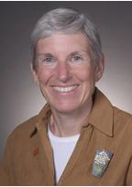
Nancy Franz, Ph.D., Professor Emeritus, School of Education at Iowa State University

Dr. Franz discusses personal, organizational, and public value related to volunteers in Extension. She has done extensive work on Communicating Value and its importance for Extension and its volunteers.
- To learn more watch: https://youtu.be/1HmJ1WJes_I or contact the Volunteer Specialist in your state
- Course Fee $250. Staff who are not from Minnesota need to create a Guest Account to register.
- Click Here to Register (Link available in September)
- Participants will receive detailed course information once registration closes.
- Go to the North Central Volunteer Specialists website for registration and course details.
https://fyi.extension.wisc.edu/ncrvd/achieving-the-extension-mission-through-volunteers-course/

