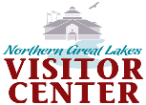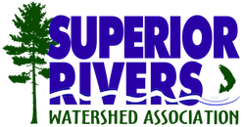[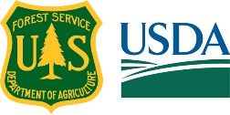](https://www.google.com/url?sa=i&rct=j&q=&esrc=s&source=images&cd=&cad=rja&uact=8&ved=2ahUKEwjZy_-r56XaAhXB51MKHZzFDu0QjRx6BAgAEAU&url=https://www.kcet.org/redefine/why-is-usda-stripping-the-forest-service-of-its-pine-tree-logo&psig=AOvVaw3KytM4uTwoL8_peDrq11yK&ust=1523109307635971)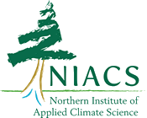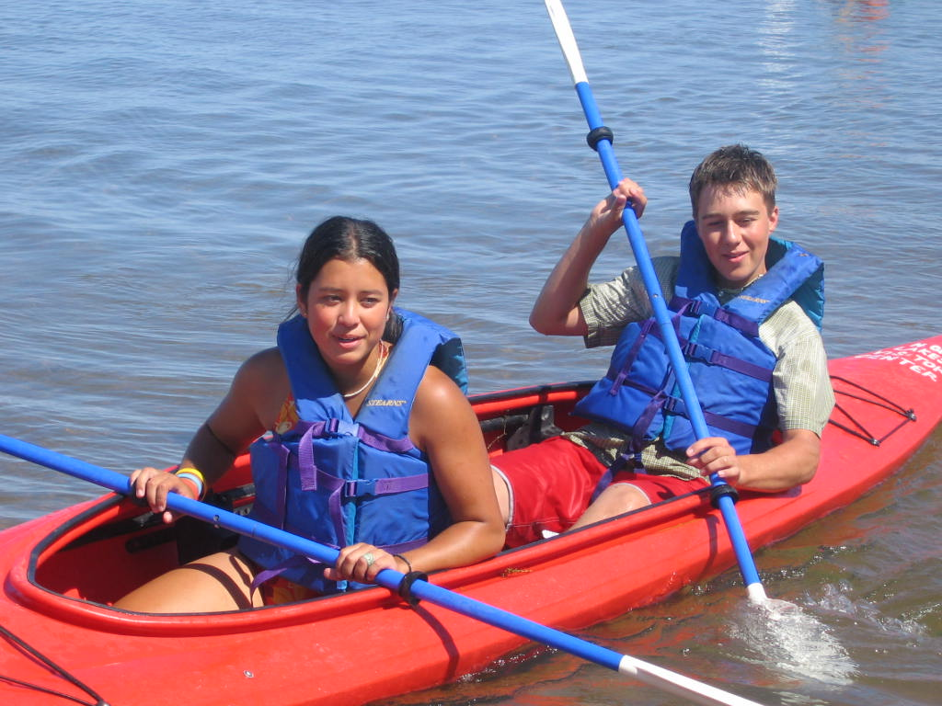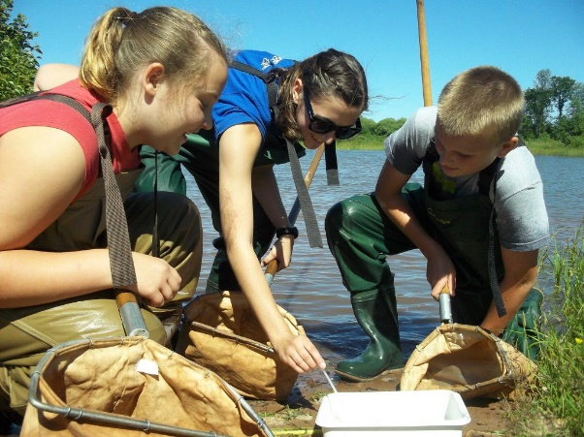

* **Monitor water quality**
* **Sample macroinvertebrates,**
* **Explore the waters by kayak**

**Guided by environmental educators from the US Forest Service, Superior Rivers Watershed Association, and University of Wisconsin-Extension**

**Transportation Scholarships Available**

**For more information or program reservations contact: Susan Nelson-Northern Great Lakes Visitor Center, Phone: 715-685-2644 or email** [**sbnelson@fs.fed.us**](mailto:sbnelson@fs.fed.us)

**Who: This program is open to youth ages 12 and older including school classes, summer camps, youth groups & organizations. Group sizes between 8 to 52 participants are welcome.**

**When: June-October 2018. Program duration = 3 hours. Advance registration required.**

**Where: Fish Creek Estuary and the Northern Great Lakes Visitor Center, Ashland, WI.**

**Cost: Program costs provided by a US Forest Service Youth Engagement grant. Transportation “scholarships” are available. No experience needed. All equipment provided.**

**Why? This program is offered to provide fun, hands-on learning experiences for youth that builds their connection to public lands, forests, and the water.**

**Kids Paddle! Forest to Lake Program**

**Connecting youth with public lands, habitats, and watersheds on Lake Superior’s Fish Creek Estuary, Ashland WI**