Brief Summary of Accomplishments at End of Year Two (2017) for Implementation of Red Cedar River Watershed Plan
Below is a collection of the information, in no particular order, provided by various Partners about their work and accomplishments in 2017 (year two of plan implementation) in the Red Cedar River watershed. This is by no means a comprehensive list, as many Partners do work beyond what can be cataloged or categorized to fit this format, and other events and activities simply went unreported.

John Sippl (NRCS Dunn County)
Cover Crops in Dunn 2016 – 25000; 2017 - 21500 reported to FSA.
Much of the decrease from 2016 to 2017 may be attributable to difficult weather conditions.
Nels Paulson and Alyssa Quilling (UW-Stout LAKES REU) - LAKES REU Project
The LAKES REU project completed another summer with 13 undergraduate students participating in 8 weeks of research focused on phosphorus pollution in the Red Cedar Watershed. This summer was the first year of the grant renewal, which includes funding for an additional three years of summer research. Students completed research projects in Biology, Sociology, Anthropology, Economics, and Geography. The students shared their research at well-attended community forums in Menomonie and Chetek.
Farmers throughout the watershed were surveyed about their land practices, community engagement, and social networks. Education programs are extremely important for encouraging the use of BMPs, especially conferences farmers can attend as part of a group. It is also important to foster social connections between farmers using conventional agriculture and conservation agriculture.
Two of the economics students completed an IMPLAN analysis, modeling the effects of meeting the goals of the Red Cedar Water Quality Implementation Plan. Meeting the goals of the plan would mean 3,060,000 pounds of phosphorus pollution prevented, $2,126,880 saved in soil retention, and $2,221,820 tax revenue generated, as well as the creation of 449 jobs. Considering direct, indirect, and induced effects, it could potentially grow the local economy by $38 million by 2025. A 10% increase in tourism in Dunn and Barron counties, it could bring in an additional $4.6 million and create 70 jobs; a 10% decrease in tourism in Dunn and Barron counties could trigger a loss of $4.9 million and the loss of 100 jobs.
Two other economics students examined the creation and implementation of water quality policies. One student looked at Minnesota’s Phosphorus-Free Fertilizer Law, finding that it does have an impact in reducing phosphorus content in surface waters in Minnesota. It also could have an impact in Wisconsin and the Red Cedar Watershed reducing the amount of phosphorus in surface waters. The other student looked at the difference between manure and commercial fertilizer and their effects on surface water quality. He found that manure (when used properly) is better for surface water quality than fertilizer. A policy promoting the use of manure over fertilizer could have a positive impact on surface water quality.
The anthropology students from this summer studied the importance of community organizations in building capacity for water quality, the complexities regarding the growth of large-scale animal operations, and water quality conversations happening in Chetek, WI. The anthropological research suggests the need to integrate more diverse non-profit organizations into water quality efforts, an opportunity to build an ambitious initiative in Chetek if given the right guidance and engagement of diverse stakeholders. In addition, research on CAFOS revealed 1) the need for regulation of larger farms, 2) the need for policies for smaller farms to manage manure and environmental impacts better, and 3) the status of the built community capacity in Dunn county to collaboratively address this issue.

Tyler Gruetzmacher (Barron Co)
Transect survey showed us at 24% of row crops being no-till planted.
“Farmers of Barron County” farmer-led group sponsored a workshop on soil health held in Ridgeland.

Liz Usborne (St. Croix County)
Below is a map of the 2017 practices in St. Croix County’s portion of the TMDL.
Also, St Croix County’s 2017 load reduction numbers:
Watershed | N Reduction | P Reduction | Sediment Reduction | N Reduction | P Reduction | Sed Reduction
Unit | lb/year | lb/year | t/year | % | % | %
Upper South Fork of the Hay River | 53.25 | 31.08 | 4.30 | 0.03 | 0.10 | 0.13
Middle South Fork of the Hay River | 92.12 | 51.97 | 9.53 | 0.10 | 0.25 | 0.28
Lower South Fork of the Hay River | 262.70 | 181.46 | 0.66 | 0.16 | 0.48 | 0.01
Sandy Creek - Tiffany Creek | 1573.18 | 1046.18 | 33.54 | 0.96 | 3.14 | 0.82
Beaver Creek | 602.16 | 373.58 | 35.36 | 1.06 | 2.99 | 1.75
Total | 2583.41 | 1684.27 | 83.40 | 0.41 | 1.24 | 0.48

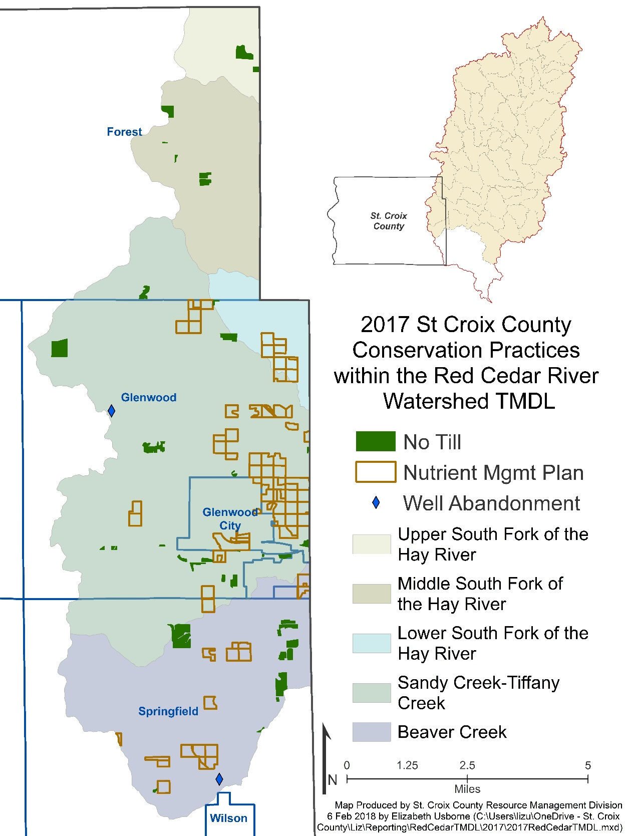

Tom Quinn (Wisconsin Farmers Union) - WFU partnered with the Grazing Network at River Country RC&D to sponsor a series of 10 pasture walks in the region. Four of these were on farms in Dunn and Barron counties and within the watershed. The events provided an opportunity for peer-to-peer information sharing on both grazing management and the conservation benefits that grazing provides. 117 farmers attended these four events. Farmers Union also sponsored a Women Caring for the Land workshop on a watershed farm in Dunn County. This event was sponsored in partnership with the NRCS / Pheasants Forever Biologist Team (which is an all women team), and was focused on providing farm women with an opportunity for an informational workshop and discussion, followed by an on-farm tour of local conservation projects. 16 farm women attended.
Rod Olson (Desair Lake, Rice Lake District)
- Project manager and volunteer for the design and construction of the Rice Lake Beach Walk. This was a collaborative effort between the Rice Lake Lake Improvement District and the City’s Parks Department to build a rain garden at the old City Beach. A $15,000 project was completed to beautify Lakeshore Drive and filter water off the street before it crosses the beach into the lake.
- Designed and helped build a rain garden at the Lake Montanis public landing using volunteers and support from the Rice Lake Town Board. $400 project.
- Built a waterway and lined it with ground cloth and rock on over 2000 feet of a steep grade street. Before this project was done, erosion from this street lead to two truckloads of gravel eroding to Desair Lake every year. $750 of rock and ground cloth was used with all volunteer help from the Lake Association.
- A 200-foot grass waterway was installed on private property to divert field runoff from flooding the yard and basement. $80 in equipment use and volunteer time.
- A 50-foot rock waterway with 150 feet of grassed berm diverted field runoff from eroding a woodlot bank. $100 of rock and erosion control blanket with all volunteer time.
- Power Point presentations on “Getting Soil to Stay Home and not Runoff” was given to students at UWBC Campus.
- Power Point presentation given to Jennie-O Turkey Store staff who manage the farms and environmental maintenance for the company. I presented the value of developing conservation leases for their farm land (over 15 farms) to promote soil health and better water management.
- Stop the Bleeding of Soil from or precious farm fields, “The Soil Health Initiative”
- Use more conservation Band-Aids such as stream buffers and waterways
- Infiltrate Stormwater (let it soak in) rather than sending it downstream
- Use Rain Gardens, wetlands and detention ponds as sponges in our yards, parks and public landings
- The Olson’s purchased an additional 24 acres to add to their planned shoreline conservancy. A long-term management plan is being developed for this area with Barron County.
- Built a rain garden and a 10,000sq ft prairie on private property.
- A member of the Rice Lake Township building committee to help design the new Town Shop and Office with built-in onsite stormwater management.
- Worked with City government, Townships, civic organizations, lake district and lake associations and farming groups promoting soil health and getting water to soak in.

Kris Olson (Chetek Lakes) - Successful year of clp harvesting and algae skimming and fundraising for the continued use of the EcoHarvester (Tm)
Investigation into dredging with farmer coordination and land spreading.
Healthy lakes initiative, site selection for $25k grant app in 2018
Reestablishment of zebra mussel monitoring locations.
Lindsay Olson (data from Hay River farmer led council)
Grassed waterways installed: 5,845ft
Cover crops planted: 1,081 acres
FLC sponsored a workshop in Ellsworth that attracted 35 attendees.
(Further info from Dunn Co Land and Water Conservation)
Dunn County now has 21% of crop acres in nutrient management plans as of December. Some year-end stats: CREP: 17.7 acres of new 15-year contracts and 95.4 acres of renewed 15-year contracts in the watershed equaling the following environmental benefits: P loss reduced in TMDL: 473 lbs, N loss reduced in TMDL: 254 lbs, Sediment loss reduced in TMDL: 222 tons.
Gerry Johnson (Red Cedar Lakes Association)
*2017 represented the last year of Red Cedar Lakes Association's current Aquatic Invasive Species DNR grant. Bed mapping of plants found curly leaf pondweed (CLP) in the normal locations in Balsam Lake, with slight increases in Red Cedar and Hemlock. Hand pulling of CLP resulted in 10 boat loads removed from the north east section of Balsam Lake by students from the Blue Hills Charter School (Birchwood) under supervision of RCLA.board members. RCLA will be returning to herbicide treatment of CLP starting in 2018.
*Water quality monitoring on Red Cedar, Balsam and Hemlock Lakes was conducted monthly by RCLA member volunteers, with results entered in the DNR SWIMS data base. In summary, phosphorous readings were slightly improved in Balsam Lake, but continued to slightly increase in Red Cedar and Hemlock Lakes.
* In early July, students from the Blue Hills Charter School also raised and released beetles in Red Cedar Lake to help control purple loosestrife. This effort was conducted by RCLA and Lisa Burns - Washburn County AIS Coordinator.
* RCLA conducted many hours of boat landing monitoring on holiday and other weekend in 2017, with the help of Boy Scout Troops 29 and 106.The monitoring and boater education efforts has become even more important with the discovery of zebra mussels on in-land lakes in northern Wisconsin in 2016. Zebra mussel plates were placed in several location on all three lakes, with no evidence of infestation in our lakes at this time.
* Buoys, markers and kiosks were updated and repaired on our lakes to provide safety and general information to lake users.
* RCLA sponsored a Nature Program at Lock Lomond Beach Club in June. Nikki Junisin of Hunt Hill Audubon Sanctuary made a presentation on "Wisconsin Butterflies". In addition, RCLA's Nature Committee also was active in loon monitoring as part of the Loon Watch program, conducted a Tree Planting program in conjunction with Barron County Soil and Conservation Dept., and continued promoting the "Get the Lead Out" program for fishermen.
* RCLA shoreline and restoration efforts produced three individual owner projects supported by the DNR's Health Lakes Project. Also, all public islands on our lakes were inspected, with smal lerosion control efforts to be re-initiated in 2018 if approved by the DNR and Barron County Soil and Conservation Dept.

Mark Robinson (Big Chetac and Birch Lakes Association BCABLA)
An overarching objective of the BCABLA at the end of 2016 and throughout 2017 was to obtain a variety of inputs and public comments to create a five-year lake management plan for Big Chetac, Birch and Little Birch lakes from 2018 through 2022. With that goal in mind, a stakeholders committee was formed with volunteers selected from local government boards (Town and Village of Birchwood, and Town of Edgewater), local resorts, BCABLA and RCLA leadership, and lakeshore property owners. Meetings under the direction of consultant/lake educator Dave Blumer (Lake Education and Planning Services or LEAPS – Chetek) were held roughly monthly throughout the year to develop draft goals, objectives, actions, and measurements. The most recent public meeting, held October 28 at Birchwood School’s commons, offered an opportunity for input to a draft lake management plan consisting of the following topics and related sub-topics (titles are shortened): Support a healthy, diverse and sustainable fishery; Maintain or improve water quality; Reduce the threat of new aquatic invasive species (AIS); Balance lake uses; Tracking, monitoring and modification of management strategies; Improve collaboration between public, local governments, WDNR and BCABLA to achieve shared management goals; and, Implement the management plan effectively and efficiently . The detailed draft management plan outline for each of these topics is available at: BCABLA.com.
BCABLA (with LEAPS support) submitted a project request under Wisconsin’s Lake Planning Grant Program that was approved in 2017. Entitled Big Chetac and Birch Lakes WQ, Shoreland and Aquatic Plant Project, LPL164317 was funded by WDNR with a completion deadline of June 30, 2019. Activities supported by the grant include:
- Lake and tributary water quality testing.
- Whole-lake aquatic plant point-intercept survey (cold and warm).
- Shore land habitat evaluation – site, pictures, woody debris, report.
- Fishing success survey (resorts).
- Stakeholder’s committee support.
Graphs and tables of representative data collected over the summer and fall months are listed on the BCABLA web site as part of Dave Blumer’s presentation at a public meeting on October 28, 2017. Noteworthy data include Birch Lake and Chetac aquatic plant surveys showing CLP density and native species richness along with Birch Lake inlet and outlet water quality surveys. Interested parties are encouraged to read the documents online. They may contact Dave Blumer at LEAPS with questions on data collected or proposed inputs to the draft lake management plan.
Ted Ludwig (Red Cedar Basin Monitoring Group)
Continued to sample dozens of sites during ice-off times throughout the watershed. This included 20 stream sites testing for phosphorus, and another 19 for general water quality parameters, and 7 sites on Tainter and Menomin Lakes. In 2017, 66 total phosphorus samples were taken from waters in the watershed, and only 12 met state standards.
Liz Usborne (Tainter Menomin Lake Improvement Association)
Events Coordinated: • Host Guest Speaker Series at the beginning of select monthly meetings • Volunteer at Sharing Our Resources on the Water disabled fishing event with our partners on the Dunn County Conservation Alliance • Organize lake themed check point challenge as part of the St. Valentine’s Day Hustle Bike Race • Facilitate Water Resources 3rd Grade Field Trip for 82 Wakanda students • Answer questions as part of a Community Conversations panel discussion
Collaborative Participation within These Groups: • West Wisconsin Trout Habitat Projects Planning • Wilson Annis Creek Watershed Partnership • Red Cedar Water Quality Partnership for TMDL implementation • Dunn County Livestock Operations Study Group • Joint Sustainable Working Group • LAKES REU (Linking Applied Knowledge in Environmental Sustainability Research Experience for Undergraduates) • Work with UW-Stout graphic design students to develop Lakeside Park rain garden signage
Informational Booths Held at: • Music Over Menomin • Floating Through History: two part presentation at Menomonie library • Clear Lake Earth Day Celebration • 3M Employee Earth Day • UW-Stout Communications Connection (COMMconn) Advisement Day
Support through Advocacy: • Helped Menomonie exceeded the public education and outreach goals outlined in the city’s MS4 (Municipal Separate Storm Sewer System) Stormwater Report • Represent water quality issues at the State Senator Listening Session • Represent water quality issues at the State Representative Listening Session • Represent water quality issues at the Joint Finance Listening Session • Attend Citizens’ Water Lobby Day • TMLIA included as a signer on the letter to the Congressional delegation and State Legislature expressing opposition to the proposed relaxation of phosphorus limits for point sources
Conferences: • Over 400 people attend the 2017 Red Cedar Watershed Conference: Land, Water, & People • Members attend WI Land + Water Annual Conference • Members attend St. Croix Summit • Members attend WI Lakes Partnership Convention
Grants: • TMLIA member and Conagra employee wins Conagra Sustainability competition and awards TMLIA $5,000 • $2,500 3M Grant awarded to expand Lakeside Park rain garden into interactive outdoor museum • TMLIA continues to participate in Civic Governance training to better empower watershed citizens
Andrew Norman (West Wisconsin Land Trust)
WWLT acquired a plot of land in the Red Cedar (known as the Russian Slough) that was purchased with assistance from the WDNR Knowles-Nelson Stewardship Grant. The property will be open to the public and managed by WWLT.

