Certificate of Completion
of the

Strengthening Families Program
presented to the
Smith Family
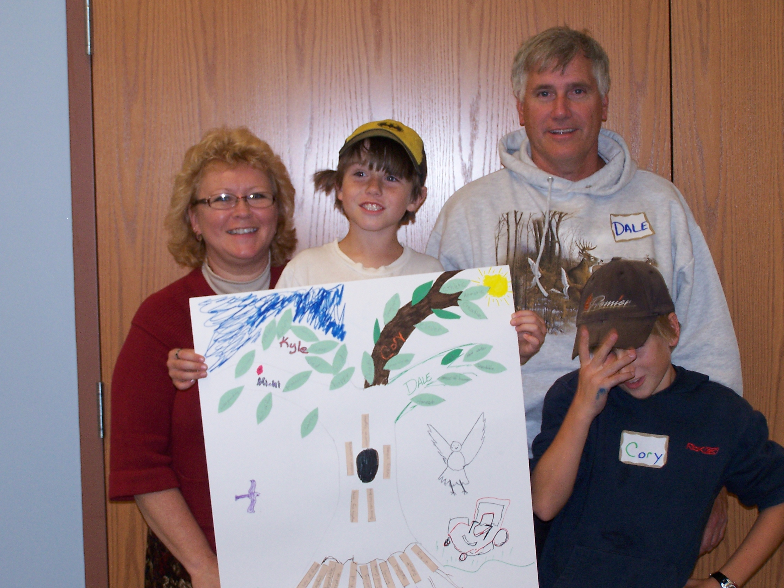

This award is given in recognition of skills gained by youth in handling stress and peer pressure, and by parents/caregivers in offering support and setting limits.


Pam Peterson , Gina Wautier, Katie Miller
November 4, 2012

