Register now for Strengthening Families Program in Neshkoro
An enjoyable seven-week program for parents and youth ages 10-14

Strengthening Families Program is for you if your child is age 10-14. Do you sometimes worry about their behavior or choices, or wonder how they will handle peer pressure? Would you like to tone up your parenting skills, prevent conflict, or improve your family atmosphere to ensure your child has the best chance to develop strong, positive life skills? Or just maybe it would be nice to relax and learn as a family, having someone else prepare, serve and clean up a nutritious family meal each week.

Strengthening Families Program produces positive results that are proven to work. Families in Marquette County say it is “Informative, fun, interactive and a good experience.” “I got the chance to talk to other parents and remember that we are not the only ones with these struggles.” “How great - it has helped me and my child. We are way better people.” “Take it if it’s available. Really helped me!” “It was our daughter’s idea that we attend and we decided to make it a priority. It was a good decision!” “Good fun. Take the class.” “Even if you think you know everything about raising your children, this program will open your heart & mind even more. It is an amazing program.”

All kinds of families are invited to register – single-parent, two-parent, foster, adopted, blended, and step. You and your family will:
* eat dinner together and enjoy family activities
* learn useful, tested tools for getting along and helping each other
* pick up new communication and coping skills
* understand setting and keeping healthy boundaries
* get to know each other better while having fun
* feel more relaxed as a family

The program is one Thursday evening per week starting Thursday, March 21st and ending May 9th at the old Neshkoro Elementary School. But you need to register by Thursday, March 14 so we can arrange family meals and child care, which are provided at no cost to you. Moose Inn, Wautoma, will be catering the meals. For complete details, call 608-297-3141. We can answer your questions, send or email you a registration brochure, or you can view or print it from http://marquette.uwex.edu/

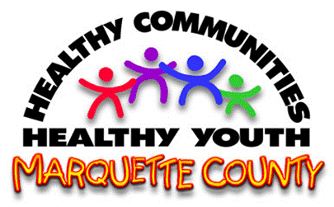
This program is brought to you by Marquette County UW-Extension Family Living and Healthy Communities Healthy Youth (HCHY). UW-Extension provides equal opportunities in programming, including ADA requirements. Please make requests for reasonable accommodations to ensure equal access to educational programs as early as possible before the scheduled event.
#####

