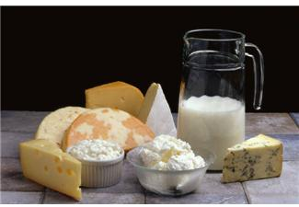
Grant Programs and Financial Options

for Farmers & Food Entrepreneurs

Are you looking for ways to develop your

innovative agricultural business?

Join us for a workshop designed to help you identify which grants or other financial options might be right for you. This workshop will discuss ways to plan your project and strengthen your application. Specific grant programs to be covered include:

- USDA’s Value Added Producer Grant (VAPG) program provides planning and working capital funds to farmers and farmer-based enterprises to develop and implement value-added ventures.
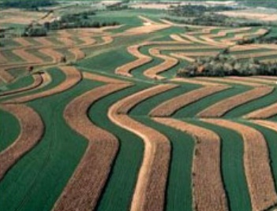
- USDA’s Sustainable Agriculture Research and Education (SARE) grant program funds research, marketing and demonstration projects.

- USDA’s Specialty Crop Block Grant (SCBG) program funds endeavors that enhance the competitiveness of Wisconsin Specialty Crops

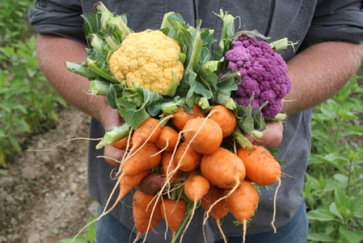
- Wisconsin DATCP’s Buy Local, Buy Wisconsin (BLBW) grant program funds projects that increase the demand for and supply of locally produced foods in Wisconsin.

Dates and Locations

Thursday, September 17th – Western WI - Hixton
Club 95, 101 Sand Prairie Road N., Hixton, WI 54635
to register contact: Trisha Wagner at trisha.wagner@ces.uwex.edu or
Jackson County UW Extension at (715) 284-4257

Friday, September 18th – Northern WI - Merrill
Lincoln County Service Center Room 255, 801 N. Sales Street, Merrill, WI 54452
To register contact: Dan Marzu at daniel.marzu@ces.uwex.edu or (715) 539-1072

Wednesday, September 23rd – Southeastern WI – West Bend
Wellspring Conference Center Lower Level, 4382 Hickory Rd, West Bend, WI 53090
To register contact: Mary Ann Ihm at wellspring@hnet.net or (262) 675 -6755

Wednesday, September 30th – Southwestern WI - Platteville
UW-Platteville Markee Pioneer Student Center, University North room, University Plaza 1, Platteville, WI 53818
To register contact: Amy Seeboth at seebotha@uwplatt.edu or (608) 342-7244

registration fee of $15 will cover the cost of lunch and materials
If you are interested in attending but need translation assistance,
please inquire with the local registration contact at each location.
Successfully Applying to Agricultural Grant Programs
2015 Workshop Agenda

This workshop is designed to give farmers and agricultural entrepreneurs information, tools, and hands-on training to strengthen grant and loan applications. This workshop will help you create a competitive application and get the financial resources you need to fuel your business.

9:00 AM Registration

9:30 AM Welcome and Introductions
Participants are invited to give a brief introduction to their projects
Andrew Bernhardt, UW-Extension/SARE

10:00 AM Designing a sound project, identifying funding sources and grant-writing basics
Margaret Krome, Michael Fields Agricultural Institute

12:00 PM Lunch

12:30 PM Lunch Program – Perspective from a grant recipient:
“How I applied for and used a grant in my agriculture business”

1:15 PM Grant Programs Highlight Panel
      - WI DATCP Buy Local, Buy Wisconsin – Teresa Engel
      - USDA Specialty Crop Block Grant – Juli Spek
      - USDA Value Added Producer Grant – Mike Daniels
      - USDA SARE Farmer and Rancher Grant – Andrew Bernhardt

2:00 PM Hands-on Grant Proposal Evaluation & Development
- Review and evaluate an actual proposal in groups.
Andrew Bernhardt, UW-Extension/SARE

3:00 PM Additional Financial Options Panel
- Farm Service Agency – Farm Loans & Micro-loan Program
- Natural Resources Conservation Service – Cost Share Programs
- Farm Credit System Bank – Loan Program

3:45 PM Networking and one-on-one Q&A with presenters

4:00 PM Adjourn

Partners:
Michael Fields Agricultural Institute USDA, Rural Development USDA, SARE UW-Cooperative Extension
WI Department of Agriculture, Trade and Consumer Protection

---
An EEO Affirmative Action Employer, University of Wisconsin-Extension provides equal opportunities in employment and programming, including Title IX and ADA requirements.

