Visual Archery Instructions
Whistle Commands | Proper Archery form/technique
- Get Ready!  (2 whistles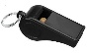 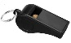)  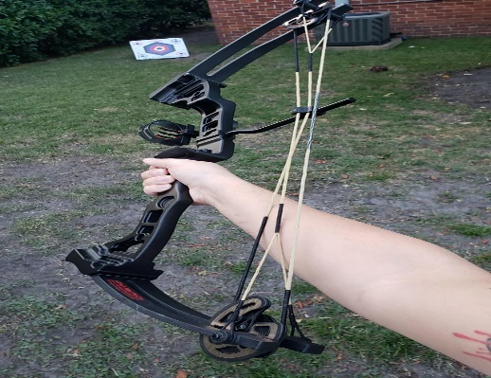 | Step 1: Determine eye dominance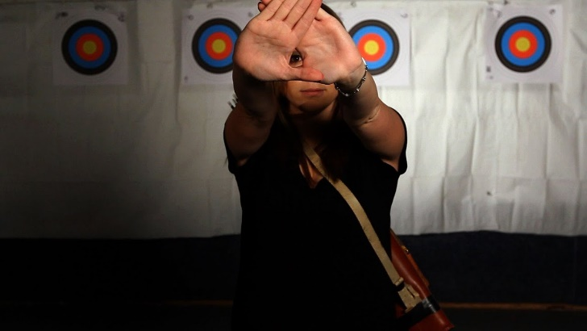
- FIRE!  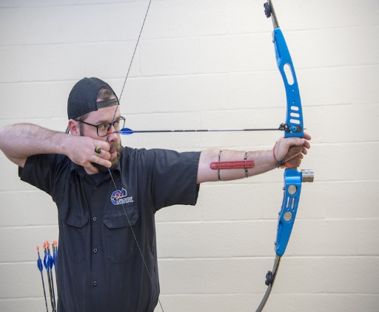  (1 whistle ) | Step 2: Proper Grip/Hand placement
 | 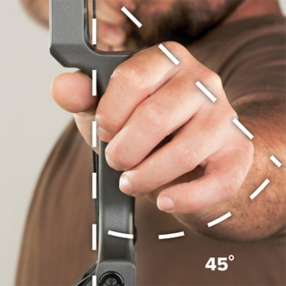  Front hand placement | 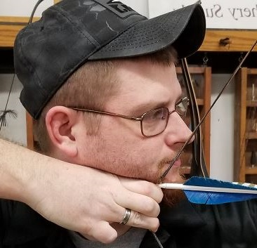  Back hand placement
- Grab Your Arrows!  (3 whistles ) | 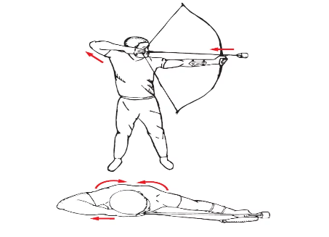  Step 3: Drawing the bow  