BEHAVIOR CHANGE PLANNING TOOL: Educating About Behavior and the Environment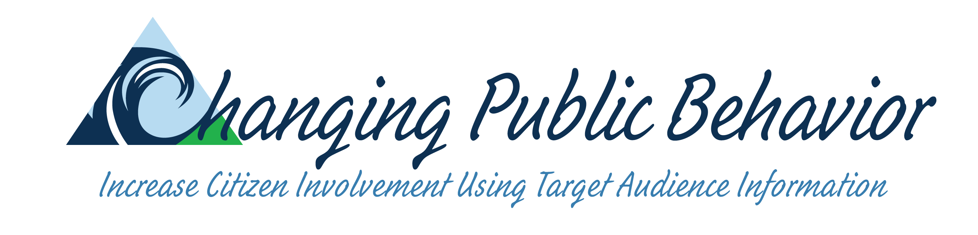
Use this worksheet to: a) Set measurable and achievable goals; b) Identify the audience and develop audience information; c) Identify outreach techniques unique to the problem and each target audience.
While it’s important to complete each step, results of any one step often take you back to a previous step to provide more detail or clarity.

STEP 1 – Assess and describe the problem or opportunity in cooperation with stakeholders, key informants, and experts:  _________________________________________________________________________________  _________________________________________________________________________________ |  |  |  |  |  |  |  | STEPS 2 & 4 – Audience  2. Identify and engage in a preliminary dialogue with the potential target audience(s) and secondary audience(s) in cooperation with stakeholders, key informants, and experts.  4. Collect and analyze information about each audience relative to the proposed behaviors. Consider current behavior, perceived consequences, barriers, social norms, knowledge, skills.
STEP 3 & 5 – Behavior change analysis  3a. Describe the preferred environmental practice that could have an impact on the environmental problem. Integrate advice from experts, stakeholders, and key informants.  3b. Outline single behaviors required to implement the environmental practice. An ideal behavior is a single, observable action that experts consider people need to perform in order to reduce or help resolve a specific environmental problem.  5. Assess potential for adoption of single behaviors and potential for adoption of the environmental practice. |  |  |  |  |  |  |  | STEPS 6 & 7 – Identify relevant outreach/education strategy  6. Compare audience information with single behaviors. Select behaviors with potential for adoption.  7a. Use audience information to craft one or more audience specific outreach or education techniques to address selected behaviors.  7b. Monitor and evaluate.
 | 2. Primary audience: _________________________________  Secondary audience: ______________________________ |  |  | 5. Rate potential for behavior change  Is it likely that the user will adopt the behavior? [yes, maybe, don’t know, no] |  |  |  |  |  |  | 6. Select recommended behavior(s) | 7. Describe outreach or education strategy. Use audience information.
 | 3a. Environmental Practice  Describe the practice that a specific audience can implement to address the environmental problem. | 3b. Single Behaviors  Outline steps to accomplish the environmental practice. What does the audience need to be able to do? | 4. Audience Information  Identify and understand “segments” of the relevant population. What does the audience already do relative to the preferred behavior? Are there barriers? What are audience skills/ interests/ needs? | Does it meet an audience need or address an interest? | Does it have an impact on the problem? | Does it provide users with an observable consequence? | Is it similar to what the user does already? |  | Is it simple for the user to do? | Is it low cost in $, time and energy for the user? | Select behaviors that have potential for adoption. Revise problems statement and target audience selection, if necessary. | - Ask for a commitment?  - Provide a specific prompt, near behavior?  - Communicate the norm?  - Remove barriers?  - Provide information?  - Increase skills?  - Engage in a problem-solving activity?

DEFINING SINGLE BEHAVIORS – Leading to an environmental practice |  | PUTTING YOUR EDUCATION STRATEGY INTO PRACTICE – Sample techniques
Hints for defining each single behavior |  | Using commitment to promote behavior
1. Define the environmental problem and the overall objective of the communication or outreach program. Refer to these ideas as you develop your list of single behaviors that will lead to the preferred environmental practice. |  | Waste reduction • ask household, when delivering a compost unit, to place a sticker on the side of their recycling container indicating that they compost
2. Identify target audiences. Primary audiences are people who perform the behavior. Secondary audiences are people who influence the primary audience. |  | Energy conservation • invite homeowners to participate in a home assessment; conclude by asking when they expect to complete activities such as weather-stripping
3. Express ideal behaviors as:  a) what the primary audience should do, not what should be done for them c) single, observable events  b) specific behaviors (begin with an action verb) d) one behavior per statement |  | Water conservation • ask households to sign a pledge committing themselves to watering their lawn on odd or even days based on their house number
Sample environmental practice: managing household waste |  | Using prompts to promote behavior
Identify ideal behaviors. For example, ideal behaviors for managing waste might include:  a) separate recyclable containers, paper, hazardous materials, and organic materials from other trash  b) store each type of material in separate containers  c) put out appropriate materials on the correct pick-up day  d) compost organic garbage and take hazardous materials to the appropriate collection site |  | Waste reduction • signs at the entrances to supermarkets remind shoppers to bring reusable shopping bags
 |  | Energy conservation • signs encourage drivers to turn off engines while parked in locations where drivers frequently wait (schools, train stations)
 |  | Water conservation • ask homeowner for permission to place a tag on the outside water faucet encouraging watering on odd or even days
Developing the education strategy |  | Using norms to promote behavior
1. Compare “doers” and “non-doers.”  What specific factors make one adopt a practice and the other not?  2. Identify skills and performance deficits.  Do people refrain from a practice because they don’t know how to do it or because of other factors, such as access to appropriate technology or lack of awareness of positive consequences?  3. Address skills deficit.  Develop strategies which provide skill information or teach necessary skills.  4. Address performance deficit.  Identify strategies that reduce barriers and increase positive consequences.  5. Conduct quantitative research.  Study results of education program with a sample of the target audience. Determine applicability of study sample to larger audience. Fine tune recommendations.  6. Conduct behavior trials. |  | Waste reduction • ask supermarket shoppers to wear a button that shows their support for buying products that are recyclable or have recycled content
 |  | Energy conservation • in stores, attach decals to energy-efficient products indicating how many people believe it is important to purchase environmentally friendly products
 |  | Water conservation • to encourage odd/even watering, ask householders to place a sign on their front lawn that asks “Are You Odd or Even?”
 |  | Remove barriers to behavior
 |  | Waste reduction • it is difficult to identify products that are recyclable or have recycled content. Solution: provide prompts that make identification easier.
 |  | Energy conservation • homeowners lack the skill to install energy-efficient devices. Solution: use home assessment opportunities to instruct homeowners.
 |  | Water conservation • it is too expensive to install a low-flow toilet. Solution: allow the cost of the toilet and installation to be paid for from savings in the water bill.

EDUCATING ABOUT BEHAVIOR AND THE ENVIRONMENT WORKSHEET was developed by Elaine Andrews, University of Wisconsin Extension. June 2006
Adapted from Starting With Behavior, Elizabeth Mills Booth, 1996; Promoting a Sustainable Future, Doug McKenzie-Mohr, 1995; Understanding and Influencing Behaviors: A Guide, Bruce Byers, 2000

