2019 Youth as Partners in Civic Leadership Conference

Friday, November 8th
1:00-3:00: Check in & Icebreakers- Get Checked In & Settled In
3:00: Welcome by Governor Jordan Blue- Welcome & Group introductions
3:30-4:30: Program Showcase- Share and get to know the other teams
4:30-6:00: Camp Tour Scavenger Hunt- Get familiar with the camp
4:30-6:00: Adult Leaders Orientation/Meeting
6:00-7:00: Dinner
7:15-8:15: Keynote Speaker-Rep. David Bowen
8:15-9:15: Healthy Living Roundtable
9:15-11:00: Recreation Time- Dance, board games, bonfire, networking space
11:00-11:30: Cabin Talks- Setting the Norms of the cabins
11:30: Curfew
12:00: Lights Out

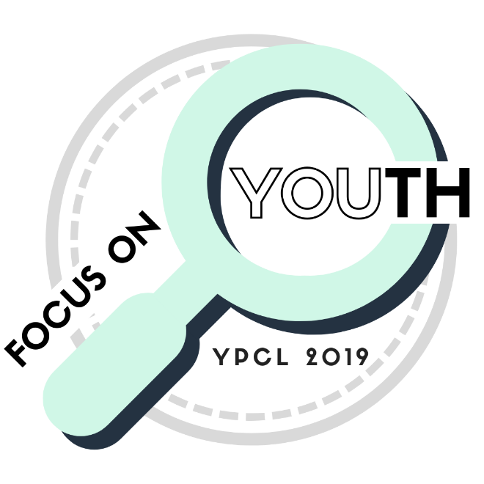
Saturday, November 9th
8:00-9:00: Breakfast & Morning assembly- Review the day ahead
9:15-10:15: Healthy Living Workshop (selection on back)
10:15-10:45: Mindfulness break – Relaxation in cabins
10:45-11:45: Advocacy Workshop (selection on back)
12:00-1:00: Lunch
1:00-2:00: Rec Time #1- Choose an activity
2:15-3:15: Rec Time #2- Choose an activity
3:30-5:00: Action Planning- Work within your groups on projects in your youth groups.
5:10-6:00: Advocacy Roundtable
6:00-7:00: Dinner
7:00-7:30: Talent Show Preparation- Relax in cabins & prepare for the talent show
7:30-9:00: Talent Show
9:00-11:00: Recreation Time- Dance, Bored games, Bonfire, networking space
11:30: Curfew
12:00: Lights Out
Sunday, November 10th
7:00-8:00: Clean & Move out of cabins
8:30-9:30: Morning Assembly- Action plan presentations, Capstone Panel Discussion, and YPCL Planning Committee Selection
10:00-11:00: Brunch
11:00-11:30: Closing assembly- Slideshow recap of YPCL 2019 & Goodbye/depart

Friday Night Roundtables- Group discussion focused on a specific topic and that allows all to share thoughts and feelings about that topic. Very organic in nature. Propose your own or attend one of these:

- Mindfulness-What is it?
- Hunger & food Insecurity
- Trauma + Youth Engagement = ? Does Technology Help or Hurt...

Healthy Living Focused Workshops, Saturday 9:15 – 10:15
Discovery Dating…it’s about more than just dating! End Abuse Teen Council Lower Dining Hall
One way to understand healthy relationships is by getting to really know yourself and what YOU want for your life. We'll do an activity from Discovery Dating, a curriculum that helps explore our lives, determine our own values, and figure out how to align our values with others, friends, family, and more!

Be YOUnique - A Focus on Self Acceptance, WING State Teen Panel Birch Cabin Left
As Dr. Seuss once said, “Today You are YOU, that is truer than true. There is no one alive who is youer than YOU.” Join in an in-depth search of being yourself as you will discover how to put the YOU in uniqueness & show the world what you’re made of.

Using Digital Apps to Share Your Voice, UW-Madison and Bayview Foundation Birch Cabin Right
Explore how digital technologies promote youth voice. What sorts of apps and technologies are currently out there? What should you be mindful of? What is photo journalism? Learn a free and available tool for youth voice (SIFTR, created by UW field day lab). Share your perspective on using these platforms to promote advocacy and how can we get youth excited about youth advocacy using these tools.

Who We Be, Urban Underground Lodge
This introductory workshop covers the basics of identity and community. Through sharing their own experiences, participants will discuss stereotypes, divisions between communities, and the systems of oppression. Objectives include: 1) understand how our identity shapes our experiences in the world. 2) understand how systems of oppression are connected to our experiences. 3) explore our experiences with stereotypes, discrimination, and assumptions. 4) discuss how we can use our experiences to fight against all forms/systems of oppression.

Advocacy in Social Justice Workshops, Saturday 10:45-11:45
Using Digital Apps to Share Your Voice, UW-Madison and Bayview Foundation Birch Cabin Right
Explore how digital technologies promote youth voice. What sorts of apps and technologies are currently out there? What should you be mindful of? What is photo journalism? Learn a free and available tool for youth voice (SIFTR, created by UW field day lab). Share your perspective on using these platforms to promote advocacy and how can we get youth excited about advocacy using these tools.

Julie through the System, Urban Underground Lodge
Explore juvenile justice through an interactive and information-filled session.

The Skills They Need, Rusk County Youth Council WAC Lower Dining Hall
This presentation will focus on building presentation skills and confidence while trying to get your message out.
