4-H/NRA JUNIOR AIR RIFLE 23rd ANNUAL SECTIONALS & NQE
QUALIFYING STATE EVENT
SPONSORED BY Chippewa County 4-H Shooting Sports
_____ 3 Position Sporter …60 shots NQE-Wis. 4-H National Qualifying Event
_____ 40 Shots Standing

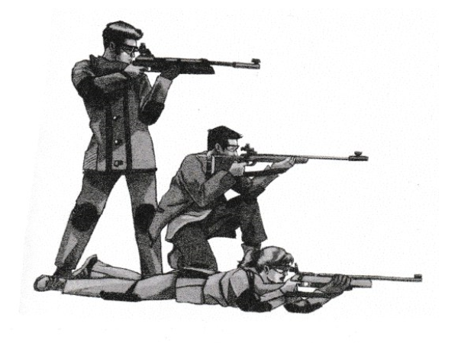
Chippewa County 4-H Shooting Sports is sponsoring a
4-H/NRA Indoor Junior Air Rifle Sectional April 4, 17 & 18 at the Westgate Sportsman Club, Eau Claire, WI.

NRA Junior Sectionals are held all across the country using the same exacting NRA rules. When all the sectionals are completed, the results are sent to the NRA, and a “National Championships Results Bulletin” is published. This allows participants to see how they compared to all the air rifle shooters in the nation. The Orion computerized scoring system is used.

Because of the nature of 4-H, which is formed around youth, not sports, 4-H Shooting Sports is at entry and intermediate level shooting. This tournament is a chance for 4-H shooters, who are “into” shooting sports, to move up and compare
themselves to other “like” shooters.

The registration fee is $15.00 for air rifle and $10.00 for 40 Shots Standing. Also, NRA AFFILIATION IS NOT REQUIRED. Your group can register as a four-person team at $10.00, for team sectional awards and for National Team placings in 3 position. This can be done the day of the shoot. Call Joe if you have questions. Fee includes a wildlife component with awards.

LOCATIONS: On April 4, 17 & 18 held at Westgate Sportsman Club, Eau Claire, WI – GPS: 4909 Sportsman Dr. N., Eau Claire, WI 54703.

- AWARDS -
AWARDS: NRA provides gold, silver, and bronze medallions to top overall finishers in each event as well as to the top team. Chippewa County 4-H Shooting Sports will provide medals to place finishers in each of three age categories, as well as for each of the shooting positions in each of the three age categories.

EQUIPMENT: All equipment will be checked to meet official NRA rules and regulations.

Return the attached registration form by March, 30, 2020 to Joe Tiry, 34075 County Hwy. O, Stanley, WI 54768.
For more information, call Joe Tiry at (715) 644-2538, cell: 715-379-1071, OR E-mail: jtiry@centurytel.net.

NOTE: Chippewa County 4-H is hosting the NRA Sectional and the Junior Olympic on the same dates. You may shoot one or both tournaments, but each is shot separately, with its own score and rules.

4-H/NRA JUNIOR AIR RIFLE SECTIONALS & NQE QUALIFYING STATE EVENT

Sponsored by Chippewa County 4-H Shooting Sports

REGISTRATION AND PERMISSION STATEMENT
April 4, 17 & 18, 2020

Name of Shooter_______________________________________E-mail address_____________________________
**MAKE SURE EMAIL ADDRESS IS LEGIBLE AND CURRENT**
Address__________________________________________City, State, Zip_________________________________

County/Shooting Club_________________________Date of Birth__________Telephone______________________

Current Age as of Date of Relay _____
Please mark first and second choice for shooting time.
CONFIRMATION OF SHOOTING SECTIONAL TIME WILL BE HANDLED BY E-MAIL.
Saturday, April 4: _____10:00 a.m. OR _____ 12:30 p.m.
Friday, April 17:_____7:00 p.m. Saturday, April 18: _____10:00 a.m. OR _____12:30 p.m.
(All Shooters should be at the site 45 minutes prior to shooting time.)
“SPONSOR RESERVES THE RIGHT TO ADD OR ALTER RELAY TIMES ACCORDING TO REGISTRATION NUMBERS.”

Shooting Class: Shooters may shoot in more than one class; please include appropriate fees.
_______Sporter Class 3P 60 Shots ($16 fee) _______40 Shots Standing (Air Rifle Sporter; $10 fee)
***PLEASE USE A SECOND FORM FOR SECOND EVENT!
TOTAL FEES ENCLOSED: _____________

Age Group - Check one: NRA age designation.
_______ Sub-Junior – born in 2006 or later
_______ Intermediate Junior – born in 2003, 2004, 2005
_______ Juniors – born in 2000, 2001,2002

My NRA Competition Number is: ______________________________
Your competitor number will be asked for when you sign in on the day of the sectional. One of the following will apply:
- If you are an NRA member, give your membership number.
- If you are NOT an NRA member, but have shot in a sectional before, the NRA computer assigned you a number. If you don’t know it, please call: Competitor’s Liaison at the NRA, 703-267-1468 and they will find your number. (PLEASE NOTE: this is not your CMP number)
- If you have NEVER shot in an NRA sectional before, you don’t have a number; just leave this blank and the computer will automatically assign you a number for the next time you shoot.
This number is used in the NRA National Shooter Classification System.

I hereby give permission for my child to be involved in the 2020 4-H/NRA Junior Air Rifle Sectional. I understand that my child will be shooting air rifles at a rifle range using NRA rules.

I release the University of Wisconsin-Extension, its employees and volunteer 4-H leader(s) from any financial responsibility for sickness or accident to my child while in transit to or from, and in attendance at this Shooting Sports event. I hereby authorize the event’s responsible person to incur expense considered necessary to insure prompt attention in case of serious sickness/accident. I agree to pay for necessary expenses incurred, if this is not covered by an accident/sickness insurance policy.

I understand that I must provide adequate eye protection for my child with safety glasses. I also understand that all 4-H and NRA range and safety rules will be followed.

I release any pictures/videos taken at this tournament to be used for educational/media purposes.

Additionally, I hereby give consent to the officer in charge to use reasonable disciplinary action with my child while at the shoot, if needed. This can include disqualification or removal from the grounds.

_________________________________ _______________________________ ______________
Signature of Parent/Guardian Signature of Shooter Date

RETURN BY March 30 with a check payable to: CHIPPEWA COUNTY 4-H SHOOTING SPORTS

ADVANCED REGISTRATION HELPS IMMENSELY TO MAKE THE SHOOT RUN SMOOTHLY, ON TIME, AND INSURES A SHOOTING LANE WHEN YOU GET TO THE SHOOT.

MAIL TO: Joe Tiry, 34075 County Hwy “O”, Stanley, WI 54768

