Building Strong Relationships Across Difference
IMPORTANT TIPS FOR POSITIVE CROSS-CULTURAL COMMUNICATION
As we work towards culturally inclusive and open relationships, there are some key issues to remember. Differences in culture and values aren’t things that need to be “fixed;” rather, it is the responsibility of everyone to work towards a mutual understanding of one another. As you do so, be willing and open to challenges; it is at the edge of our limits where we experience the most growth. If you feel angry, upset, or afraid, take a step back and examine your feelings before you become defensive or critical. Be willing to listen to others talk about their experiences without taking it personally and listen attentively even if the message is difficult to hear.
- Recognize your own privileges in different dominant groups. Rather than feeling ashamed or guilty about your privileges, use them to empower others who aren’t privileged in the same way.
- Be willing to share your story. It will help others gain an insight into who you are and the experiences that have shaped you. When you have the courage to share your own story, you can help others to be brave enough to discuss their paths in life. Once we have these insights about one another, we can begin to build a sense of trust and empathy.
- Keep a sense of humor through your journey. Conversations about diversity can be emotionally charged and sometimes difficult. Humor can serve to unite us and lighten the mood when times are challenging.
- Be aware of your own personal boundaries during conversations about difference. Multicultural growth can redefine and challenge the way you see the world and the things you value. This process can be very powerful and unsettling, so stay committed to your own growth and safety throughout.
- Strive every day to be honest and build trust with others. So much of what we don’t know about others comes from a place of fear, which isn’t helpful to building positive relationships. Honesty can feel scary and vulnerable, but is essential to developing trust.

- Limit assumptions. When you insist that you truly understand what someone is experiencing or how he or she feels, you may actually make that person feel invalidated. We can never know exactly what someone experiences; we can only strive to empathize with them and be open to hearing their story.
- Learn from missteps. When you model compassion with yourself and the ability to acknowledge that you are imperfect and sometimes make mistakes, you leave space for others to do the same. Multicultural growth is not a final destination; rather, it is an ongoing journey that can sometimes be slower and more difficult than anticipated. Despite the challenges, maintain your commitment to changing.
- Understand that conversations may not get neatly wrapped up. Relationships between people, especially those who come from different cultures, require ongoing discussions where individuals share their feelings, are open with one another, and explore new territory together. Even though it may be difficult, stay committed to the relationship and give it the time and effort it deserves.
- Remember language can be powerful. Certain words have historically been used or continue to be used to keep some groups oppressed. Though we use language as our primary way of communicating with one another, it has also been used to maintain systems of power, prejudice, and bias. Be aware of how the words you say can hurt others as well as bring healing in relationships.
- Align behaviors with spoken intentions. Be the person who follows through on promises and is open to feedback from others. Doing so will help you build trust with others.

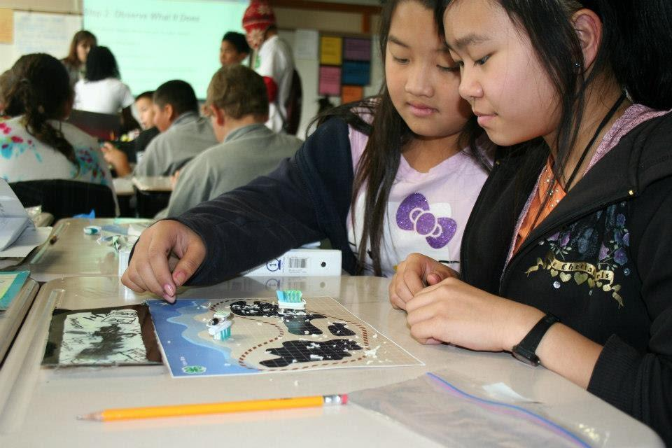

Adapted from “Tips for Building an Authentic Mentoring Relationships across Differences.”
Ready to Go: Mentor Training Toolkit. East Lansing, MI: Michigan State University Extension.

