The Tree Model of Culture
The Tree Model of Culture:
A tree model is one way to think about dimensions of culture and how they can interact. Like trees, cultures come in a wide variety and are continually growing and changing—adapting to ever-changing environments. A culture has some parts that you can observe through many senses “above ground.” At the same time, important foundational aspects of culture are not observable; these roots are “below ground”—usually primarily out of our awareness—and yet have a profound connection to each part of the whole.

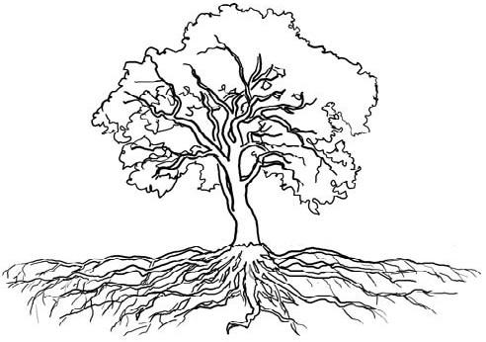
Below Ground (primarily out of our awareness): Ordering of time; preference for competition or cooperation, arrangement of physical space; rules of descent; relationship to animals; ideals governing child raising; patters of superior/subordinate relations; courtship practices; conceptions of justice, of past and future, of beauty, of cleanliness, of status mobility, and of “self”; notions of logic and validity, of adolescence, of modesty, and of leadership; tempo of and incentives to work; patterns of group decision-making; attitudes to the dependent; theory of disease; approaches to problem-solving; roles in relation to status by age, sex, class, occupation, kinship, etc.; nature of friendship; patterns of handling emotions; definition of insanity; conversational patterns in various social contexts; social interaction rate; and more.
Above Ground (primarily in our awareness):
Dress, fine arts, literature, drama, classical music, popular music, folk-dancing, games, cooking, social interaction preferences

Definitions of Culture:
The concept of culture has many definitions. Here are two good ones:
- More than traits, values, customs, artifacts and institutions. It is also a way of being, thinking, organizing knowledge, reasoning, problem solving, valuing past, present, and future; and relating to others.
- Culture is the collective programming of the human mind that distinguishes the members of one human group from those of another. Culture in this sense is a system of collectively held values.
Culture with a big “C” (Culture) includes dance, food, lecture, classical music, cultural systems; cultural institutions among groups of people; these things can usually be seen. Culture with a little “c” (culture) includes subjective behaviors and values within a culture which are not observable from the outside. These relate to the above and below ground parts of the tree model.
As we work towards culturally inclusive and open relationships, remember that differences in culture and values aren’t things that need to be “fixed.” Rather, it is the responsibility of everyone to work toward a mutual understanding of one another. See the handout Building Strong Relationships across Difference for more tips on cross-cultural communication.

Items in and out of awareness adapted from AFS Intercultural Programs, Inc. (1984) American Field Service Orientation Handbook, 4, p. 14.
Mestenhauser, J. (Spring 1998). International education on the verge: A search for a new paradigm. International Education, 7(2-3), pp. 68-76.
Hofstede, G. (1991). Cultures and Organizations: Software of the Mind. New York, NY, McGraw-Hill.
Bennett, M. (1998). Better Together than A-P-A-R-T at the Summer Institute for Intercultural Education. [Video]. Developed by Heidi Haugen, Extension Educator

