Shared Definitions
Assumption:
Something that is taken for granted or accepted as true without proof.
Cultural Competency:
The ability to work and respond in a way that acknowledges and respects an individual's cultural customs, attitudes, values, and behaviors.
Cultural Identity:
How one sees oneself in relationship to others; influenced by how a person grows up and the social context he or she lives in.
Cultural Institutions:
Societal institutions that transmit and maintain rules and norms. They include: 1) government, politics, and law; 2) financial and corporate institutions; 3) health and medicine; 4) media, entertainment, and the arts; 5) peers and community; 6) military; 7) social services and prison; 8) education 9) religion; 10) family.
Cultural Relativism:
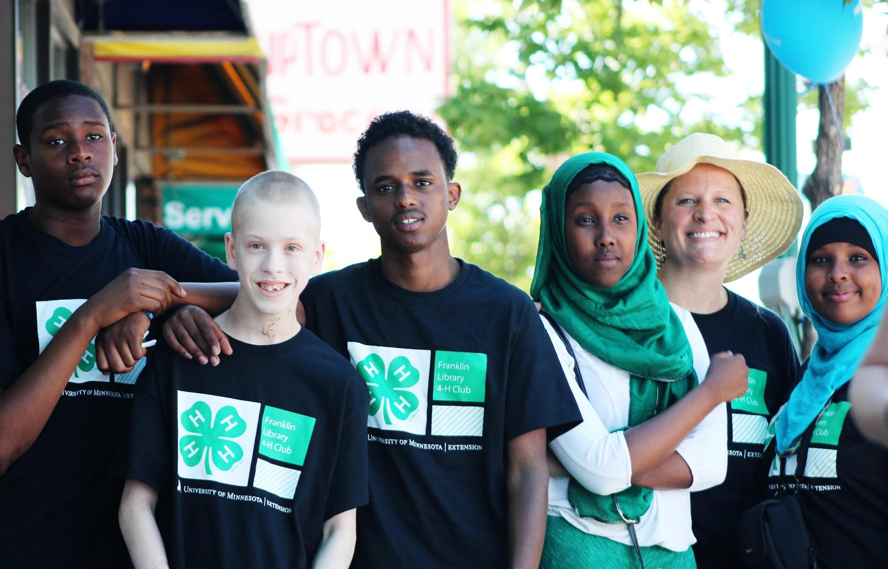
The perspective that the behavior in one culture should not be judged by the standards of another.
Culture:
More than traits, values, customs, artifacts, and institutions. It is also a way of being, thinking, organizing knowledge, reasoning, problem solving, valuing the past, present, and future, and relating to others.
Discrimination:
The unfair treatment of a person or group on the basis of prejudice (an action). Under civil rights law, unlawful discrimination includes: Race, Color, Sex, Creed, Disability, Religion, Ancestry, Age, Sexual Orientation, Pregnancy, Marital or Parental Status, and National Origin.
Diversity:
Differences between people that may be obvious (e.g. skin color, eye color, hair, clothes, appearance) as well as differences between people that may not be obvious (e.g. personality, heritage, education, values, worldviews).
Dominant Culture:
A group that determines the social and cultural norms and standards because it is more widespread, influential and has more social power and capital
than other cultural groups in a place where multiple cultures are present. They often impose a set of standards and rules, often unwritten, for correct behavior or normalcy.
Empathy:
Being able to identify with and understand another's situation, feelings, and motives.
Ethnocentrism:
The tendency to use one's own cultural standards and values to judge the behavior and beliefs of people from a different culture.
Generalization:
Using labels to describe people or placing people into categories.
Global Citizenship:
A mindset of being responsible for people, places, and things around the world and believing that your actions impact others.
Identity:
A combination of qualities (e.g. personal, cultural, universal) that continuously evolves, making individuals unique.
Interpretation:
An explanation of the meaning of someone's actions (your explanation of the facts).
Intersectionality:
A framework that shows how different parts of a person’s identity (such as race, class, sexual orientation, age, disability status and gender) are interwoven together in how that person experiences everyday life in society.
Marginalization:
The process of assigning something or someone (especially a group of people) to a lower status or position; the process of looking down upon or thinking less of.
Perception:
An understanding of something or how one sees the world.
Power:
The ability to influence or control others.
Privilege:
A special right, advantage or immunity given to a particular person or group of people that may or may not be earned.
Shifting Frames of Reference:
Being able to change how you see and understand people, places, things and events.
Stereotype:
An overly simplified judgment or bias regarding a person or group.
Suspension of Judgment:
Holding back on forming an opinion.
Tolerance for Ambiguity:
Being okay with uncertainty; not having to be in control; being comfortable in new situations.
Values:
Things, ideas, or ways of being that are important to people

Definitions taken from WeConnect (2009), University of Minnesota and
Ready to Go: Mentor Training Toolkit (2012), Michigan State University.
© 2015 Regents of the University of Minnesota. All rights reserved. University of Minnesota Extension is an equal opportunity educator and employer. In accordance with the Americans with Disabilities Act, this material is available in alternative formats upon request. Direct requests to 612-624-2116.Printed on recycled and recyclable paper with at least 10 percent postconsumer waste material.

Kimberlé Crenshaw (14 March 2016). Kimberlé Crenshaw – On Intersectionality – keynote – WOW 2016 (Video). Southbank Centre via YouTube. Retrieved 7 Aug 2018. An EEO/AA employer, University of Wisconsin-Extension provides equal opportunities in employment and programming, including Title VI, Title IX, and the Americans with Disabilities Act (ADA) requirements. Adapted with permission from the University of Minnesota Extension.

