2019-20 Wisconsin 4-H Leadership Council Application

Information: Electronic file found at https://fyi.extension.wisc.edu/wi4hvolunteers/wi-4-h-leader-council/

Purpose of the Wisconsin 4-H Leadership Council:
- To be advocates for Wisconsin 4-H
- To provide input into enhancing the Wisconsin 4-H Program
- To model youth and adult partnerships
- To provide education and leadership opportunities for others
- To engage youth and adult volunteers in statewide leadership roles

Required of Wisconsin 4-H Leadership Council Members:
- Attend and participate in Wisconsin 4-H Leadership Council In-Person Meetings:
Fall Forum-November 1-3, 2019; Winter Retreat-Fri-Sun, Jan 2020; Spring Planning Meeting-Fri-Sun, April 2020; 2020 Youth Conference Meeting- June 20 or 21 and 3-4 additional teleconferences
- Contribute to statewide events, including but not limited to Wisconsin 4-H & Youth Conference-June 21-25, 2020, Fall Forum, and may include Governor’s Blue Ribbon Meat Products Auction at the Wisconsin State Fair and Wisconsin 4-H Foundation fundraisers.
- Fulfill committee work, promote Wisconsin 4-H Youth Development, communicate with and present to counties in your region and other agreed upon responsibilities
- Communicate regularly with Wisconsin 4-H Leadership Council advisors and members
- Conduct yourself, at all times, in a manner that is consistent with UW-Extension and
4-H Youth Development Behavior Expectations

Demonstrated Skills and Expectations of Wisconsin 4-H Leadership Council Members:
- Leadership in Local and County 4-H Programs
- Teamwork and Cooperation
- Verbal and Written Communication Skills
- Public Relations Skills
- Responsibility
- Positive Role Model
- Positive Attitude
- Accepting of Differences in Others

Cost:
The majority of Leadership Council expenses are covered by the Wisconsin 4-H Foundation and Wisconsin 4-H Youth Development. Council members are responsible for registration fees and lodging at Fall Forum; meals at training events, as well as, other supplies such as t-shirts; transportation to workshops and trainings; and apparel costs. Support for costs may be available from your county leaders’ association or other sources. Cost should not be a barrier for application.

Wisconsin 4-H Leadership Council Eligibility:
Youth:
- 4-H youth member in good standing and in 9th through 11th grade at time of election
- Support from your county 4-H Youth Development Staff/Educator to serve on a statewide council
- Experience working with youth in leadership roles
- Willingness to serve on committees and work with adult volunteers
- Agree to abide by Youth Behavior Expectations
Adults:
- Enrolled, certified 4-H volunteer leader
- Support from your county 4-H Youth Development Staff/Educator to serve on a statewide council
- Experience working with youth in leadership roles
- Willingness to serve on committees and work with youth leaders
- Agree to abide by Volunteer Behavior Expectations
WI 4-H Leadership Council Member Election Process:

Youth: The number of representatives per region (East Metro, North Central, Northwest or Southwest) will be determined by size of 4-H membership in each region with a minimum of 3 representatives per region. In 2019-20, there are 12 vacant positions for youth with openings in the region East Metro Region (1), Northcentral Region (3), Northwest Region (3), Southwest Region (4) and possibly (1) At Large. Terms are two years.
Adults: Three representatives per region (East Metro, North Central, Northwest, Southwest).
In 2019-20, there are 6 vacant positions for adults with opening in the East Metro Region(1), Northcentral Region (2), Northwest Region (1), and Southwest Region (2).

- The completed Wisconsin 4-H Leadership Council Application, cover letter and resumé must be received by the State 4-H Office no later than October 1, 2019. While electronic files are preferred, paper applications will also be accepted. Email applications to justin.lieck@wisc.edu, fax to 608-265-6407 or mail to Attention: Justin Lieck,
4-H Youth Development, 130 Pyle Center, 702 Langdon St, Madison WI 53706.
- Applicants need to allow time for their Staff/Educator and another volunteer leader to provide a recommendation. References must be sent directly to justin.lieck@wisc.edu and arrive no later than October 1. If your county has 4-H Staff/Educator vacancies, you may have an adult 4-H leader, not related to the applicant, complete the reference.
- Applicants need to register for Fall Forum via 4HOnline no later than September 29.
- Current officers and advisors of the WI 4-H Leadership Council will select and rank a slate of candidates by region by reviewing the applications and recommendations using the Application Review Form. We will do our best to notify candidates by October 22, 2019.
- Candidates will attend Fall Forum and should be present to be elected. There will be youth and adult caucuses by region for candidates to give a short presentation and answer questions before the election. If not present, only the application will be read to represent the candidate. Candidate resumés will be shared with delegates and delegates will utilize the Candidate Evaluation Form to assist in their votes. (Find the Candidate Evaluation Form at https://fyi.extension.wisc.edu/wi4hvolunteers/wi-4-h-leader-council/)
- One youth delegate and one adult delegate from each county will be designated to cast a vote for youth and adult candidates respectively (i.e., youth will select youth and adults select adults.) Candidates are not eligible to vote. In the event of a tie, the applicant with the highest ranked application will be selected. Results will be announced at Fall Forum.
- Newly elected Council members take office immediately following the voting at Fall Forum.

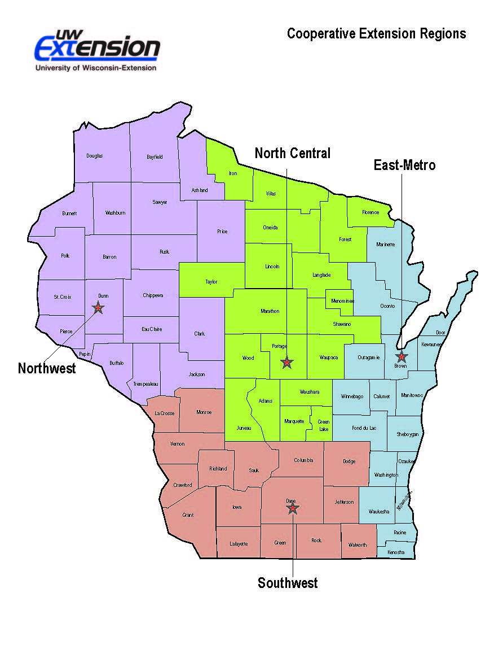

TIMELINE
- Application, Resume and Cover Letter Due – October 1, 2019
Email to justin.lieck@wisc.edu, fax to 608-265-6407 or mail to Attention: Justin Lieck,
4-H Youth Development, 130 Pyle Center, 702 Langdon St, Madison WI 53706
Electronic documents preferred. An email confirmation will be sent upon receiving them.

- References Due – October 1, 2019

- Review of Applicants – October 1-19, 2019

- Candidates Notified – October 22, 2019

- Election at Fall Forum – November 1-3, 2019

Wisconsin 4-H Leadership Council Meetings
Council members are expected to attend and participate in:
- Fall Forum – November 1-3, 2019
- Winter Retreat-January 2020
- Spring Planning Meeting-April 2020
- Wisconsin 4-H & Youth Conference-June 21-25, 2020 (depending on responsibilities,
only some adults will attend the whole conference, all youth will attend the entire conference and pre-conference prep; we may schedule a business meeting for the Council on June 20 or 21)
- Fall Forum-Nov 2020
Council members also participate in other statewide events, including but not limited to the Governor’s Meat Products Auction at the Wisconsin State Fair, the Wisconsin Farm Bureau Annual Meeting, and other Wisconsin 4-H Foundation fundraisers and events.

Applicant Checklist:
- Submit the following items no later than October 1, 2019
- Cover Letter
- Resumé (No more than 2 pages; see sample at https://fyi.extension.wisc.edu/wi4hvolunteers/wi-4-h-leader-council/)
- 2-page Offical WLC Application
- Reference from your county staff and and another leader due to justin.leck@wisc.edu

Address questions to Amber Rehberg (amber.rehberg@wisc.edu)
Kandi O’Neil (kandi.oneil@wisc.edu)

2019-2020 WISCONSIN 4-H LEADERSHIP COUNCIL (WLC)
OFFICIAL APPLICATION

Please submit this application with a cover letter and no more than a 2 page resume of your 4-H, school/work and community leadership experiences. Sample resumes can be found at: https://fyi.extension.wisc.edu/wi4hvolunteers/wi-4-h-leader-council/.

Personal Information

Name County____________________________
(first) (middle initial) (last)

Home address _____________________________________________________________________________

City __________________________________________Zip Code ________ Gender: ____________________

Primary phone (_____ )__________________________ Secondary phone (______)______________________
(Check: home work) (Check: cell school work)
E-mail ________________________________________

Youth ______ Year in School as of September 1, 2019________ Years in 4-H ________
Parent/guardian name ________________________________________________________________

Address/telephone ___________________________________________________________________

Adult ______ Years as a 4-H Adult Leader _______

Please answer the following questions IN THE SPACE PROVIDED only. The most helpful responses will include specific details about your role, activities and learning from the experience. FONT SIZE to be used is 10-12. Do not add pages or write on the back of any pages or change this form. If guidelines are not followed, points will be deducted.

- What are your TWO (2) strongest skills/traits that you would bring to WLC? How would these two skills/traits help achieve the goals and purposes of WLC?

- Describe ONE (1) experience you have had working with youth and adult partnerships in any group (examples of groups: 4H, school, church, community, FFA, etc.). Explain in detail. What was your specific roles and how did the partnership work?

- Give an example, from something that has happened within the past TWO (2) years, where you helped to develop leadership in others. Explain in detail how you specifically helped to develop their leadership; what things did you do or not do to ensure they had an opportunity to grow?

Submit No Later Than OCTOBER 1, 2019 to:
justin.lieck@wisc.edu, fax: 608-265-6407 or 130 Pyle Center, 702 Langdon St, Madison, WI 53706
Electronic documents preferred
The University of Wisconsin-Madison Division of Extension provides affirmative action and equal opportunity in education, programming and employment for all qualified persons regardless of race, color, gender/sex, creed, disability, religion, national origin, ancestry, age, sexual orientation, pregnancy, or parental, arrest or conviction record or veteran status.
La Universidad de Wisconsin-Extensión proporciona acción afirmativa e igualdad de oportunidades en educación, programas y empleo, para todas las personas calificadas, sin tener en cuenta raza, color, sexo, credo, discapacidad, religión, nacionalidad de origen, ascendencia, edad, orientación sexual, gravidez o paternidad, historial de detención o condena o estado de veterano de guerra.
WISCONSIN 4-H LEADERSHIP COUNCIL
CONFIDENTIAL 4-H Youth Development Staff/Educator Reference
(if county position is vacant, other Extension Educator)
Applicant's Name _____________________________ County ___________________________
How long have you known this applicant and in what capacity? ______________________________
The above named individual has applied to be a Wisconsin 4-H Leadership Council member. Your thoughtful evaluation of the applicant's ability to participate as a responsible delegate is appreciated. Candidates are selected by the Wisconsin 4-H Leadership Council officers and advisors. All information is confidential.
1. Interpersonal Relations: As you observe this applicant in relationships with others, is the applicant usually:
Comments
Cooperative ___ yes ___no _______________________________
Looked to for Guidance ___ yes ___no _______________________________
Respected ___ yes ___no _______________________________
Willing to Try New Things ___ yes ___no _______________________________
Inclusive ___ yes ___no _______________________________
Sensitive Toward Others ___ yes ___no _______________________________
Experienced in Youth/Adult Partnerships ___ yes ___no _______________________________

2. In comparison with persons you have known, how would you rate the applicant in the following areas?
 | Below Average | Average | Above Average | Top 10%
Public Speaking | _____ | _____ | _____ | _____
Leadership | _____ | _____ | _____ | _____
Role Modeling | _____ | _____ | _____ | _____
Responsibility | _____ | _____ | _____ | _____
Positive Attitude | _____ | _____ | _____ | _____
Teamwork | _____ | _____ | _____ | _____
Dependable | _____ | _____ | _____ | _____

3. Do you recommend this applicant? ___ yes ___no Why or why not?

Please review the information sheet on the Wisconsin 4-H Leadership Council and comment on this candidate’s strengths and limitations for this role below.

Date ____________________ Agent/Educator Name______________________________________
Signature (or Type Name)

Submit No Later Than OCTOBER 1, 2019 to:
justin.lieck@wisc.edu, fax: 608-265-6407 or 130 Pyle Center, 702 Langdon St, Madison, WI 53706
Electronic documents preferred
The University of Wisconsin-Madison Division of Extension provides affirmative action and equal opportunity in education, programming and employment for all qualified persons regardless of race, color, gender/sex, creed, disability, religion, national origin, ancestry, age, sexual orientation, pregnancy, or parental, arrest or conviction record or veteran status.
La Universidad de Wisconsin-Extensión proporciona acción afirmativa e igualdad de oportunidades en educación, programas y empleo, para todas las personas calificadas, sin tener en cuenta raza, color, sexo, credo, discapacidad, religión, nacionalidad de origen, ascendencia, edad, orientación sexual, gravidez o paternidad, historial de detención o condena o estado de veterano de guerra.

WISCONSIN 4-H LEADERSHIP COUNCIL
CONFIDENTIAL Volunteer Reference (4-H Leader, Coach, Teacher, Mentor)
(cannot be related to the applicant)
Applicant's Name _____________________________ County ___________________________
How long have you known this applicant and in what capacity? ______________________________
The above named individual has applied to be a Wisconsin 4-H Leadership Council member. Your thoughtful evaluation of the applicant's ability to participate as a responsible delegate is appreciated. Candidates are selected by the Wisconsin 4-H Leadership Council officers and advisors. All information is confidential.
1. Interpersonal Relations: As you observe this applicant in relationships with others, is the applicant usually:
Comments
Cooperative ___ yes ___no _______________________________
Looked to for Guidance ___ yes ___no _______________________________
Respected ___ yes ___no _______________________________
Willing to Try New Things ___ yes ___no _______________________________
Inclusive ___ yes ___no _______________________________
Sensitive Toward Others ___ yes ___no _______________________________
Experienced in Youth/Adult Partnerships ___ yes ___no _______________________________

2. In comparison with persons you have known, how would you rate the applicant in the following areas?
 | Below Average | Average | Above Average | Top 10%
Public Speaking | _____ | _____ | _____ | _____
Leadership | _____ | _____ | _____ | _____
Role Modeling | _____ | _____ | _____ | _____
Responsibility | _____ | _____ | _____ | _____
Positive Attitude | _____ | _____ | _____ | _____
Teamwork | _____ | _____ | _____ | _____
Dependable | _____ | _____ | _____ | _____

3. Do you recommend this applicant? ___ yes ___no Why or why not?

Please review the information sheet on the Wisconsin 4-H Leadership Council and comment on this candidate’s strengths and limitations for this role below.

Date ____________________ Name______________________________________
Signature (or Type Name)

Submit No Later Than OCTOBER 1, 2019 to:
justin.lieck@wisc.edu, fax: 608-265-6407 or 130 Pyle Center, 702 Langdon St, Madison, WI 53706
Electronic documents preferred
The University of Wisconsin-Madison Division of Extension provides affirmative action and equal opportunity in education, programming and employment for all qualified persons regardless of race, color, gender/sex, creed, disability, religion, national origin, ancestry, age, sexual orientation, pregnancy, or parental, arrest or conviction record or veteran status.
La Universidad de Wisconsin-Extensión proporciona acción afirmativa e igualdad de oportunidades en educación, programas y empleo, para todas las personas calificadas, sin tener en cuenta raza, color, sexo, credo, discapacidad, religión, nacionalidad de origen, ascendencia, edad, orientación sexual, gravidez o paternidad, historial de detención o condena o estado de veterano de guerra.

Wisconsin Leadership Council Assessment Form
***NOTE: This example form will be used to review your application. It is for your reference only and does not have to be filled out when you apply.***
Applicant Name: | Info not provided by the applicant | Appears to be less than  qualified | Appears to be somewhat qualified | Appears to be acceptably qualified | Appears to be highly qualified
Minimum Qualifications Required
Submitted required information
- Resume – 1 page suggested
- 2 page application
- Reference
Enrolled 4-H member in 9th – 11th grade –or-
Enrolled certified 4-H volunteer leader
Demonstrated leadership in local and county programs
Experience working in youth adult partnerships
Depth of experience with verbal and written communication skills
Demonstrated experience on committees
Additional Skills and Experiences

Demonstrated leadership at state level
Experience speaking with stakeholders
Experience teaching and facilitating workshops for youth and adults
Strengths:

Limitations:

