2019
Wisconsin 4-H Livestock Quiz Bowl
Resource Handbook

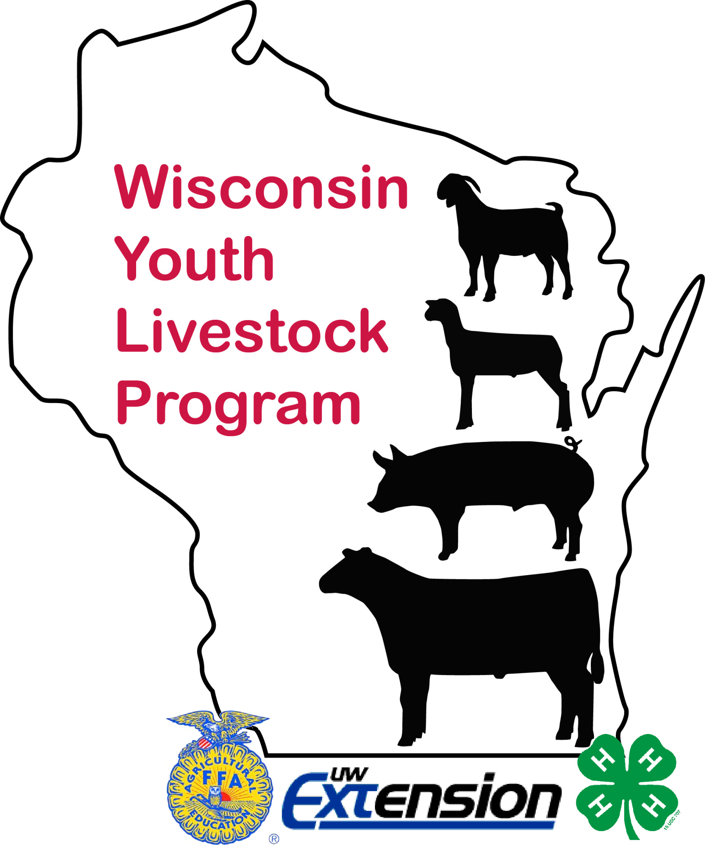
A guide for coaches and youth
Sponsored by:

Contest Materials available at: Wisconsin Youth Livestock Page – UW-Extension: http://fyi.uwex.edu/youthlivestock/programs/quizbowlskillathon
Like us on Facebook at: Wisconsin Youth Livestock Program
Follow us on Twitter: WIYOUTHLVSTK
Instagram: WIYOUTHLVSTK
University of Wisconsin, United States Department of Agriculture and Wisconsin counties cooperating.
University of Wisconsin-Extension provides equal opportunities in employment and programming, including Title IX requirements.

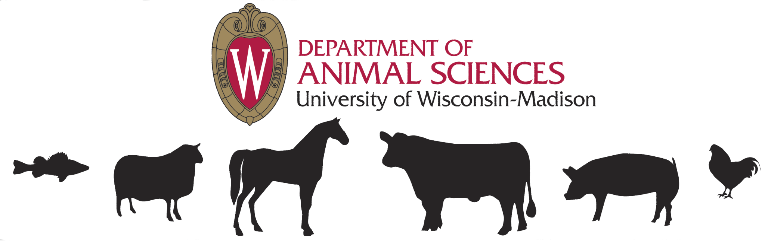

College of Agricultural and Life Sciences • University of Wisconsin-Madison
Department of Animal Sciences-Extension 286 Animal Sciences Building Phone: 608-263-4304
1675 Observatory Drive Fax: 608-262-5157
Madison, WI 53706-1284 Email: borourke2@ansci.wisc.edu
January 7, 2019

TO: Past State 4-H Livestock Quiz Bowl & Skillathon Participants
FROM: Bernadette (Bernie) O’Rourke, Extension Youth Livestock Specialist
Alissa Grenawalt, Extension Outreach Specialist
RE: 2019 State 4-H Livestock Quiz Bowl & Skillathon Event

The 15th Annual Quiz Bowl & Skillathon Contests will be held together again on Saturday, March 2, 2019. The contest will start with registration at 9:00 a.m. with the competition starting at 9:30 a.m. Youth are encouraged to participate in both contests. Deadline for registration is Feb. 22, 2019. Only emailed registrations will be accepted, mailed registrations will NOT be accepted. The cost is $12 per youth and due at the time of registration. This is a strict deadline as there is much to coordinate. Checks can be made out to: UW Extension and fees are non-refundable.

All information is on the Extension youth livestock website at http://fyi.uwex.edu/youthlivestock/programs/quizbowlskillathon/

2019: No paper will be allowed in quiz bowl matches for coaches to write down scores etc.

2019: These changes were implemented in 2016.
- Senior Division Quiz Bowl ONLY – To align with the National Quiz Bowl rules - Phase One will consist of eight (8) one-on-one questions. During the one-on-one competition, only one member of each team who the specific question is directed to will be eligible to respond. This eligibility will rotate with each question beginning with the captain of each team, and rotating to the 2nd, 3rd, and 4th contestants of each team, respectively, until all eight questions have been asked. This means each pair of individuals (one member from each team) will be asked two questions.
  - The Junior and Mixed divisions will continue as they have been, NO one to one competition. The questions will be directed to one team at a time, the team leaves and the next team comes in to be asked the same series of questions.
- Skillathon scoring – We will hand score the written test and skillathon stations in an effort to give out awards at the end of the day. However we do reserve the right to perhaps not have results to report for whatever reason. We will do what we can.

Other updates from previous years:
- Friendly reminder: There is to be NO talking of parents or coaches in quiz bowl rooms, hand gestures and cell phones are OFF. As per the rules, contest management reserves the right to remove anyone from quiz bowl rooms if behavior and conduct are of question. As I’ve always stated, of all the questions we ask there inevitably will be issues with some. That’s the joy of this contest, empowering youth to ask for clarification.
- To assist in allowing coaches to comment on questions, I will have a form to fill out where you need to state the division, round and paraphrase the question and state your thoughts on the question. You can drop it in a box where the quiz room coordinator will be.
- Change in Quiz Bowl – phase one will have 8 questions rather than 12 questions. This is an effort to speed up matches and reflects national rules.
- Change in rule - In an effort to keep matches moving along and to follow the national rules – questions will NOT be re-read. The only event that they will be re-read for the other team is if the question wasn’t fully read-the team buzzed in during the reading of the question.
- Make sure the kids are acknowledged before they answer a question. Points will be deducted. Also make sure the team captain is answering all the bonus questions, no other members.
- Parents aren’t allowed in the skillathon area of the stations. Youth are usually done with this by noon or so, I will communicate a time when they are open for viewing for coaches and parents.
- Timing of events – be mindful on getting all the pieces done for both skillathon and quiz bowl. After last year, you might be able to gauge that better. We had kids still doing team exercises at 4:30 p.m.; this makes it difficult for timely results. Please defer other activities until you are able to get all the components done. We all want to get home at a decent time – this will assist on a realistic completion.
- We hope to offer the 2nd place senior quiz bowl team the opportunity to go to the National Western Stock Show in Denver. They have a livestock quiz bowl competition. However, for this coming year there will not be traveling funds from the 4-H Foundation, perhaps in future years.

Some usual reminders:
- It is the responsibility of the teams to bring resources into the room for challenges during the quiz bowl contest.
- You can bring food, however PLEASE pickup after yourselves. There are food locations around campus, pizza and/or sub sandwiches can be ordered as well. Please don’t bring food into the animal areas. We will not be breaking for lunch.

If you have any questions, please contact me at the above information. Study hard and look forward to seeing you in March!!

WISCONSIN STATE LIVESTOCK QUIZ BOWL
Saturday, March 2, 2019 – Madison, WI
University of Wisconsin – Madison Animal Science Building
9:00 a.m. Registration; Start Promptly at 9:30 a.m.
Deadline: February 22, 2019 Only emailed registrations will be accepted, mailed registrations will NOT be accepted. The cost is $12 per youth and due at the time of registration.

OBJECTIVES:
- To provide an exciting and fun way for youth to explore their 4-H animal project.
- To encourage youth to develop teamwork, self-confidence and decision making skills.
- To develop committee member organization and leadership skills.

ELIGIBILITY:
- Team members must be 4-H members in good standing in the county they represent. They need not, however, have to be enrolled in the livestock (beef, sheep, swine, meat goat) projects. The Extension Youth Livestock Specialist reserves the right to check eligibility.
- Each team must designate a captain and a coach.
- Selection of team members is up to each county. Teams should consist of four members, with a minimum of 3 members. (Only 4 members are seated at a time.) An alternate is suggested.
- All 4-H members (grades 3-13) in the state of Wisconsin are eligible. The contest will be divided into junior (grades 3-8), senior (grades 9-13) divisions and a mixed team division where the team must contain at least one youth in each age division. Contestants must participate in the division according to their grade as of January 1, 2019.
- Contestants may attend a college beyond high school and still compete. However, members who enroll in or audit an animal science course prior to the fall term are not eligible to compete. National Contest rules dictate eligibility and supersedes state contest policy. Contestant must already have reached his or her 14th birthday, and may not have reached his or her 19th birthday, before January 1 of the year in which the National 4-H Contest is held.
- The captain selected for each team need to be seated next to each other, in the middle.

BEHAVIOR AND CONDUCT:
4-H conduct and behavior expectations apply to all participants, coaches and spectators. Officials in the room can and will hand out warnings to team members, coaches, etc., to anything they deem unsportsmanlike, sarcastic or out of line conduct or behavior. A team will get 1 warning all day, 2nd warning – individuals will be removed from rooms for the rest of the day. Further consequences could follow. Inappropriate behavior will not be tolerated! Contest officials reserve the right to remove individuals, teams, parents, coaches at any time.

PROCEEDURE OF PLAY:
- The contest is organized on a double elimination basis with teams competing in a series of one-on-one elimination matches, advancing on, until a champion team emerges. Teams will be assigned to the first round competition before the contest. Some teams may be awarded byes during the elimination as part of the assignment process. Teams face the judge, timer and score keeper. They don’t face the audience to eliminate the chance mouthing answers and or using hand gestures to participants.
- Coaches, parents, etc. may not challenge Livestock Quiz Bowl room officials. Challenges may only be initiated from youth team members. If a coach or a member of the audience disrupts the contest, they will be asked to leave. NOTE: Challenges are on questions only not procedure of play.
- Three officials will conduct the bowl. A judge/moderator who asks the questions and maintains overall control, and who will rule on all responses and challenges. Others are timekeeper and scorekeeper.
- Mixed and Junior teams will have two phases in their matches: Phase 1 and Phase 3. Seniors teams will have phases 1, 2 and 3 during their matches.

DESCRIPTION OF PHASES:
Phase 1 (Junior & Mixed): 8 questions total. This phase begins with one team starting in the room and the other team outside the room in isolation. (No discussion among team members during this phase).

- Team 1 will begin this phase with the Captain of each team being asked an individual question, and rotating to the 2nd, 3rd, and 4th contestants of each team, respectively, until all eight questions have been asked. Therefore, each team member will be asked two general livestock questions in rotation.
- Once Team 1 completes their phase, they will stand outside the room until Team 2 completes the
same 8 questions in rotation.
- Each question in this phase is worth 10 points with no deduction given for incorrect answers. No teammate assistance may be offered or received. Questions will not be repeated. Contestants have 5 seconds to answer the questions in this phase. If neither contestant buzzes in, the question dies and no points are awarded or lost.
Phase 1 (Senior): Senior Division Quiz Bowl ONLY – To align with the National Quiz Bowl rules - Phase One will consist of eight (8) one-on-one questions. During the one-on-one competition, only one member of each team who the specific question is directed to will be eligible to respond. This eligibility will rotate with each question beginning with the captain of each team, and rotating to the 2nd, 3rd, and 4th contestants of each team, respectively, until all eight questions have been asked. This means each pair of individuals (one member from each team) will be asked two questions. Correct answers are worth 10 points with no deduction for incorrect answers. If neither contestant buzzes in, the question dies and no points are awarded or lost. No teammate assistance may be offered or received in this phase. A contestant must buzz in within 5 seconds after the question is read and answers must be started within 5 seconds of the contestant being recognized by the moderator (starting an answer after the 5 second buzzer goes off is not acceptable). Answers will consist of multiple choice; fill in the blank, and/or completion type questions.
- The moderator shall indicate prior to reading of each question which two contestants are eligible to respond. If the first recognized contestant fails to respond or answers incorrectly, the moderator will offer the question to the other contestant. The moderator will read the correct answer if both contestants answer the question incorrectly or no answers are given.
- Each question shall be addressed to only one member of each team, beginning with the team captain and progressing with subsequent questions to the number 2, 3, and 4 contestants, respectively. If neither contestant buzzes in, the question dies and no points are awarded or lost. The next pair of contestants gets a new question.
- A contestant must be recognized by the moderator prior to beginning his/her answer. Any member answering a question without being acknowledged will result in the deduction of 10 points from the team score. The opposing contestant has the option of answering the question within 5 seconds after receiving an offer from the moderator.
- If a contestant buzzes in and fails to respond to the question in the form of an answer, a five point penalty will be assessed.
- There will be a five point deduction if any contestant, other than the two designated contestants, responds.
- If the equipment allows a member of each team to buzz in at the same time or locks out both team members because they hit the button at the same time, and the moderator cannot determine which team member buzzed first, the question will be discarded and a new question will be selected by the judges.

Phase 2: (SENIORS ONLY) Phase 2 also consists of 8 questions. Each team will be asked 4 questions on alternating basis. Correct answers are worth 10 points, with no deductions for incorrect answers.

- Teams can discuss questions prior to answering in this phase, but only the Team Captain can report the answer to the moderator. If anyone other than the team captain answers, no points will be awarded.
- Answers must be started within 20 seconds after the question is read (starting an answer after the 20 second buzzer goes off is not acceptable).
- Questions will primarily be fill in the blank, completion or short answer, but may include some multiple choice. When a team fails to answer the question in the allotted time or answers the question incorrectly, the moderator shall offer the question to the opposing team, WITHOUT re-reading it.
- The opposing team may discuss the question and shall have 20 seconds (from the time the moderator offers the question) to begin an answer to the question.
- The opposing team may discuss the question only after being offered to them by the moderator (not while the team originally asked the question is discussing it). Again, only the team captain reports the answer.

Phase 3: Consists of regular, toss-up and bonus questions with a possible total of 16 questions worth 10 points each. During this phase, any team member from either team can buzz in to answer a regular or toss-up question. Every 3rd question will be a toss-up question with a bonus attached. The only difference between a regular and a toss-up question will be that the toss-up questions will have a bonus attached.

- Scoring and procedures of regular and toss-up questions with no violation of play: After the regular or toss-up question has been read, the first individual from either team to signal will answer the question within 5 seconds after being acknowledged by the moderator, or will lose 10 points. 10 points will also be deducted for incomplete or incorrect answers. In the event of an incorrect answer, the opposing team has the opportunity to answer after buzzing and being acknowledge by the moderator. The second team must buzz in within 5 seconds of being offered the question by the moderator. The question will NOT be re-read. If neither team can offer an answer within 10 seconds, the moderator will give the correct answer and neither team will forfeit points.
- Scoring and procedures of regular and toss-up questions with violation of play: Any member answering regular or toss-up questions without being acknowledged will result in the deduction of 10 points from the team score. The opposing team has the option of answering the question within 10 seconds after receiving an offer from the moderator. The question will not be re-read. The second team must buzz in and be acknowledged by the moderator before answering.
- Bonus questions: If a bonus question is attached to a correctly answered toss-up question, the moderator reads the bonus question and the team that answered the toss-up question is allowed to discuss the question. The question will not be re-read. Answers must be started within 20 seconds after the question is read. Only the team captain may answer the question. If anyone other than the team captain answers the question, no points will be awarded. Correctly answered bonus questions are worth 10 points. All parts of bonus questions must be answered correctly. No points are deducted for incorrect or incomplete answers to bonus questions. The opposing team does not have the opportunity to answer bonus questions.
- If a bonus question was attached to an unanswered toss-up question or an incorrectly answered toss-up question, the bonus question dies with no points awarded and the moderator will read the next regular question.
- Pre-maturing buzzing: When the buzzer is pushed before the question is completed red, the moderator will stop reading and that person must answer the question after being acknowledged. If the answer is incorrect or incomplete, 10 points will be deducted from the team score. The judge(s) will not ask for clarification of answers in these instances. Answers must be complete and correct. In the event that a multiple choice question must be answered before all the possible answers have been read, the contestant’s answer must match the moderator’s correct answer exactly, either by letter choice, or by the corresponding wording of the correct letter. If the answer is not complete and correct, the question will then be completely re=read and the other team will have the opportunity to answer it after buzzing and being acknowledged.
- Both teams buzz at the same time: If the equipment allows a member of each team to buzz in at the same time or locks out all team members because they hit the button at the same time, and the moderator cannot determine which team member buzzed first, the question will be discarded and a new question will be selected by the judges.

Questions will not re-read, except as in number 5 above.The score of both teams will be announced periodically.

Ties: If both teams are tied at the end of a match, the moderator will read a series of three additional toss-up questions until the tie is broken. Questions will be scored as in Phase Three (see below). If still tied after this series of questions, the match becomes “Sudden Death” play. Thus, the first team to achieve a higher score will become the winner of the match. Questions for “Sudden Death” play will be selected by the judges.
Aids and Materials: Teams may not bring or use any prepared aids or other resource materials during a match. Pencils and scratch paper will be provided.
Final Score: Once the moderator has declared a winner based on the total team point accumulation, there shall be no protests.

CHALLENGES
- No source of information is infallible. There may at times be answers given to questions that are in agreement with the recommended sources, but which are in fact erroneous. Every effort shall be made to eliminate such questions; but in the event of such an occurrence, any team may challenge the answer.
- Coaches cannot challenge, signal a challenge, or use a time out to prompt a challenge.
- Answers and interpretations of questions will be the sole responsibility of the judge. A decision made by the judge after the answer is verified will be final.
- All challenges must be made after both teams have had a chance to answer the question and before the start of the next question.
- Challenges must be resolved within a 2 minute time period.
- The burden of proof from the listed references is with the team challenging.
- Any team member or coach of the challenging team may look up information in the references.
- References can only be opened during a challenge and must be provided by the teams.
- All questions or contest procedures not immediately resolved by the judge should be referred immediately to the contest coordinator for clarification before proceeding.

PROCEDURE OF CHALLENGING
If an answer is ruled correct and is challenged by the opposing team:
- Phase 1 & 2: Only the designated team member may challenge after the answer is given and before the next question is asked. The team member that is eligible to answer that question is to say…”I challenge that ruling. The correct answer is _____.” The team has 2 minutes to prove the challenge and the designated team member is to answer.
- Phase 3: After the answer is given and before the next question is asked, any seated team member may challenge by saying…”I challenge that ruling. The correct answer is _____.” The team has 2 minutes to prove the challenge.
- If the challenge is successful: The original ruling is changed. The team that did not give the correct answer does not earn 10 points. If it is Phase 1, that team loses no points. If it is Phase 3, that team loses 5 points. The challenging team earns 10 points.
- If the challenge is ruled unsuccessful: The original ruling stands. The first team keeps their earned 10 points. Challenging team is recorded with one unsuccessful challenge. Each team will be allowed two unsuccessful challenges per match without penalty. After 2 unsuccessful challenges, there will be a 5 point deduction for each unsuccessful challenge.

If an answer is ruled as incorrect for both teams and is challenged by either team.
- Phase 1 & 2: After the judge rules incorrect and the opposing team member has had a chance to answer, but before the next question is read, the designated team member of either team may challenge by saying…”I challenge that ruling. The correct answer is______.” The team has 3 minutes to prove the challenge and designated team member is to answer.
- Phase 3: After the judge rules incorrect and the opposing team has a chance to answer, but before the next question is read, any seated team member for either team may challenge by saying…”I challenge that ruling. The correct answer is_____.”
- If the challenge is ruled successful: The original ruling is changed. The challenging team earns 10 points.
- If the challenge is ruled unsuccessful: The original ruling stand. Challenging team is recorded with one unsuccessful challenge. Each team will be allowed 2 unsuccessful challenges per match without penalty. After 2, there will be a 5 point deduction for each unsuccessful challenge.

TIME-OUTS
- A coach, team captain, or the moderator may call for a time-out for clarification of a rule, to replace team members, or to allow for unexpected problems.
- Time outs maybe called only after a question has been answered and before the start of the next question.
- There is a limit of 3 minutes for each time out, and a limit of 2 per team in each match.
- Timeout will not be charged to either team for replacement of members between Phase 1 and Phase 2.

REPLACEMENT OF TEAM MEMBERS
- Alternates can be subbed in during the completion of the phase.
- During any match, one or two team members only maybe replaced at the panel when the moderator deems it impossible for one of the seated members of the team to continue in the contest.
- The team member removed from a match becomes ineligible to return to the particular match. The team member removed and the replacement member are both eligible to participate in further matches.

QUESTIONS/REMINDERS
- Only the first answer given is accepted and will be ruled as correct or incorrect. Any additional answers will not be considered.
- All teams will be asked the same questions in the same round. In the next and subsequent rounds, a different set of questions will be used.
- The moderator reads each question until the completion of the reading of the question OR until a contestant activates a buzzer.
- If a buzzer is activated during the reading of any question, the moderator will immediately stop reading the question and recognize the participant buzzing in.
- When the moderator recognizes (calls the name of) the participant “buzzing in”, that participant has 5 seconds to begin to answer.
- The repeating of the question by the contestant shall not be considered the indication of the answer.
- No questions or any parts thereof shall be repeated during the asking.
- Only if a question was not completely read due to an early signal by the first team, will the question be re-read for the second team.
- When the first team answers a question incorrectly, the opposing team gets 10 seconds to activate the buzzer.
- If neither team “buzzes in” within 10 seconds, the moderator will give the answer and neither team will score points.
- If a question is thrown out either due to poor reading by the moderator or a decision of the judges, it will be replaced by another question, of the same degree of difficulty, so that a constant total number of questions will be asked.
- If 2 teams buzz in at the same time and the buzzers cancel each other out, the question will be thrown out and a new one inserted.
- It is the responsibility of the coaches to bring resources into the room for challenges.

OBSERVERS
- Watching contests: No team members, coaches, parents or other spectators may watch any round other than their own match until that team has been eliminated from the contest. If someone is watching a contest other than his/her own before that team is eliminated, the team is disqualified from competition.
  - If a coach is responsible for multiple teams, they must choose ONE team to follow and if needed, select another volunteer to serve as the coach for the additional teams.
  - This includes a senior team watching a junior team or vice versa.
  - The contest coordinator will assign teams not competing in Round 1 a match to watch/observe in Round 1 only so they have a chance to hear the questions.
- Warning: If any members, coaches, helpers or spectators share questions or answers with other teams, the team(s) of the offenders(s) will be disqualified. This includes mouthing or signaling during a match.
- Talking or misbehavior of coaches or spectators: First time offenders will receive one warning for the day. Upon a second offense, the offending person will not be allowed to enter the contest room for the rest of the day.
- Coaches may keep score. However score sheets will be collected at the conclusion of each match.
- Since there are so many requests for the score periodically throughout the match, I’m allowing a volunteer from the crowd to keep score on the chalk board during the match. However, there will be no gesture or encouraging of answers from these individuals as they will be facing the competitors. The Judge will make the call on this if they deem this a problem and that individual will be removed from that position.
- No notes may be taken and no tape recorders or video cameras may be used by anyone in the audience including coaches, during the conduct of the match.
  - At the first offense, tapes and material will be confiscated and a warning given.
  - Upon a second offense, the offending person will not be allowed to enter the contest room for the rest of the day
.
- Cell Phones must be off while in Quiz Bowl Rooms!! No Exceptions!!
- No paper will be allowed in quiz bowl matches for coaches to write down scores etc.

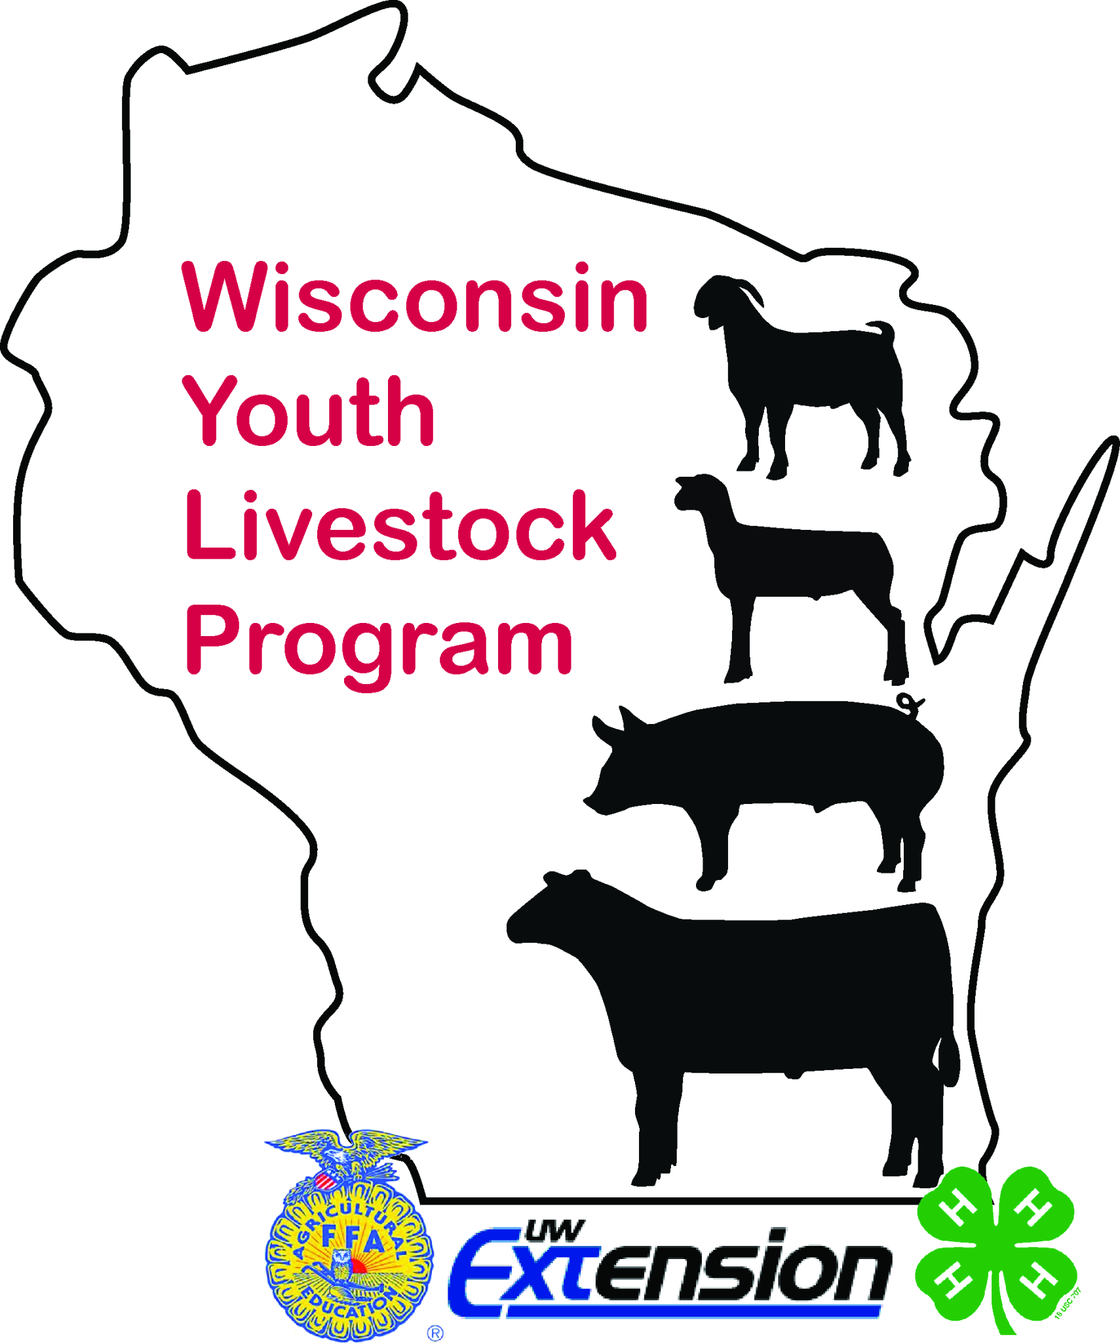
Quiz Bowl & Skillathon References
Updated 1/2019

The following is a list of references that will assist in preparing for livestock quiz bowl contests that involve beef, sheep, meat goat, and swine. Please note that actual references may deviate from this list in an effort to keep current with a rapidly changing livestock industry.

Purchasing of buzzer sets
www.zeecraft.com - purchase them new, have somewhat of a warranty, most like the buzzers used in the state contest.
www.ebay.com - you maybe able to purchase sets at a cheaper price but it is a riskier situation as you are buying used sets, not knowing how they have been handled.

Swine
OSU Swine Resource Handbook
4-H circular 134R
The Ohio State University
https://extensionpubs.osu.edu/swine-resource-handbook-for-market-and-breeding-projects/

4-H Literature:
Swine 1 – Growing with Swine (revised 2004)
Swine 2 – Becoming Swine Smart (revised 2004)
Swine 3 – Entering the Arena (revised 2004)
Swine Helper’s Guide (revised 2004)
Available from your extension offices
4-H CCS Materials – Available at https://4-h.org/parents/curriculum/

National Pork Board Swine Quiz and Skillathon Resources:
http://www.pork.org/youth-and-education/skillathon-quiz-bowl/

Pork Checkoff Quick Facts publication:
http://www.pork.org/pork-quick-facts/

Seedstock Edge: www.nationalswine.com
National Swine Registry
West Lafayette, IN

Nasco Farm & Ranch Catalog
Fort Atkinson, WI 1-800-558-9595
http://www.enasco.com

National Hog Farmer
Monthly Periodical
7900 International Drive, Suite 300
Minneapolis, MN 55425 http://www.nationalhogfarmer.com/

OSU Swine Learning Lab Interactive CD
The Ohio State University
Phone: 614-292-4848
https://ohio4h.org/sites/ohio4h/files/d6/files/CD%20flyer%20smallest.pdf

Livestock E-Quiz: http://web.extension.illinois.edu/equiz/

Illinois Trail - Technology and Research: Allied & Integrated Livestock Linkages
http://livestocktrail.illinois.edu/
Illini Porknet (Ask the Expert): http://livestocktrail.illinois.edu/porknet/

PORK magazine: http://www.Porkmag.com

Information on all swine breeds: http://www.ansi.okstate.edu/breeds/

American Meat Institute: https://www.meatinstitute.org/

Pork Industry Handbook
https://www.usporkcenter.org/jobs-resources/pork-industry-handbook/

Beef
UNL Beef Manual Handbook
This is an updated manual that replaces the OSU beef manual
Download is electronic and costs approximately $40.
http://marketplace.unl.edu/ne4h/4h4200.html
OSU Beef Resource Handbook
4-H circular 117R
The Ohio State University
https://extensionpubs.osu.edu/beef-resource-handbook/

4-H Literature:
Beef 1 – Bite into Beef (revised 2005)
Beef 2 – Here’s the Beef (revised 2005)
Beef 3 – Leading the Charge (revised 2005)
Beef Helper’s Guide (revised 2005)
Available from your extension offices
4-H CCS Materials – Available at https://4-h.org/parents/curriculum/

Information on all beef breeds: http://www.ansi.okstate.edu/breeds/
Illini Beefnet (Ask the Expert): http://web.extension.illinois.edu/oardc/

Illinois Beef Handbook – http://web.extension.illinois.edu/oardc/downloads/43908.pdf

Beef Production and Management Decisions 2nd Edition by Robert Taylor

Feeds and Feeding by Morrison and Morrison

Forages, Fourth Edition by Maurice E. Heath, Robert F. Barnes and Darrel S. Metcalfe

Meat Evaluation Handbook by National Cattlemen’s Beef Association
For Mixed and Senior Divisions:
Nebguides: UNL Extension Publications
Beef Cattle Implant Update and Synchronizing Estrus in Beef Cattle, can be found at http://beef.unl.edu/learning/estrussynch.shtml

Sheep

Sheep Resource Handbook
4-H circular 194R
The Ohio State University
Phone number 614-292-1607
https://extensionpubs.osu.edu/sheep-resource-handbook-for-market-and-breeding-projects/

Sheep Production Handbook
Formerly called the sheep industry development handbook or SID
803-771-3500 ext. 46
4-H Literature:
Sheep 1 – Lambs, Rams, and You (revised 2000)
Sheep 2 – Shear Delight (revised 2000)
Sheep 3 – Leading the Flock (revised 2000)
Sheep Helper’s guide
Available from your extension offices
4-H CCS Materials – Available at https://4-h.org/parents/curriculum/

Meat Goats

OSU Goat Resource Handbook
4H 135R– The Ohio State University
Phone number 614-292-1607
https://extensionpubs.osu.edu/goat-resource-handbook/

4-H Literature:
Meat Goats
Meat Goat 1 – Just Browsing
Meat Goat 2 – Growing up with Meat Goats
Meat Goat 3 – Meating the Future
Meat Goat Helper’s Guide
Available from your extension offices
4-H CCS Materials – Available at https://4-h.org/parents/curriculum/

American Boer Goat Association: http://www.abga.org/

Information on Goat breeds: http://www.ansi.okstate.edu/breeds/goats/

International Boer Goat Association
P. O. Box 663 Spicewood, TX 78669
Toll Free phone: 877-640-4242 Toll Free Fax: 877-640-4060
Web: http://abga.org/

New Hampshire Extension Goat Resources: https://extension.unh.edu/4-H-Animal-and-Ag-Science/4-H-Meat-Goat-Page

The 4-H Meat Goat Project: An Introduction - https://extension.unh.edu/blog/new-hampshire-4-h-goat-project-overview
Texas A&M University Meat Goat Resources: https://extension.unh.edu/resources/files/Resource002493_Rep3663.pdf

North Carolina State University Meat Goat Materials:
https://youthlivestock.ces.ncsu.edu/

Penn State University Meat Goat Materials:
https://extension.psu.edu/animals-and-livestock/goats

Iowa State Meat Goat Resources: http://www.extension.iastate.edu/4h/projects/meat-goat
http://www.extension.iastate.edu/4h/page/meat-goat-judging

Cornell University Meat Goat Fact Sheets: http://4h.ansci.cornell.edu/animal-programs/goats/meat-goats/
Langston University Goat Materials: Search this site for a variety of goat related tools and resources. http://www.luresext.edu/

Other Helpful Resources:

4-H Literature: Vet Science Curriculum Books
Book 1 – From Airedales to Zebras (2004)
Book 2 – All Systems Go (2004)
Book 3 – On The Cutting Edge (2004)
Helper’s Guide (2004)
Available from your extension offices
4-H CCS Materials – Available at https://4-h.org/parents/curriculum/

The Meat We Eat (13th edition, Interstate Publishers, Inc.) 510 North Vermillion St., PO Box 50, Danville, IL 61834. Phone 800-843-4774. It is also available from www.amazon.com

Websites & Current Event References:
A small percentage of questions will be based on current events in the beef, sheep and swine industries. Since studying from these may appear to be overwhelming, keep these points in mind. Think about major issues that has affected the livestock industry in many ways such as: animal diseases, exports, animal ID, environmental issues, and regulator changes. The following on-line resources will be used to develop these questions:

- American Sheep Industry Association website at: www.sheepusa.org
- National Cattlemen’s Beef Association website at: www.beef.org
- National Pork Board website at: www.pork.org
- American Meat Institute website at: https://www.meatinstitute.org/
- Pork Magazine (questions related to current industry issues, at: www.porkmag.com, you need to subscribe for a free subscription.
- Beef Magazine (questions related to current industry issues, at: http://www.beefmagazine.com/
- National Hog Farmer Magazine (questions related to current industry issues), website at: http://nationalhogfarmer.com/
- Meatingplace.com (an on-line community for red meat and poultry processors
in North America, questions related to current industry issues, January) website at: www.meatingplace.com
- Drovers CattleNetwork (questions related to current industry issues) website at: http://www.cattlenetwork.com/
- American Boer Goat Association - http://www.abga.org/
- Aphis – www.aphis.usda.gov
- Wisconsin Livestock Identification Consortium www.wiid.org
- Wisconsin/USDA Ag Statistics (NASS): http://www.agcensus.usda.gov/Publications/2012/Full_Report/Volume_1,_Chapter_1_State_Level/Wisconsin/

Forage Resources

Forages CD-ROM Companion
Volume 1 – An Introduction to Grassland Agriculture Volume 2 – The Science of Grassland Agriculture Iowa State University Press
Ames, IA 50014
Orders: 1-800-862-6657
Office: 1-515-292-3348

Forages-The Science of Grassland Agriculture, 4th Edition
by Maurice E. Heath, Robert F. Barnes, Darrel S. Metcalfe Iowa State University Press
Ames, IA 50014
Orders: 1-800-862-6657

Online at: http://www.amazon.com/Forages-Volume-Introduction-Grassland-Agriculture/dp/0813804213

Pennsylvania Forage Handbook
Penn State College of Agricultural Sciences 217 Ag Administration Bldg.
University Park, PA 16802 Phone: 814-865-2541

Southern Forages
Circulation Department Potash & Phosphate Institute
655 Engineering Drive, Suite 110
Norcross, Georgia 30092-2843
Phone: 770-447-0335
Price: $25.00

Forage Web Links

Purdue University - http://www.agry.purdue.edu/ext/forages/forageid/forageid.htm
University of Idaho- https://www.uidaho.edu/cals/kimberly-research-and-extension-center/research/forage
UW-Extension- https://fyi.uwex.edu/forage/
University of Kentucky- http://www.uky.edu/Ag/Forage/ForageBooks.htm

Meat Resources

ITCS Instructional Materials
1401 South Maryland Drive Urbana IL 61801 USA (217) 244-3906 (800) 345-6087 (orders only)
FAX (217) 333-0005
http://im.itcs.illinois.edu/MDS100a.htm

Flash Cards
Retail Meat Cut Identification-Flash Card Set (updated 2017)
This is the easiest way to teach or learn to recognize the common retail cuts of beef, pork, and lamb! These 5”x7” cards, with cut descriptions on the back, showcase 126 full-color photographs of the retail cuts of meat. Each image is printed on high-quality, glossy- finished card stock and comes in a custom-designed box.
https://www.enasco.com/p/Retail-Meat-Cut-Flash-Cards%2BC30003?searchText=flash+cards+meat 175 cards $97.25

Online Web Resources

QUIZLET– online tool with a variety of resources: FLASH CARDS:
https://quizlet.com/ - use key words to search for sets. These are tools that people have uploaded to the site; they may or may not be accurate.

ICEV Media – Great listing of online tools/judging classes
https://www.cevmultimedia.com/index.php?p=catalog&mode=search&search_str=meats+judging

Texas A&M – Listing of relevant meats judging contacts
http://agrilife.org/4hmeat/academics/meat-science/4h/resources/

Texas A&M Meat Judging Online Judging Tools
http://agrilife.org/4hmeat/academics/meat-science/4h/meat-judging/

American Meat Science Association
http://meatscience.org/students/meat-judging-program/national-4-h-meat-judging

Nasco Farm and Ranch Catalog
https://www.enasco.com/q?question=meats&x=0&y=0

Online Meats Identification and Placing Classes
Texas A&M University Aggie Meat Judging Resources
http://aggiemeat.tamu.edu/

Texas Tech University Meat Judging Resources
http://www.depts.ttu.edu/meatscience/classes.php

University of Nebraska–Lincoln Meats Judging Resources
https://animalscience.unl.edu/pase-and-cde-meats-contest

The Guide to Identifying Meat Cuts
Booklet published cooperatively by American Meat Science Association, National Cattlemen’s Beef Association and National Pork Producers Council focused on meat labeling, meat safety, cuts of meats, nutrition labeling, wrapping meat, and meat cookery.

ONLINE at: https://www.beefresearch.org/CMDocs/BeefResearch/PE/GuideToID_MeatCuts.pd
Registrations are due February 22!

See you on March 2!

