2020
Wisconsin 4-H
Livestock Skillathon
Resource Handbook

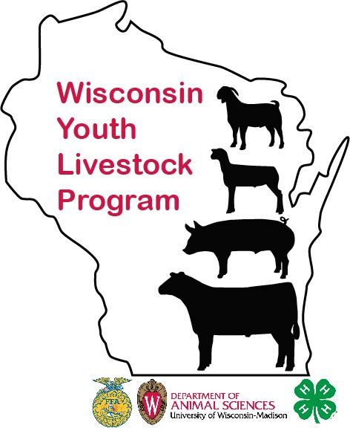

Registrations are due February 21!

Contest Materials available at: Wisconsin Youth Livestock Page – UW-Extension: https://fyi.extension.wisc.edu/youthlivestock/programs/quizbowlskillathon/
Like us on Facebook at: Wisconsin Youth Livestock Program
Follow us on Twitter: WIYOUTHLVSTK
Instagram: WIYOUTHLVSTK
A guide for coaches and youth
Sponsored by:
University of Wisconsin, United States Department of Agriculture and Wisconsin counties cooperating.
University of Wisconsin-Extension provides equal opportunities in employment and programming, including Title IX requirements.

Table of Contents

2020 State 4-H Livestock Quizbowl and Skill-a-Thon Contest Rules 3
Contest Conduct/Awards 4
LIVESTOCK FEED IDENTIFICATION 8
LIVESTOCK BREED IDENTIFICATION 9
MEAT JUDGING 12
FLEECE/HAY JUDGING 12
LIVESTOCK EQUIPMENT IDENTIFICATION 13
QUALITY ASSURANCE - INDIVIDUAL 15
QUIZ 17
QUALITY ASSURANCE EXERCISE 22
Swine Resources 26
Beef Resources 27
Sheep Resources 27
Goat Resources 27
Forage Resources 28
Meat Resources 28

2020 Wisconsin State 4-H Livestock Quiz bowl and Skill-a-Thon Contest
Contest Date: Saturday, March 7, 2020
Location: UW-Madison – Animal Sciences Building
1675 Observatory Drive
Madison, WI 53706

Contest Coordinators

Bernie O’Rourke
Extension Youth Livestock Specialist
Email: borourke2@ansci.wisc.edu

Joe Muellenberg
4-H Outreach Specialist
E joe.muellenberg@wisc.edu

2020 Rules and Regulations
Objectives:
- This contest covers the understanding and practical application and the principles of Animal Sciences related to the beef, sheep, swine, and meat goats project areas.
- To provide an exciting and fun way for youth to explore their 4-H animal project.
- To encourage youth to develop teamwork, self-confidence and decision making skills.
- To develop committee member organization and leadership skills.
Eligibility:
- All 4-H members (grades 3-13) in the state of Wisconsin are eligible. The Junior 4-H division will include Wisconsin 4-H members who are under 14 years of age as of January 1 of the current year. The Senior 4-H division will include Wisconsin 4-H members who are 14 years of age or older as of January 1 of the contest year. Contestants must not have graduated from high school prior to January 1 of the contest year. A mixed team division where the team must contain at least one youth in each age division. Contestants must participate in the division according to their age as of January 1, 2020. The top 4-H senior team will be invited to attend the National Skill-a-Thon Contest which will be held in November in Louisville, Kentucky.

- Teams may consist of three or four members. All members of a four-person team will compete, but the member receiving the lowest overall score will automatically be declared the alternate.

- Contestants must not have competed previously in any official post-secondary livestock quiz bowl or livestock quadrathalon contests. Contestant must already have reached his or her 14th birthday, and may not have reached his or her 19th birthday, before January 1 of the year in which the National 4-H Contest is held.

- This resource packet includes a number of sample applications contestants may see at the contest. Contest coordinators reserve the right to change station activities based on availability of livestock, supplies, etc.

- Registration forms are due to UW-Madison Department of Animal Sciences, by February 21, 2020. Please use the Official Registration form for entry which can be found at https://fyi.extension.wisc.edu/youthlivestock/programs/quizbowlskillathon/

- Only emailed registrations will be accepted, mailed registrations will NOT be accepted. The cost is $12 per youth and due at the time of registration. This is a strict deadline as there is much to coordinate. Checks can be made out to: UW Extension and are non-refundable.

Contest Method of Conduct

- Registration for the contest will begin at 9:00 AM with the contest starting at 9:30 AM.

- Contestants will be allowed to compete in individual rounds and team activities.

- During the individual competition round, contestants will be divided into groups and will remain with that assigned group throughout the round of classes. While completing the individual competition classes, there will be no conferring between contestants or between a contestant and anyone else except as directed by contest officials. Once the individual rounds are complete then complete the team activities. If there are too many starting with the individual stations, then some teams will start with the team activities.

- Team members will complete one official answer sheet for each team class representing the combined effort of all team members. Teams will be allowed twenty minutes to complete the group assignment for each class and turn in their answer sheet. During the team competition round of the contest, contestants will only be allowed to confer with their own team members during the time period allowed for each class.

Contestants shall not wear any hats. No smart watches or cell phones are allowed.

- Contestants should bring a blank steno pad, clipboard, and blank paper. Contestants may also use a small pocket calculator (programmable calculators will not be permitted). The contestants may not bring books, notes, pamphlets, or other reference materials into the contest area. Contestants found in contempt of this rule will be disqualified.

- Contestants are not to pick up or touch any item that is being identified or evaluated in the individual competition classes, unless it is part of the class, i.e.: wool judging, etc.

Awards

Junior Awards
Awards for the top three skillathon teams
Awards for the top ten individuals

Senior Awards
Awards for the top three skillathon teams
Awards for the top ten individuals

2020 Skillathon Contest Classes
Disclaimer: Stated classes are just examples of what might be asked or included in the contest. The contest committee reserves the right to add additional, subtract or alter classes that might not be included in this list.
Individual Classes
  - Retail Meat Cut Identification: From a provided list, identify the uniformly accepted name of a combination of ten beef, pork, and lamb retail cuts on display, including the species, wholesale cut from which each retail cut originates and the retail cut.
  - Livestock Feed Identification: Identify the proper name for ten livestock feeds and identify each corresponding nutrient group. Feed samples and lists of feed names and nutrient groups will be provided.
  - Livestock Breed Identification: Identify from photographs or pictures, ten livestock (beef cattle, swine, and sheep) breeds. Seniors must also match the breed with the most appropriate description supplied for each breed.
  - Meat Judging Class: Rank two classes of four similar retail cuts of meat. Seniors must also answer five questions for each class.

  - Fleece and Hay Judging Class: Rank a class of four hay samples with forage analysis information. Rank a class of four samples of fleece.
  - Livestock Equipment Identification: Identify the proper name for ten pieces of equipment used in livestock production. (A list of equipment will be provided.) Seniors must also identify their usage type (ex: breeding).
  - Quality Assurance Exercise: Demonstrate how to read a medicine label, calculate withdrawal times, complete a treatment record, and make responsible management decisions regarding quality assurance.

  - Quiz: Complete a multiple choice quiz concerning topics relating to the livestock industry.
Skillathon Team Classes
- Quality Assurance Exercise: Demonstrate how to read an animal health product label, calculate dosage rates and withdrawal times, complete a treatment record, be familiar with administration routes, and make responsible management decisions regarding quality assurance.
2. Animal Breeding Scenarios and Exercise: Team members will evaluate a breeding animal scenario and make animal selection decisions based upon performance data to rank breeding animals for use within the situation.
3. Live Judging Class: Rank one class of live animals and answer a set of questions related to the class.
4. Welfare Scenario: Evaluate management systems and practices on farms or in situations on how well animal welfare and care are monitored and decisions made for best practices.
5. Reproduction and Genetics (new 2020): Members should be prepared to identify parts and discuss reproduction strategies; genetics forecasting resulting progeny from a mating.
*Total team scores will be determined by adding the three highest individual team members’ class totals with the total accumulated from the team competition classes. *

JUNIOR & MIXED RETAIL CUT IDENTIFICATION
Retail Cut Identification score sheets are included with this packet.

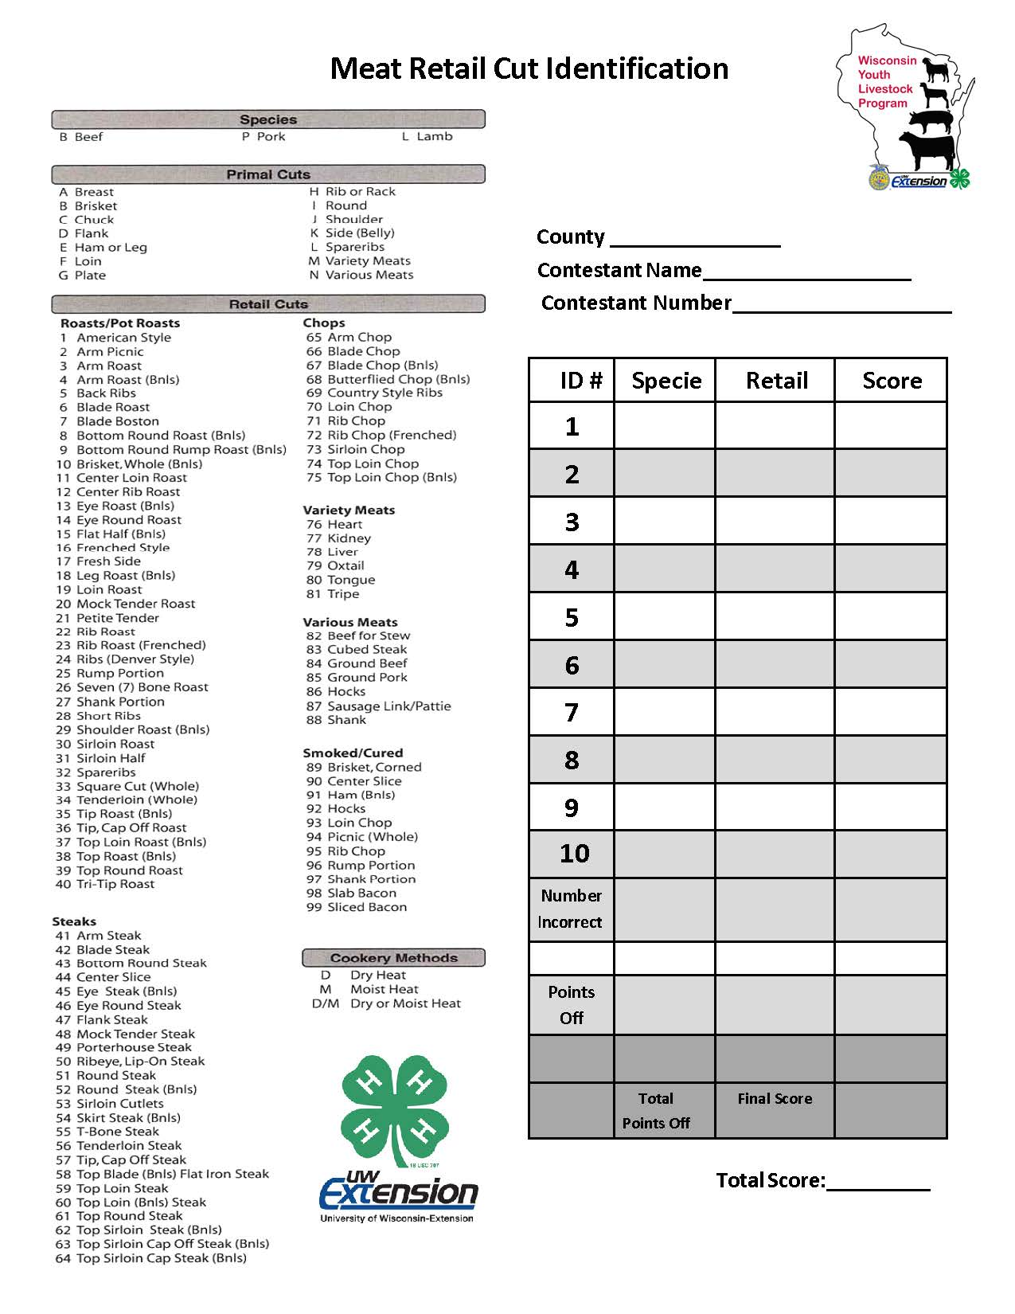

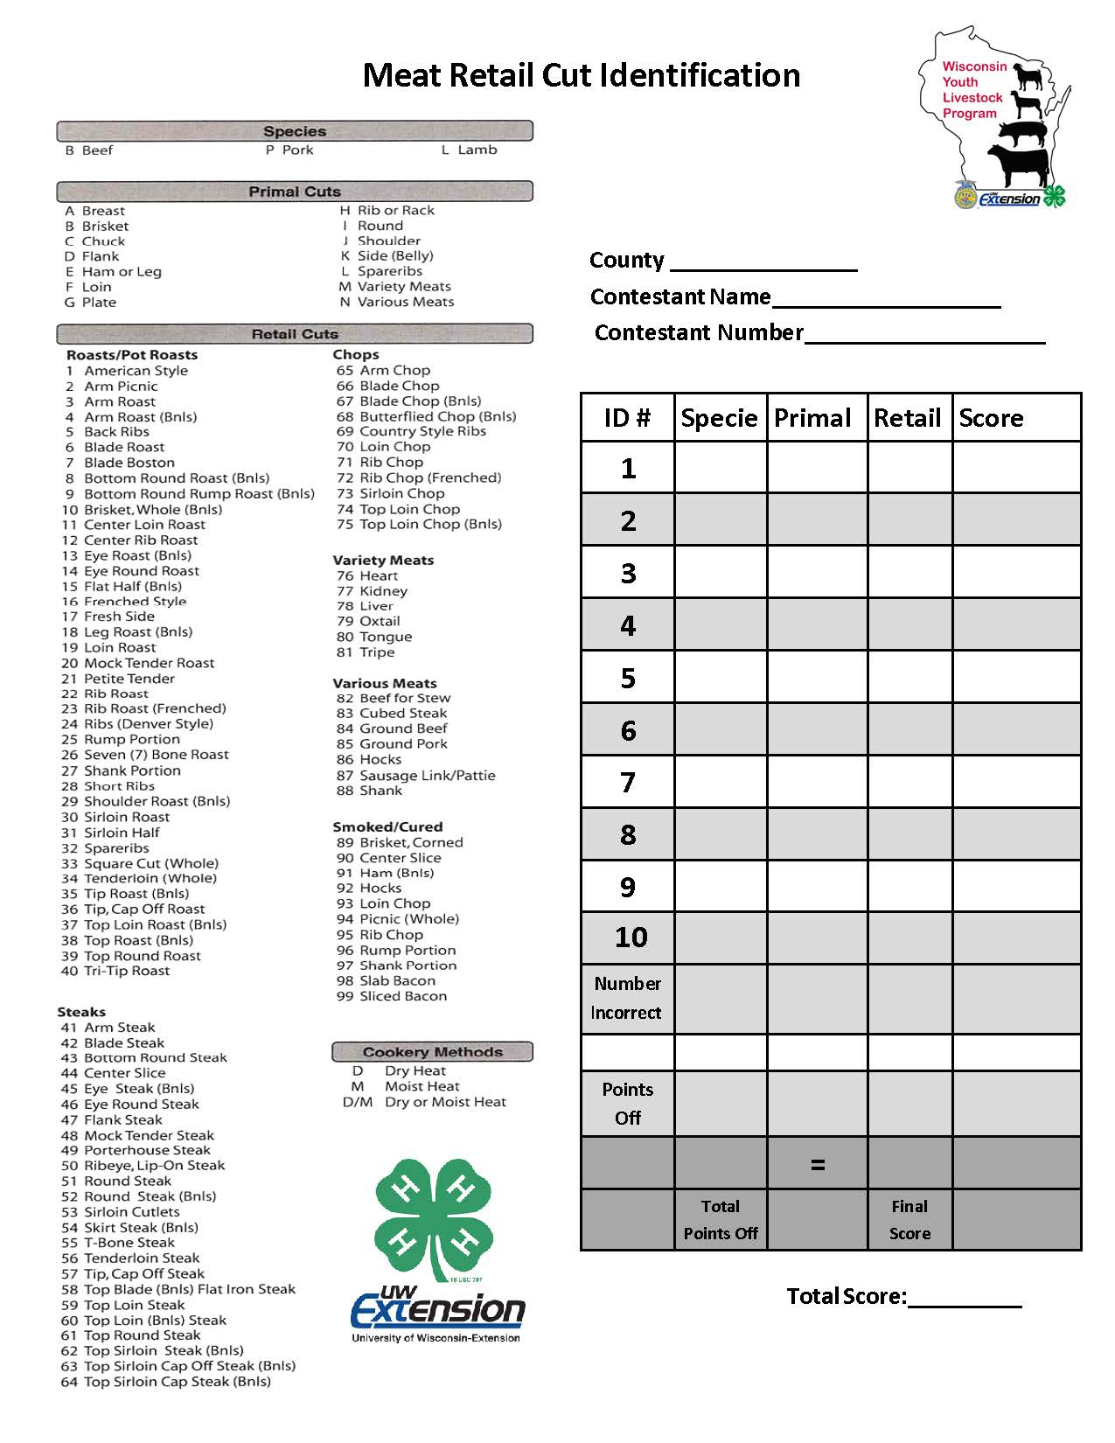
SENIOR RETAIL CUT IDENTIFICATION

LIVESTOCK FEED IDENTIFICATION
Below are the various feedstuffs that will be selected from for the 2020 Wisconsin 4-H Livestock Skill-A-Thon Contest. Students could be asked to identify 10 feedstuffs and the energy group of which they are categorized. Additionally, it might be helpful to collect an actual feedstuff bank so students can determine textures and smells associated with each feedstuff that cannot be determined online.

Feed/Feedstuffs Blood Meal Buckwheat
Complete Pelleted Feed Cracked Corn
Corn Gluten Meal
Dehydrated Alfalfa Meal Pellets Dicalcium Phosphate
Distillers Grain
Dried Sugar Beet Pulp Dried Whey
Dry Molasses Fish Meal
Ground Limestone (Calcium Carbonate)

Hay Cube Soybean Hulls Soybean Meal
Steam Rolled Barley Steam Rolled Oats Trace Mineral Salt Urea
Wheat Middlings White Salt
Whole Grain Oats Whole Grain Wheat Whole Kernel Corn

Nutritional Group
Energy Minerals Proteins Vitamins Water

LIVESTOCK BREED IDENTIFICATION
Students identify pictures of livestock from four species (beef, sheep, swine and meat goats). Seniors will also be asked to match the breed description with the appropriate picture and breed.

Junior & Mixed Livestock Breed Identification
(ANSWER KEY)

Name

Contestant #

(Place the letter of the correct breed in the blanks beside the number that corresponds to the pictures)
Description

1. F

2. T

- AA 4. C 5. X 6. V 7. ___J__
8. R 9. Y
10. B
Beef Breeds
- Angus
- Brahman
- Charolais
- Chianina
- Gelbvieh
- Hereford
- Limousin
- Santa Gertrudis
- Shorthorn
- Simmental

Sheep Breeds
- Cheviot
- Columbia
- Corriedale
- Dorset
- Finnsheep
- Hampshire
- Katahdin
- Merino
- Rambouillet
- Southdown
- Suffolk

Swine Breeds
- Berkshire
- Chester White
- Duroc
- Hampshire
- Hereford
- Landrace
- Pietrain
EE. Poland China FF. Spot
GG. Yorkshire

Meat Goats
HH. Boer
II. Spanish
JJ. Pygmy
KK. Kiko
LL. Angora
MM. Mytonic

Senior Livestock Breed Identification (ANSWER KEY)
Name
Contestant #
(Place the letter of the correct breed and the letter of the correct breed description in the blanks beside the number that corresponds to the pictures)
BREED/ Description

1. BB z

2. D c
Beef Breeds
- Angus
- Brahman
- Charolais
Beef Breed Descriptions
  - Developed in Switzerland, noted for high growth rate, milking ability, and carcass cutability.
  - Hardy British breed which in recent years combined polled and

3. N
w
- Chianina
- Gelbvieh
horned associations.
- Large framed, developed in Italy as dual purpose for beef and draft.
- British breed with highest number of registration in the U. S. noted

- DD ff
- Hereford
- Limousin
for mothering ability and carcass marbling.
- High growth breed originally from France known for cutability.

- FF

6. I
gg

j
- Santa Gertrudis
- Shorthorn
- Simmental
- Bos indicus breed with heat and insect tolerance.
- Developed in Germany with good carcass cutability and relatively early puberty.
- Developed in France with moderate growth rate and frame size and

7. H i

Sheep Breeds
high carcass cutability.
- Developed in Texas by crossing the Brahman and Shorthorn breeds.
- British breed with three distinct color patterns.

8. S
s
- Cheviot
- Columbia

9. G h
- Corriedale
- Dorset
Sheep Breed Descriptions
- Small framed, early maturing meat breed developed in England.

10. P
v
- Finnsheep
- Hampshire
- Katahdin
- Merino
- Rambouillet
- Southdown
- Suffolk

Swine Breeds
- Berkshire
- Chester White
- Duroc AA. Hampshire BB. Hereford CC. Landrace DD. Pietrain
EE. Poland China FF. Spot
GG. Yorkshire

Meat Goats
HH. Boer
II.Spanish
JJ. Pygmy
KK. Kiko
LL. Angora
MM. Mytonic

Small sized meat breed noted for its hardiness from Scotland.
- Large framed, English, meat breed with black face and wool cap.
- Very fine fleece breed with heavy wool production from Spain.
- Large frame wool breed developed from crossing Lincoln or Leicester rams on Merino ewes.
- Wool breed developed in France and Germany from Merino breed.
- Hair breed developed in U. S. that does not require shearing because it sheds its’ wool.
- Large framed, black faced breed known for high growth rate and carcass cutability from England.
- Lighter muscled breed from Finland noted for prolificacy.
- English, white face, meat breed known for out of season breeding.
- Large frame U. S. breed, developed from Lincolns and Rambouillets.

Swine Breed Descriptions
- Noted for high growth rate, durability, and pork quality, developed in New Jersey and New York.
- Known as a maternal breed with droopy ears, developed in PA.
- Dual purpose breed, red with white markings on head and lower body.
aa. Black and white, developed in U. S., noted for rapid growth and as aggressive breeders.
bb. Lean, heavy muscled, black breed with six white points and droopy ears.
cc. Known as “Mother Breed”, they are typically long bodied and sound with erect ears.
dd. Predominantly black with erect ears, originally from England noted for pork quality tenderness and marbling.
ee. Noted for large litters and large droopy ears, generally refined in bone.
ff. Noted for extreme muscle volume and shape, with a high propensity for stress which is related to pork quality concerns.
gg. Terminal sire breed with unique color markings noted for cutability.

Meat Goat Breed Descriptions
HH. Developed in South Africa, horned with loped ears, showing a variety
of color patterns.
II. Known as the “brush or scrub goat, imported from Mexico to the US.
JJ. Developed in Africa, known as the Cameroon Dwarf Goat
KK. Developed in New Zealand mating feral goats to dairy goats for meat.
LL. Goat that produces Mohair and not as prolific as other meat goat breeds.
MM. A multi-purpose breed for pets, food and fiber, i.e. “fainting goats”

MEAT JUDGING
Meat Judging Class: Rank two classes of four similar retail cuts of meat (100 possible points). Seniors must also answer five questions for each class (50 points). For more information on placing meat cuts please refer to the Skill-A-Thon Contest Resource List

FLEECE/HAY JUDGING
Fleece and Hay Judging Class: (100 possible points) Rank a class of four hay samples with forage analysis information. Rank a class of four samples of fleece. For more information on evaluation of hay and fleece samples please refer to the Indiana 4-H/FFA Skill-A-Thon Contest Resource list.

2020 Hay Judging Class – EXAMPLE
Scenario: The hay being ranked will be fed to cattle during early lactation. In addition to the hay, their rations will also be supplemented with grain. Any hay remaining will be marketed to other local beef producers.

 | Hay #1 | Hay #2 | Hay #3 | Hay #4
Dry Matter | 91.96 | 90.27 | 92.03 | 90.05
Crude Protein | 15.75 | 17.83 | 16.22 | 18.67
ADF* | 34.91 | 27.83 | 33.67 | 26.53
NDF* | 47.39 | 41.34 | 42.46 | 39.05
TDN* | 57 | 58 | 57 | 59
RFV* | 112 | 135 | 123 | 141

Official Placing: 4-2-3-1 Cuts: 3-3-5

- ADF = Acid Detergent Fiber * TDN = Total Digestible Nutrients
- RFV = Relative Feed Value * NDF = Neutral Detergent Fiber

LIVESTOCK EQUIPMENT IDENTIFICATION
Livestock Equipment Identification: (50 possible points) Identify the proper name for ten pieces of equipment used in livestock production. (A list of equipment will be provided.) Seniors must also identify their usage type (ex: breeding).
Contestant Number

Livestock Equipment Identification – Junior & Mixed Scorecard
(under 14 years of age)
Place the letter of the correct piece of equipment in the blank matching the number on the item.

1. | A. | Ammonia sensor | AA. | Hoof trimmer
2. | B. | Antiseptic applicator | BB. | Intravenous set
3. | C. | Balling gun | CC. | Knife steel
4. | D. | Beef cattle frame stick | DD. | Lamb boot
5. | E. | Beef Halter | EE. | Lamb tube feeder
6. | F. | Breeding catheter | FF. | Nasal cannula
7. | G. | Cattle clippers | GG. | Needle teeth clippers
8. | H. | Cattle straw A. I. gun | HH. | Nipple waterer
9. | I. | Cauterizing tail docker | II. | Nose lead
10. | J. | Curry comb | JJ. | Pig obstetrical forceps
 | K. | Dehorner | KK. | Pig resuscitator
 | L. | Disposable syringe | LL. | Pistol grip syringe
 | M. | Drench gun | MM. | Prolapse ring retainer
 | N. | Ear notchers | NN. | Implant gun
 | O. | Ear tag pliers | OO. | Ram marking harness
 | P. | Elastrator | PP. | Rumen magnet
 | Q. | Electric fence tester | QQ. | Scalpel
 | R. | Electronic I.D. tag | RR. | Scotch Comb
 | S. | Emasculator | SS. | Shearer's screwdriver
 | T. | Ewe spoon | TT. | Sheep shears
 | U.  W. | Foot rot shears Freeze branding iron | UU.  WW. | Swine breeding spirette Test tube
 | X. | Heat detection patch | XX. | Transfer needle
 | Y. | Hog snare | YY. | Vacutaner
 | Z. | Hoof chisel | ZZ. | Wool card

Contestant Number

Livestock Equipment Identification - Senior Scorecard (14 years of age and older)
Place the letter of the correct piece of equipment in the blank matching the number on the item.

I.D. Equipment I.D. List

1. | A. | Ammonia sensor | AA. | Hoof trimmer
2. | B. | Antiseptic applicator | BB. | Intravenous set
3. | C. | Balling gun | CC. | Knife steel
4. | D. | Beef cattle frame stick | DD. | Lamb boot
5. | E. | Beef Halter | EE. | Lamb tube feeder
6. | F. | Breeding catheter | FF. | Nasal cannula
7. | G. | Cattle clippers | GG. | Needle teeth clippers
8. | H. | Cattle straw A. I. gun | HH. | Nipple waterer
9. | I. | Cauterizing tail docker | II. | Nose lead
10. | J. | Curry comb | JJ. | Pig obstetrical forceps
 | K. | Dehorner | KK. | Pig resuscitator
 | L. | Disposable syringe | LL. | Pistol grip syringe
 | M. | Drench gun | MM. | Prolapse ring retainer
 | N. | Ear notchers | NN. | Ralgro implant gun
 | O. | Ear tag pliers | OO. | Ram marking harness
 | P. | Elastrator | PP. | Rumen magnet
 | Q. | Electric fence tester | QQ. | Scalpel
 | R. | Electronic I.D. tag | RR. | Scotch Comb
 | S. | Emasculator | SS. | Shearer's screwdriver
 | T. | Ewe spoon | TT. | Sheep shears
 | U.  V. | Foot rot shears UU. Forage probe | Swine VV. | breeding spirette Tattoo pliers
 | W. | Freeze branding iron | WW. | Test tube
 | X. | Heat detection patch | XX. | Transfer needle
 | Y.  Z. | Hog snare Hoof chisel | YY.  ZZ. | Vacutainer Wool card

QUALITY ASSURANCE - INDIVIDUAL
Quality Assurance Exercise: (50 possible points) Demonstrate how to read a medicine label, calculate withdrawal times, complete a treatment record, and make responsible management decisions regarding quality assurance.

Contestant Number: KEY

4-H Skill A thon Quality Assurance exercise — JUNIOR Division

10 questions — 5 points each for a total of 50 points

Please reference KENT First Rate Show Lamb Diet 18DQ feed tag when answering these questions

  - True or False (circle one) Withdrawal times are the minimum amount of time, usually in number of days, that must pass from the time the medication is administered until the animal can be slaughtered for meat consumption.

  - True or False (circle one) This feed needs to be mixed with corn and oats before I feed it to my lambs.

  - My lamb weighs 75 pounds. How much feed should my lamb consume per day to provide the recommended amount of the active drug ingredient.
    - 1.875 pounds
    - 2.53 pounds
    - 1.57 pounds
  - Yes or No (circle one) We are taking both lambs and pigs together to a preview show this weekend. If we run low on pig feed, will I violate label warnings by feeding this lamb feed to my pigs?

  - I am concerned about my lambs getting coccidiosis. What minimum length of time should I feed this feed to prevent coccidiosis?
    - 10 Days b. 3 weeks c. 4 weeks

  - Yes or No (circle one) I just weaned lambs from my ewes and they weigh 40 - 45 pounds. Can I start giving them this feed to eat?

  - What are the 3 primary ingredients in this feed?
    - corn, alfalfa meal, fishmeal
    - corn, barley, oats
    - corn, oats, grain by-products
  - Which 2 feed ingredients list both minimum and maximum on the guaranteed analysis?
    - crude fat and calcium b. salt and selenium c. calcium and salt

  - 18.0% What percent crude protein is in this feed?

  - Yes or No (circle one) I am also feeding another feed to my lambs containing bentonite. Can I feed them both feeds at the same time?

First Rate Show Lamb Diet 18DQ Medicated

Product Description
Kent First Rate™ Show Lamb Diet 18DQ is an 18% protein, texturized product for growing and finishing show lambs. It is a diet with a very specific combination and ratio of ingredients designed to optimize the genetic growth potential of sheep. Kent First Rate™ Show Lamb Diet 18DQ incorporates multiple protein and energy sources; precise, highly absorbable minerals and vitamin fortification; yeast; and appetite enhancers.

Features and Benefits
Steam-rolled and cracked corn – improves carbohydrate availability, releasing more energy for gain.
Steam-rolled barley – provides unique fermentation and a source of energy to improve
gain and facilitate proper finish.
Oats – improve diet texture, promoting appetite and gain,while providing a unique combination of digestible fiber and energy.
Multiple protein sources (including fish meal) – provide for maximum muscle expression and development, plus high- quality wool production.
Dehydrated alfalfa meal – digestible fiber source provides delayed energy release, calcium, phosphorus, and vitamins.
High-vitamin levels – improve energy and protein metabolism, feed utilization, immunity, and overall health to help fight stress in show environments.
Yeast – improves palatability and feed digestion, leading to increased gain and feed efficiency while promoting stable rumen fermentation.
Sodium molybdate with no added copper – reduces the likelihood of copper toxicity.
Ammonium chloride – aids in the prevention of urinary calculi (water belly).
Molasses – increases palatability and intake for improved acceptance and average daily gain.

Feeding Directions
Gradually adapt lambs 60 pounds or heavier to First Rate™ Show Lamb Diet 18DQ. Lambs should consume First Rate™ Show Lamb Diet 18DQ at the rate of 0.25 lb per 10 lb of body weight to provide 22.7 mg of decoquinate per 100 lb of body weight. Feed at least 28 days during periods of exposure or when experience indicates coccidiosis is likely to be a hazard. It may also be desirable to feed 0.25 to 0.5 lb of good-quality hay per head, daily.
Do not use in feed containing bentonite.
Do not feed to sheep producing milk for food.
First Rate™ Show Lamb Diet 18DQ
Medicated
A complete grain feed for growing and finishing show lambs.
For the prevention of coccidiosis caused by Eimeria ovinoidalis, Eimeria parva, Eimeria bakuensis and Eimeria crandallis.
ACTIVE DRUG INGREDIENT
Decoquinate . . . . . . . . . . . . . . . . 0.00198% (18 gm/ton)
GUARANTEED ANALYSIS
Crude Protein, min. . . . . . . . . . . . . . . . . . . . . . . 18.0%
This includes not more than 1.3% equivalent crude protein from non-protein nitrogen (NPN from Ammonium Chloride)
Crude Fat, min.. . . . . . . . . . . . . . . . . . . . . . . . . . . 3.0%
Crude Fiber, max.. . . . . . . . . . . . . . . . . . . . . . . . . 7.5%
Calcium (Ca), min. . . . . . . . . . . . . . . . . . . . . . . . . 0.8%
Calcium (Ca), max.. . . . . . . . . . . . . . . . . . . . . . . . 1.3%
Phosphorus (P), min.. . . . . . . . . . . . . . . . . . . . . . 0.4%
Salt (NaCl), min. . . . . . . . . . . . . . . . . . . . . . . . . . . 0.4%
Salt (NaCl), max.. . . . . . . . . . . . . . . . . . . . . . . . . . 0.9%
Selenium (Se), min. . . . . . . . . . . . . . . . . . . . . 0.3 ppm
Vitamin A, min. . . . . . . . . . . . . . . . . . . . . . . 6,000 IU/lb
Vitamin D3, min. . . . . . . . . . . . . . . . . . . . . . . 600 IU/lb
Vitamin E, min.. . . . . . . . . . . . . . . . . . . . . . . . . 37 IU/lb
Warning: This feed should be used in accordance with directions on this label. Feed to ruminants only.
INGREDIENTS
Corn, Barley, Oats, Dehydrated Alfalfa Meal, Processed Grain By- Products, Plant Protein Rations, Fishmeal, Cane Molasses, Vegetable Oil, Calcium Carbonate, Salt, Ammonium Chloride, Animal Fat, Yeast Culture, Vitamin A Acetate, Cholecalciferol (source of Vitamin D3), Vitamin E Supplement, Niacin Supplement, Calcium Iodate, Manganous Oxide, Ferrous Sulfate, Cobalt Carbonate, Zinc Oxide, Magnesium Oxide, Sodium Molybdate, Sodium Selenite, Natural and Artificial Flavors, Ethoxyquin and BHT(preservatives).

Specialty (6601)
6/01 ©COPYRIGHT 2001 KENT FEEDS, INC.

QUIZ
Quiz: (50 possible points) Complete a quiz concerning the total livestock industry.

2020 Livestock Skill A Thon - KEY Junior & Mixed Written Test

C 1. A is a castrated male lamb.
A) Ram B) Steer C) Wether D) Ewe

C 2. is the weight of a lamb taken within 24 hours after birth.
A) Birth date B) Weaning Weight C) Birth Weight D) Yearling Weight

A 3. Which of the following beef breeds originated in Scotland and is known for its carcass quality and mothering ability. These animals are polled with a black, smooth coat.
A) Angus B) Hereford C) Charolais D) Shorthorn

D 4. Animals develop a comfortable space around them; as a person enters the space the animal becomes tense. This space is called the animal’s .
A) Handler B) Quality Zone C) Dam D) Flight Zone

B 5. is the removal of the testicles.
A) Docking B) Castration C) Weaning D) Injection

C 6. A contains the correct amount of nutrients to nourish an animal during a 24 hour period.
A) Concentrate B) Roughage C) Balanced Ration D) Digestion

C_ 7. A is an intact male pig
A) Ram B) Bull C) Boar D) Stallion

A 8. is the most essential and cheapest off all the nutrients provided to livestock.
A) Water B) Protein C) Vitamins D) Minerals

C 9. Which of the following is a breed of swine?
A) Angus B) Dorset C) Duroc D) Piedmontiese

D_ 10. Which of the following are products provided by hogs?
A) Heart Valves B) Medicines C) Paint brushes D All of the Above

B_ 11. Which of the following is a breed of sheep?
A) Hereford B) Southdown C) Chester White D) Polled Hereford

D_ 12. Processing a new litter of pigs includes .
A) Weighing B) Cord Care C) Clipping Needle Teeth D) All of the above

C 13. The muscle, bone and fat associated with the slaughter of an animal is called the
.
A) Retail Cut B) Dressing C) Carcass D) None of the above

C 14. A group of cattle managed together is called a .
A) Flock B) Grade C) Herd D) Sire

B 15. An animal whose parents are of the same breed is called a .
A) Ram B) Purebred C) Crossbred D) Ewe

D 16. Mutton is the meat from older than 12 months of age.
A) Swine B) Dairy C) Beef D) Sheep

D 17. Which of the following are beef industry careers?
A) Feedlot Manager B) Herd Manager C) Meat Inspector D) All of the above

A 18. A medication can sold at farm supply stores and purchased without a prescription.
A) Over the Counter B) Prescription C) Withdrawal Time D) None of the above

C 19. A is a young female pig that has not had a litter of pigs.
A) Heifer B) Sow C) Gilt D) Ewe

_C 20. is the period of time that must pass between the last treatment with a drug and slaughter.
A) Over the Counter B) Prescription C) Withdrawal Time D) Extra label drug use

_C 21. The ideal mature weight for market steers is pounds.
A) 250 to 300 B) 750 to 900 C) 1100 to 1350 D) 1500 to 1800

A 22. refers to the general body shape of the pig as determined by its skeleton and muscle structure.
A) Conformation B) Withdrawal Time C) Balance D) Cow-hocked

A 23. Which of the following is a form of identification of beef animals?
A) Tattooing B) Ear notching C) Tail Docking D) Castration

D 24. With this condition the hocks of an animal are too close together.
A) Splayfooted B) Pigeon Toed C) Post Legged D) Cow Hocked

B 25. The gene is a condition in swine that makes them susceptible to external stress associated with animal movement and changes in their environment. Animals testing positive for the gene can die when stress occurs.
A) Napole B) Porcine Stress Syndrome C) Pseudorabies D) Dysentery

2020 Livestock Skill A Thon - KEY Senior Written Test
A 1. Which of the following breeds of cattle was developed by the United States Department of Agriculture?
A) Brangus B) Gelbvieh C) Angus D) Hereford

C 2. is an inflammation of the udder or mammary gland caused by a bacterial infection.
A) Lactation B) Ketosis C) Mastitis D) Dystocia

D 3. is a form of inbreeding in which an attempt is made to concentrate the inheritance of an outstanding ancestor in a herd.
A) Crossbreeding B) Heterosis C) Out crossing D) Line Breeding

A 4. is a disease that affects lambs and is caused by a lack of vitamin E and selenium. Lambs affected cannot walk or nurse properly.
A) White Muscle Disease B) Foot Rot C) Navel ill D) Parasites

_B 5. involves the collection of embryos from a donor cow and implanting them in other cows called recipients.
A) Pasture Breeding B) Embryo Transfer C) AI D) Handmating

C 6. Which of the following is a swine breed developed in America. The breed is solid red, has droopy ears and grows quickly.
A) Chester White B) Tamworth C) Duroc D) Spot

A 7. Thread like structures that contain genes are called .
- Chromosomes B) Genetics C) Heterosis D) None of the above

B 8. Which of the following is a trait of economic importance in beef cattle?
  - Reproductive Performance B) Growth Rate
C) Conformation D) All of the Above

C 9. is a figure used to describe how offspring will perform in relation to the average performance of other animals in the breed.
A) MPPA B) 205 Day Adjusted Weaning Weight
C) EPD D) 365 Day Adjusted Yearling Weight

C 10. The length of gestation for a ewe is .
A) 83 to 92 days B) 93 to 102 days C) 143 to 152 days D) 193 to 202 days

A 11. The term used to describe the expression of genetic traits is .
A) Phenotype B) Genotype C) Qualitative D) Quantitative

C 12. Iron injections are given to baby pigs to prevent .
A) Flu B) Parvovirus C) Anemia D) Infection

D 13. is the hormone that maintains pregnancy.
A) Oxytocin B) Testosterone C) Estrogen D) Progesterone

B 14. The gene is a condition in swine that makes them susceptible to external stress associated with animal movement and changes in their environment. Animals testing positive for the gene can die when stress occurs.
A) Napole B) Porcine Stress Syndrome C) Pseudorabies D) Dysentery

15. is the hormone that causes the secondary sex characteristics in the ram/boar/bull.
- Oxytocin B) Testosterone C) Estrogen D) Progesterone

B 16. Which of the following is NOT a method of castration used for lambs?
  - The knife method B) Docking
C) Elastrator C) Burdizzo

C 17. The pig is a simple stomached animal called a .
A) Ruminant B) Hind gut fermenter C) Monogastric D) None of the above

A 18. Beef animals are called because they have a four-compartment stomach.
A) Ruminants B) Hind gut fermenters C) Monogastrics D) None of the above

C 19. Beef carcass grades are based upon marbling and maturity.
A) Yield B) Rib eye area C) Quality D) Fat thickness

B 20. is a term that is used to describe wool that is badly matted or tangled.
A) Tags B) Cotted C) Dead wool D) Shrink

A 21. causes swelling and lameness.
A). Foot Rot B) BVD C) Pinkeye D) Hardware disease

C 22. is a fungus that gets into the skin and develops a rough condition where the hair drops out in patches.
- Foot Rot B) Shipping Fever C) Ringworm D) Pinkeye

B 23. An operation that produces lamb and wool that is destined for the consumer is called a .
  - Club Lamb Flock B) Commercial Flock
C) Herd D) None of the above

D 24. Which of the following breeds of cattle was developed in Texas? The breed is 5/8 Shorthorn and 3/8 Brahman. They are known for their growth rate, long life and hardiness.
A) Saler B) Angus C) Polled Hereford D) Santa Gertrudis

D 25. Animals with this condition the hocks of an animal are too close together.
A) Splayfooted B) Pigeon Toed C) Post Legged D) Cow Hocked

QUALITY ASSURANCE EXERCISE
TEAM EXAMPLE
Quality Assurance Exercise: (100 possible points) Demonstrate how to read an animal health product label, calculate dosage rates and withdrawal times, complete a treatment record, be familiar with administration routes, and make responsible management decisions regarding quality assurance.

TEAM CLASS

Team Name:
Team Number:

2020 Wisconsin 4-H Livestock Skill-A-Thon Contest Team Quality Assurance Exercise
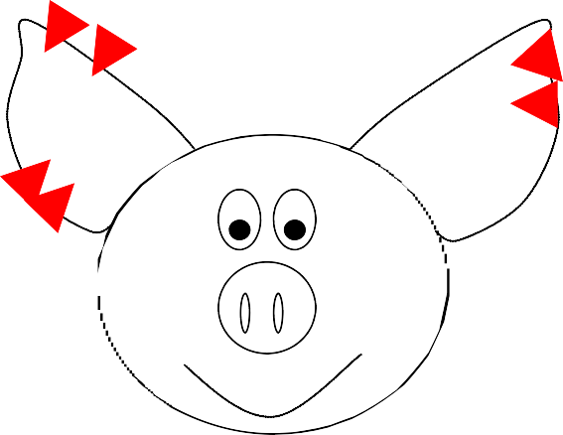
(100 Points)

Place an “X” on the proper location for a subcutaneous injection on this steer. (5 points)
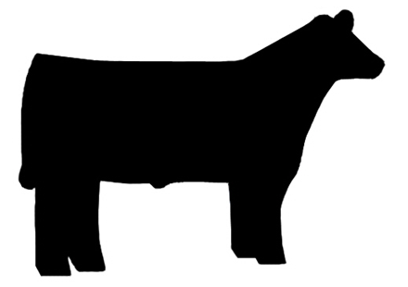

20-6

This market hog needs to be ear-notched, he was the 6th pig processed from the 20th litter born on the farm this year. Mark the appropriate position of the notches on the above drawing. (10 points Seniors/5 points Juniors)

This 4-H market lamb was born on January 28, 2020 weighing 15 pounds.
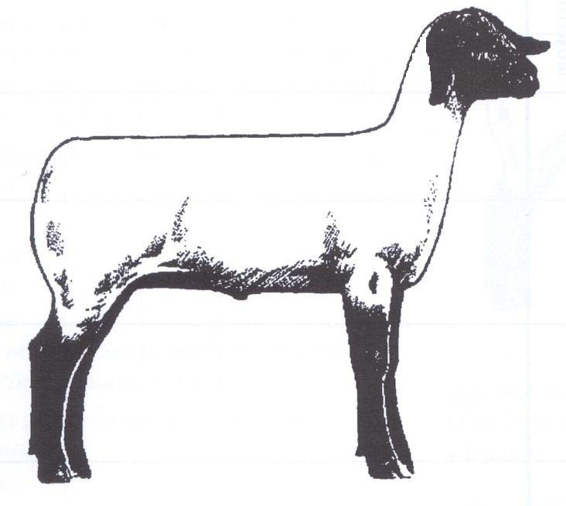

x Today is July 30, 2020 and it is ready for market at 130 pounds.
Place an “X” on the proper location for a subcutaneous injection on this lamb. (5 points)

Use the attached product labels to complete the following records and determine if the withdrawal times on all medications have been met. (3 points each seniors/5 points each juniors)

Animal ID #:
Treatment Record

1234

(5 points)

Treatment Date | Condition Being Treated | Animal’s Weight | Product Name  (Info was provided for Juniors only)* | Dosage | Route Administered | Withdrawal Time | Date Withdrawal Completed
*1/29/2020 | Vitamin E Supplement | 15 lbs. | Vital E—300 | 2—3 mL | IM or SQ | None | N/A
2/11/2020 | White Muscle Disease Prevention | 25 lbs. | BO-SE | 1 mL | IM or SQ | 14 days | 2/25/2005
3/25/2020 | Worming | 50 lbs. | Levasole | 1 bolus | Oral | 72 hours | 3/28/2005
4/22/2020 | Clostridium Vaccination | 65 lbs. | Covexin 8 | 5 mL | SQ | 21 days | 5/13/2005
6/17/2020 | Clostridium Vaccination Booster | 100 lbs. | Covexin 8 | 2 mL | SQ | 21 days | 7/8/2005
*Note to coaches: Top line and product name was provided for Juniors only.

LIVESTOCK SCENERIO
TEAM EXAMPLE
Animal Breeding Scenarios and Exercise: (100 possible points) Team members will evaluate a breeding animal scenario and make animal selection decisions based upon performance data to rank breeding animals for use within the situation. Examples from previous contests (including National Contest) follow.

2020 Animal Breeding Scenario - Team Exercise

Team Name

Ram Selection Scenario
Team Number

You are a Midwest sheep rancher who needs to purchase rams for your two flocks of ewes. One flock of ewes consists of purebred Suffolk females who have been selected over the years to excel in maternal traits, including genetic resistance to Scrapie disease and Spider Lamb Syndrome. Thirty percent of the ewe lambs are kept annually as replacements from this purebred flock. Top quality rams are retained as stud bucks or sold to other purebred producers at national sales. All other lambs are retained and fed to market weight in the family-owned feedlot.

Your second flock of ewes consists of crossbred females (Suffolk X Columbia) who have been selected for post-weaning growth and prolificacy. All offspring from this flock are sold at weaning to a lamb buyer in Colorado, who puts the lambs in a feedlot and feeds them to market weight. The lamb buyer is a regular customer because he knows this commercial flock is genetically resistant to the Spider Lamb Syndrome.

Suffolk Ram Performance Data

 |  | Expected Progeny Differences
Ram No. | Name | Weaning Weight | Post Weaning | Milk | Milk & Gain | Number of Lambs Born |  | Number of Lambs with wts. | Codon 171  Genotype | Spider Lamb Genotype | *Birth Type
1 | Star | 3.2 | 3.5 | 1.2 | 1.9 | 2.8 |  | 151 | RR | NN | TW
2 | Chapman | 1.4 | 1.7 | 0.1 | 0.8 | 0.7 |  | 08 | QQ | NS | S
3 | Donner | -1.4 | -2.5 | 0.0 | -0.7 | 1.6 |  | 17 | RR | NN | S
4 | Eagle | 2.8 | 5.6 | 1.5 | 2.9 | 2.9 |  | 43 | QR | NS | TR
5 | Perfection | 3.1 | 4.7 | -0.1 | 0.7 | 3.4 |  | 51 | RR | NN | TW
6 | Horse | 0.5 | 0.6 | 0.2 | 0.4 | 2.5 |  | 40 | QR | NN | TW
7 | Slacker | 3.1 | 5.3 | 1.6 | 2.1 | 4.7 |  | 149 | RR | NN | TW
8 | Outlier | 1.2 | 2.5 | -2.5 | -0.1 | -3.1 |  | 35 | QR | NN | S
Breed Averages |  | 1.1 | 2.1 | 0.2 | 0.9 | 1.23
*S = single *TW = twin *TR = triplet

Team Name KEY

Team Number

QUESTIONS

- Which two rams are best suited for use in the purebred flock? Star (1) and Slacker (7)
- Which ram has no genetic resistance to the Scrapie disease? Chapman (2)
- Which ram is most likely to sire the slowest growing progeny to 120 days-of-age? Donner (3)
- Which ram will improve prolificacy the most? Slacker (7)
- Which ram is least suited for use in your flock of crossbred ewes? Chapman (2)
- Which two rams should you purchase to meet the goals of your crossbred flock? Perfection (5) and Slacker (7)
- Which two rams are not genetically resistant to the Spider Lamb Syndrome? Chapman (2) and Eagle (4)
- Which two rams are the most proven? Star (1) and Slacker (7)
- Which ram’s daughters would you expect to generate the lowest number of lambs born? Outlier (8)
- Which ram has two siblings? Eagle (4)
- Which of the rams that were born a twin, offers the least post weaning growth? Horse (6)
- Which ram is the least suited as a maternal sire? Outlier (8)
- Which two rams have the most balanced performance profile when considering a combination of growth, maternal traits and Scrapie resistance? Star (1) and Slacker (7)
- Which ram would be well suited for your crossbred ewes, except for the fact that he is not genetically resistant to Spider Lamb Syndrome? Eagle (4)
- Which ram is below breed average for all of the listed traits except “number of lambs born”? Donner (3)

National/Wisconsin 4-H Livestock Skillathon Resource Materials:
*Suggested study materials include but are not limited to the following list.

Updated: 10/2019

Swine Resources
Swine
OSU Swine Resource Handbook
4-H circular 134R
The Ohio State University
https://extensionpubs.osu.edu/swine-resource-handbook-for-market-and-breeding-projects/

4-H Literature:
Swine 1 – Growing with Swine (revised 2004)
Swine 2 – Becoming Swine Smart (revised 2004)
Swine 3 – Entering the Arena (revised 2004)
Swine Helper’s Guide (revised 2004)
Available from your extension offices
4-H CCS Materials – Available at https://4-h.org/parents/curriculum/
National Pork Board Swine Quiz and Skillathon Resources:
http://www.pork.org/youth-and-education/skillathon-quiz-bowl/

Pork Checkoff Quick Facts publication:
http://www.pork.org/pork-quick-facts/

Seedstock Edge: www.nationalswine.com
National Swine Registry
West Lafayette, IN

Nasco Farm & Ranch Catalog
Fort Atkinson, WI 1-800-558-9595
http://www.enasco.com

National Hog Farmer
Monthly Periodical
7900 International Drive, Suite 300
Minneapolis, MN 55425 http://www.nationalhogfarmer.com/

OSU Swine Learning Lab Interactive CD
The Ohio State University
Phone: 614-292-4848
https://ohio4h.org/sites/ohio4h/files/d6/files/CD%20flyer%20smallest.pdf

Livestock E-Quiz: http://web.extension.illinois.edu/equiz/

Illinois Trail - Technology and Research: Allied & Integrated Livestock Linkages
http://livestocktrail.illinois.edu/

Illini Porknet (Ask the Expert): http://livestocktrail.illinois.edu/porknet/

PORK magazine: http://www.Porkmag.com

Information on all swine breeds: http://www.ansi.okstate.edu/breeds/

American Meat Institute: https://www.meatinstitute.org/
Pork Industry Handbook
https://www.usporkcenter.org/jobs-resources/pork-industry-handbook/

Beef
UNL Beef Manual Handbook
This is an updated manual that replaces the OSU beef manual
Download is electronic and costs approximately $40.
http://marketplace.unl.edu/ne4h/4h4200.html
OSU Beef Resource Handbook
4-H circular 117R
The Ohio State University
https://extensionpubs.osu.edu/beef-resource-handbook/

4-H Literature:
Beef 1 – Bite into Beef (revised 2005)
Beef 2 – Here’s the Beef (revised 2005)
Beef 3 – Leading the Charge (revised 2005)
Beef Helper’s Guide (revised 2005)
Available from your extension offices
4-H CCS Materials – Available at https://4-h.org/parents/curriculum/

Information on all beef breeds: http://www.ansi.okstate.edu/breeds/
Illini Beefnet (Ask the Expert): http://web.extension.illinois.edu/oardc/

Illinois Beef Handbook – http://web.extension.illinois.edu/oardc/downloads/43908.pdf

Beef Production and Management Decisions 2nd Edition by Robert Taylor

Feeds and Feeding by Morrison and Morrison

Forages, Fourth Edition by Maurice E. Heath, Robert F. Barnes and Darrel S. Metcalfe

Meat Evaluation Handbook by National Cattlemen’s Beef Association
For Mixed and Senior Divisions:
Nebguides: UNL Extension Publications
Beef Cattle Implant Update and Synchronizing Estrus in Beef Cattle, can be found at http://beef.unl.edu/learning/estrussynch.shtml

Sheep

Sheep Resource Handbook
4-H circular 194R
The Ohio State University
Phone number 614-292-1607
https://extensionpubs.osu.edu/sheep-resource-handbook-for-market-and-breeding-projects/

Sheep Production Handbook
Formerly called the sheep industry development handbook or SID
803-771-3500 ext. 46
4-H Literature: (Available from your Extension Offices)
Sheep 1 – Lambs, Rams, and You (revised 2000)
Sheep 2 – Shear Delight (revised 2000)
Sheep 3 – Leading the Flock (revised 2000)
Sheep Helper’s guide
4-H CCS Materials – Available at https://4-h.org/parents/curriculum/
Meat Goats

OSU Goat Resource Handbook
4H 135R– The Ohio State University
Phone number 614-292-1607
https://extensionpubs.osu.edu/goat-resource-handbook/

4-H Literature:
Meat Goats
Meat Goat 1 – Just Browsing
Meat Goat 2 – Growing up with Meat Goats
Meat Goat 3 – Meating the Future
Meat Goat Helper’s Guide
Available from your extension offices
4-H CCS Materials – Available at https://4-h.org/parents/curriculum/

American Boer Goat Association: http://www.abga.org/

Information on Goat breeds: http://www.ansi.okstate.edu/breeds/goats/

International Boer Goat Association
P. O. Box 663 Spicewood, TX 78669
Toll Free phone: 877-640-4242 Toll Free Fax: 877-640-4060
Web: http://abga.org/

New Hampshire Extension Goat Resources: https://extension.unh.edu/4-H-Animal-and-Ag-Science/4-H-Meat-Goat-Page

The 4-H Meat Goat Project: An Introduction - https://extension.unh.edu/blog/new-hampshire-4-h-goat-project-overview
Texas A&M University Meat Goat Resources: https://extension.unh.edu/resources/files/Resource002493_Rep3663.pdf

North Carolina State University Meat Goat Materials:
https://youthlivestock.ces.ncsu.edu/

Penn State University Meat Goat Materials:
https://extension.psu.edu/animals-and-livestock/goats

Iowa State Meat Goat Resources: http://www.extension.iastate.edu/4h/projects/meat-goat
http://www.extension.iastate.edu/4h/page/meat-goat-judging

Cornell University Meat Goat Fact Sheets: http://4h.ansci.cornell.edu/animal-programs/goats/meat-goats/

Langston University Goat Materials: Search this site for a variety of goat related tools and resources. http://www.luresext.edu/

Other Helpful Resources:

4-H Literature: Vet Science Curriculum Books
Book 1 – From Airedales to Zebras (2004)
Book 2 – All Systems Go (2004)
Book 3 – On The Cutting Edge (2004)
Helper’s Guide (2004)
Available from your extension offices
4-H CCS Materials – Available at https://4-h.org/parents/curriculum/

The Meat We Eat (13th edition, Interstate Publishers, Inc.) 510 North Vermillion St., PO Box 50, Danville, IL 61834. Phone 800-843-4774. It is also available from www.amazon.com

Websites & Current Event References:
A small percentage of questions will be based on current events in the beef, sheep and swine industries. Since studying from these may appear to be overwhelming, keep these points in mind. Think about major issues that has affected the livestock industry in many ways such as: animal diseases, exports, animal ID, environmental issues, and regulator changes. The following on-line resources will be used to develop these questions:

- American Sheep Industry Association website at: www.sheepusa.org
- National Cattlemen’s Beef Association website at: www.beef.org
- National Pork Board website at: www.pork.org
- American Meat Institute website at: https://www.meatinstitute.org/
- Pork Magazine (questions related to current industry issues, at: www.porkmag.com, you need to subscribe for a free subscription.
- Beef Magazine (questions related to current industry issues, at: http://www.beefmagazine.com/
- National Hog Farmer Magazine (questions related to current industry issues), website at: http://nationalhogfarmer.com/
- Meatingplace.com (an on-line community for red meat and poultry processors
in North America, questions related to current industry issues, January) website at: www.meatingplace.com
- Drovers CattleNetwork (questions related to current industry issues) website at: https://www.drovers.com/resources
- American Boer Goat Association - http://www.abga.org/
- Aphis – www.aphis.usda.gov
- Wisconsin Livestock Identification Consortium www.wiid.org
- Wisconsin/USDA Ag Statistics (NASS): http://www.agcensus.usda.gov/Publications/2012/Full_Report/Volume_1,_Chapter_1_State_Level/Wisconsin/

Forage Resources

Forages CD-ROM Companion
Volume 1 – An Introduction to Grassland Agriculture Volume 2 – The Science of Grassland Agriculture Iowa State University Press
Ames, IA 50014
Orders: 1-800-862-6657
Office: 1-515-292-3348

Forages-The Science of Grassland Agriculture, 4th Edition
by Maurice E. Heath, Robert F. Barnes, Darrel S. Metcalfe Iowa State University Press
Ames, IA 50014
Orders: 1-800-862-6657

Online at: http://www.amazon.com/Forages-Volume-Introduction-Grassland-Agriculture/dp/0813804213

Pennsylvania Forage Handbook
Penn State College of Agricultural Sciences 217 Ag Administration Bldg.
University Park, PA 16802 Phone: 814-865-2541

Southern Forages
Circulation Department Potash & Phosphate Institute
655 Engineering Drive, Suite 110
Norcross, Georgia 30092-2843
Phone: 770-447-0335
Price: $25.00

Forage Web Links

Purdue University - http://www.agry.purdue.edu/ext/forages/forageid/forageid.htm
University of Idaho- https://www.uidaho.edu/cals/kimberly-research-and-extension-center/research/forage
UW-Extension- https://fyi.uwex.edu/forage/
University of Kentucky- http://www.uky.edu/Ag/Forage/ForageBooks.htm

Meat Resources

ITCS Instructional Materials
1401 South Maryland Drive Urbana IL 61801 USA (217) 244-3906 (800) 345-6087 (orders only)
FAX (217) 333-0005
http://im.itcs.illinois.edu/MDS100a.htm

Flash Cards
Retail Meat Cut Identification-Flash Card Set (updated 2017)
This is the easiest way to teach or learn to recognize the common retail cuts of beef, pork, and lamb! These 5”x7” cards, with cut descriptions on the back, showcase 126 full-color photographs of the retail cuts of meat. Each image is printed on high-quality, glossy- finished card stock and comes in a custom-designed box.
https://www.enasco.com/p/Retail-Meat-Cut-Flash-Cards%2BC30003?searchText=flash+cards+meat 175 cards $97.25

Online Web Resources

QUIZLET– online tool with a variety of resources: FLASH CARDS:
https://quizlet.com/ - use key words to search for sets. These are tools that people have uploaded to the site; they may or may not be accurate.

ICEV Media – Great listing of online tools/judging classes
https://www.icevonline.com/search?search_paths%5B%5D=&query=judging&submit=

Texas A&M – Listing of relevant meats judging contacts
http://agrilife.org/4hmeat/academics/meat-science/4h/resources/

Texas A&M Meat Judging Online Judging Tools
http://agrilife.org/4hmeat/academics/meat-science/4h/meat-judging/

American Meat Science Association
http://meatscience.org/students/meat-judging-program/national-4-h-meat-judging

Nasco Farm and Ranch Catalog
https://www.enasco.com/q?question=meats&x=0&y=0

Online Meats Identification and Placing Classes
Texas A&M University Aggie Meat Judging Resources
http://aggiemeat.tamu.edu/

Texas Tech University Meat Judging Resources
http://www.depts.ttu.edu/meatscience/classes.php

University of Nebraska–Lincoln Meats Judging Resources
https://animalscience.unl.edu/pase-and-cde-meats-contest

The Guide to Identifying Meat Cuts
Booklet published cooperatively by American Meat Science Association, National Cattlemen’s Beef Association and National Pork Producers Council focused on meat labeling, meat safety, cuts of meats, nutrition labeling, wrapping meat, and meat cookery.
ONLINE at: https://www.beefresearch.org/CMDocs/BeefResearch/PE/GuideToID_MeatCuts.pdf
Registrations are due February 21!

See you on March 7!

